UNIT V ADVANCED TOPICS Distributed Databases: Architecture, Data Storage, Transaction Processing – Object-based Databases: Object Database Concepts, Object-Relational features, ODMG Object Model, ODL, OQL - XML Databases: XML Hierarchical Model, DTD, XML Schema, XQuery – Information Retrieval: IR Concepts, Retrieval Models, Queries in IR systems.

DISTRIBUTED DATABASES

- Distributed databases (DDBs), distributed database management systems (DDBMSs), and how the client-server architecture is used as a platform for database application development. Distributed databases bring the advantages of distributed computing to the database management domain.
- A distributed computing system consists of a number of processing elements, not necessarily homogeneous, that are interconnected by a computer network, and that cooperate in performing certain assigned tasks.
- As a general goal, distributed computing systems partition a big, unmanageable problem into smaller pieces and solve it efficiently ina coordinated manner.
- The economic viability of this approach stems from two reasons: more computing power is harnessed to solve a complex task, and each autonomous processing element can be managed independently to develop its own applications.
- DDB technology resulted from a merger of two technologies: database technology, and network and data communication technology. Computer networks allow distributed processing of data.
- Traditional databases, on the other hand, focus on providing centralized, controlled access to data. Distributed databases allow an integration of information and its processing by applications that may themselves be centralized or distributed.

5.5.1 Distributed Database Concepts

We can define a distributed database (DDB) as a collection of multiple logically interrelated databases distributed over a computer network, and a distributed database management system (DDBMS) as a software system that manages a distributed database while making the distribution transparent to the user.
Distributed databases are different from Internet Web files. Web pages are basically a very large collection of files stored on different nodes in a network—the Internet—with interrelationships among the files represented via hyperlinks.
The common functions of database management, including uniform query processing and transaction processing, do not apply to this scenario yet.
The technology is, however, moving in a direction such that distributed World Wide Web (WWW) databases will become a reality in the future. We have discussed some of the issues of

5.5.2 Differences between DDB and Multiprocessor Systems

We need to distinguish distributed databases from multiprocessor systems that use shared storage (primary memory or disk). For a database to be called distributed, the following minimum conditions should be satisfied:
■ Connection of database nodes over a computer network.
There are multiple computers, called sites or nodes. These sites must be connected by an underlying communication network to transmit data and commands among sites.
■ Logical interrelation of the connected databases.
It is essential that the information in the databases be logically related.
■ Absence of homogeneity constraint among connected nodes.
It is not necessarythat all nodes be identical in terms of data, hardware, and software.

5.5.3 Transparency

The concept of transparency extends the general idea of hiding implementation details from end users. A highly transparent system offers a lot of flexibility to the end user/application developer since it requires little or no awareness of underlying details on their part.
In the case of a traditional centralized database, transparency simply pertains to logical and physical data independence for application developers. However, in a DDB scenario, the data and software are distributed over multiple sites connected by a computer network, so additional types of transparencies are introduced.

■ Data organization transparency (also known as distribution or networktransparency).
This refers to freedom for the user from the operational details of the network and the placement of the data in the distributed system. It may be divided into location transparency and naming transparency.

- Location transparency refers to the fact that the command used to perform a task is independent of the location of the data and the location of the node where the command was issued.
- Naming transparency implies that once a name is associated with an object, the named objects can be accessed unambiguously without additional specification as to where the data is located.
- Replication transparency. As we show in Figure 25.1, copies of the same data objects may be stored at multiple sites for better availability, performance, and reliability. Replication transparency makes the user unaware of the existence of these copies.
- Fragmentation transparency. Two types of fragmentation are possible.
- Horizontal fragmentation distributes a relation (table) into sub relations

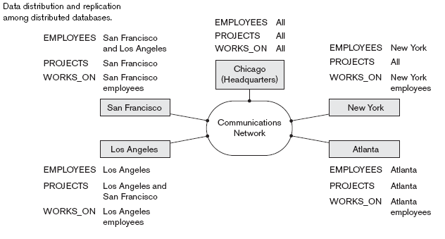

5.5.4 Autonomy

  - Autonomy determines the extent to which individual nodes or DBs in a connected DDB can operate independently.
  - A high degree of autonomy is desirable for increased flexibility and customized maintenance of an individual node. Autonomy can be applied to design, communication, and execution.
  - Design autonomy refersto independence of data model usage and transaction management techniques among nodes.

  - Communication autonomy determines the extent to which each node can decide on sharing of information with other nodes.
  - Execution autonomy refers to independence of users to act as they please.

5.5.5 Reliability and Availability

  - Reliability and availability are two of the most common potential advantages cited for distributed databases.
  - Reliability is broadly defined as the probability that a system is running (not down) at a certain time point, whereas availability is the probability that the system is continuously available during a time interval. We can directly relate reliability and availability of the database to the faults, errors, and failures associated with it.
  - A failure can be described as a deviation of a system’s behavior from that which is specified in order to ensure correct execution of operations.
  - Errors constitute that subset of system states that causes the failure. Fault is the cause of an error.

5.5.6 Advantages of Distributed Databases
Organizations resort to distributed database management for various reasons. Some important advantages are listed
    - Improved ease and flexibility of application development.
    - Increased reliability and availability.
    - Improved performance.
    - Easier expansion.

5.5.7 Additional Functions of Distributed Databases

■ Keeping track of data distribution. The ability to keep track of the data distribution, fragmentation, and replication by expanding the DDBMS catalog.
■ Distributed query processing. The ability to access remote sites and transmit queries and data among the various sites via a communication network.
■ Distributed transaction management. The ability to devise execution strategies for queries and transactions that access data from more than one site and to synchronize the access to distributed data and maintain the integrity of the overall database.

■ Replicated data management. The ability to decide which copy of a replicated data item to access and to maintain the consistency of copies of a replicated data item.
■ Distributed database recovery. The ability to recover from individual site crashes and from new types of failures, such as the failure of communication links.
■ Security. Distributed transactions must be executed with the proper management of the security of the data and the authorization/access privileges of users.
■ Distributed directory (catalog) management. A directory contains information (metadata) about data in the database. The directory may be global for the entire DDB, or local for each site. The placement and distribution of the directory are design and policy issues

5.5.8 Types of Distributed Database Systems

The term distributed database management system can describe various systems that differ from one another in many respects. The main thing that all such systems have in common is the fact that data and software are distributed over multiple sites connected by some form of communication network. In this section we discuss a number of types of DDBMSs and the criteria and factors that make some of these systems different.
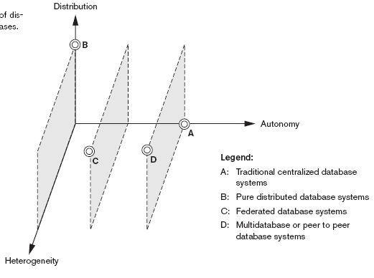

The two different client - server architecture are −
- Single Server Multiple Client
- Multiple Server Multiple Client (shown in the following diagram)
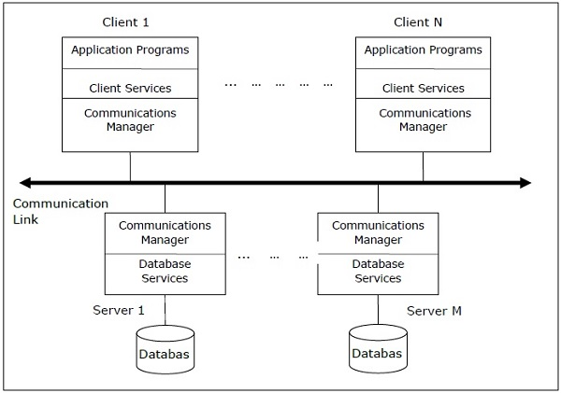

Peer- to-Peer Architecture for DDBMS
In these systems, each peer acts both as a client and a server for imparting database services. The peers share their resource with other peers and co-ordinate their activities.
This architecture generally has four levels of schemas −
- Global Conceptual Schema − Depicts the global logical view of data.
- Local Conceptual Schema − Depicts logical data organization at each site.
- Local Internal Schema − Depicts physical data organization at each site.
- External Schema − Depicts user view of data.
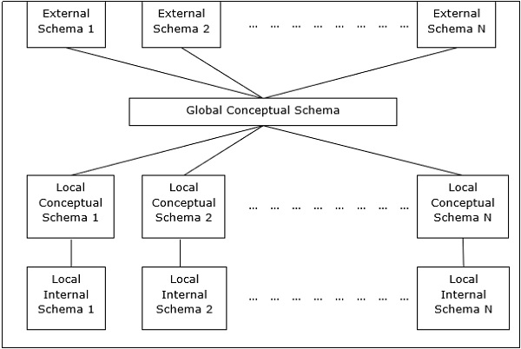

Multi - DBMS Architectures
This is an integrated database system formed by a collection of two or more autonomous database systems.
Multi-DBMS can be expressed through six levels of schemas −
- Multi-database View Level − Depicts multiple user views comprising of subsets of the integrated distributed database.
- Multi-database Conceptual Level − Depicts integrated multi-database that comprises of global logical multi-database structure definitions.
- Multi-database Internal Level − Depicts the data distribution across different sites and multi-database to local data mapping.
- Local database View Level − Depicts public view of local data.
- Local database Conceptual Level − Depicts local data organization at each site.
- Local database Internal Level − Depicts physical data organization at each site.
There are two design alternatives for multi-DBMS −
- Model with multi-database conceptual level.
- Model without multi-database conceptual level.
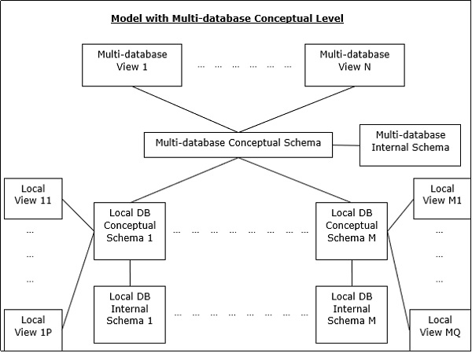

XML DATABASES
5.12.1 Introduction
- Although HTML is widely used for formatting and structuring Web documents, it is not suitable for specifying structured data that is extracted from databases.
- A new language—namely XML (eXtended Markup Language) has emerged as the standard for structuring and exchanging data over the Web. XML can be used to provide more information about the structure and meaning of the data in the Web pages rather than just specifying how the Web pages are formatted for display on the screen.
- The formatting aspects are specified separately—for example, by using a formatting language such as XSL (eXtended Stylesheet Language).

5.12.2 Structured, Semi Structured and Unstructured Data.
- Information stored in databases is known as structured data because it is represented in a strict format. The DBMS then checks to ensure that all data follows the structures and constraints specified in the schema.
- In some applications, data is collected in an ad-hoc manner before it is known how it will be stored and managed. This data may have a certain structure, but not all the information collected will have identical structure. This type of data is known as semi-structured data.
  - In semi-structured data, the schema information is mixed in with the data values, since each data object can have different attributes that are not known in advance. Hence, this type of data is sometimes referred to as self-decribing data.
  - A third category is known as unstructured data, because there is very limited indication of the type of data. A typical example would be a text document that contains information embedded within it. Web pages in HTML that contain some data are considered as unstructured data.
- Semi-structured data may be displayed as a directed graph, as shown.
- The labels or tags on the directed edges represent the schema names—the names of attributes, object types (or entity types or classes), and relationships.
- The internal nodes represent individual objects or composite attributes.
- The leaf nodes represent actual data values of simple (atomic) attributes.

5.12.3 Representing semi structured data as a graph.

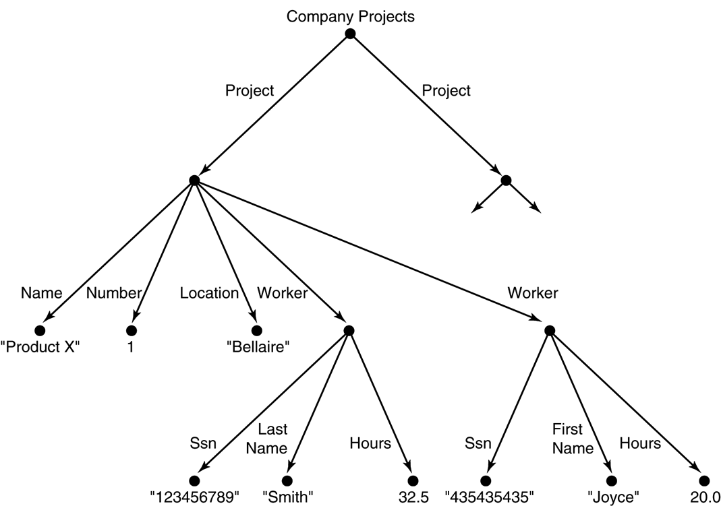

5.12.4 XML Hierarchical (Tree) Data Model
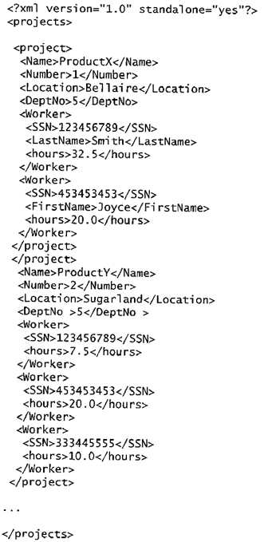

- The basic object is XML is the XML document. There are two main structuring concepts that are used to construct an XML document: elements and attributes. Attributes in XML provide additional information that describe elements.
- As in HTML, elements are identified in a document by their start tag and end tag. The tag names are enclosed between angled brackets <…>, and end tags are further identified by a backslash </…>. Complex elements are constructed from other elements hierarchically, whereas simple elements contain data values.
- It is straightforward to see the correspondence between the XML textual representation and the tree structure. In the tree representation, internal nodes represent complex elements, whereas leaf nodes represent simple elements. That is why the XML model is called a tree model or a hierarchical model.

It is possible to characterize three main types of XML documents:
1.Data-centric XML documents:
These documents have many small data items that follow a specific structure, and hence may be extracted from a structured database. They are formatted as XML documents in order to exchange them or display them over the Web.
2.Document-centric XML documents:
These are documents with large amounts of text, such as news articles or books. There is little or no structured data elements in these documents.
3.Hybrid XML documents:
These documents may have parts that contains structured data and other parts that are predominantly textual or unstructured.
5.12.5 XML Documents, DTD, and XML Schema:

Well-Formed
  - It must start with an XML declaration to indicate the version of XML being used—as well as any other relevant attributes.
  - It must follow the syntactic guidelines of the tree model. This means that there should be a single root element, and every element must include a matching pair of start tag and end tag within the start and end tags of the parent element.
  - A well-formed XML document is syntactically correct. This allows it to be processed by generic processors that traverse the document and create an internal tree representation.

    - DOM (Document Object Model) - Allows programs to manipulate the resulting tree representation corresponding to a well-formed XML document. The whole document must be parsed beforehand when using dom.
    - SAX - Allows processing of XML documents on the fly by notifying the processing program whenever a start or end tag is encountered. Valid
A stronger criterion is for an XML document to be valid. In this case, the document must be well-formed, and in addition the element names used in the start and end tag pairs must follow the structure specified in a separate XML DTD (Document Type Definition) file or XML schema file.
5.12.6 XML Documents, DTD, and XML Schema:

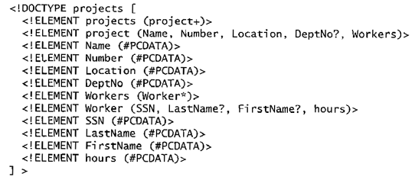
5.12.7 XML DTD Notation

- A * following the element name means that the element can be repeated zero or more times in the document. This can be called an optional multivalued (repeating) element.
- A + following the element name means that the element can be repeated one or more times in the document. This can be called a required multivalued (repeating) element.
- A ? following the element name means that the element can be repeated zero or one times. This can be called an optional single-valued (non-repeating) element.

- An element appearing without any of the preceding three symbols must appear exactly once in the document. This can be called an required single-valued (non-repeating) element.
- The type of the element is specified via parentheses following the element. If the parentheses include names of other elements, these would be the children of the element in the tree structure. If the parentheses include the keyword #PCDATA or one of the other data types available in XML DTD, the element is a leaf node. PCDATA stands for parsed character data, which is roughly similar to a string data type.
- Parentheses can be nested when specifying elements.
- A bar symbol ( e1 | e2 ) specifies that either e1 or e2 can appear in the document.
5.12.8 Limitations of XML DTD

- First, the data types in DTD are not very general.
- DTD has its own special syntax and so it requires specialized processors. It would be advantageous to specify XML schema documents using the syntax rules of XML itself so that the same processors for XML documents can process XML schema descriptions.
Third, all DTD elements are always forced to follow the specified ordering the document so unordered elements are not perm.
5.12.9 An XML schema file called company

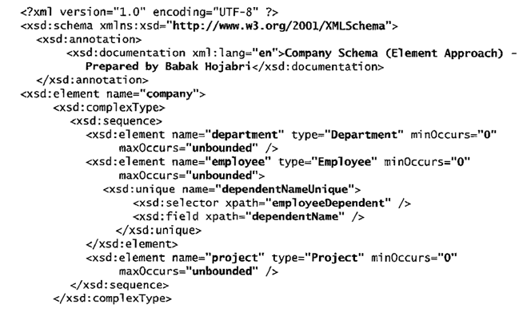

5.12.10 XML SCHEMA

- Schema Descriptions and XML Namespaces:
It is necessary to identify the specific set of XML schema language elements (tags) by a file stored at a Web site location. The second line in our example specifies the file used in this example, which is: "http://www.w3.org/2001/XMLSchema".
Each such definition is called an XML namespace.
The file name is assigned to the variable xsd using the attribute xmlns (XML namespace), and this variable is used as a prefix to all XML schema tags.
- Annotations, documentation, amd language used:
The xsd:annotation and xsd:documentation are used for providing comments and other descriptions in the XML document. The attribute XML:lang of the xsd:documentation element specifies the language being used. Eg. “en”
- Elements and types:
We specify the root element of our XML schema. In XML schema, the name attribute of the xsd:element tag specifies the element name, which is called company for the root element in our example. The structure of the company root element is a xsd:complexType.
- First-level elements in the company database:
These elements are named employee, department, and project, and each is specified in an xsd:element tag. If a tag has only attributes and no further sub-elements or data within it, it can be ended with the back slash symbol (/>) and termed Empty Element.
- Specifying element type and minimum and maximum occurrences:
If we specify a type attribute in an xsd:element, this means that the structure of the element will be described separately, typically using the xsd:complexType element. The minOccurs and maxOccurs tags are used for specifying lower and upper bounds on the number of occurrences of an element. The default is exactly one occurrence.
- Specifying Keys:
For specifying primary keys, the tag xsd:key is used.
For specifying foreign keys, the tag xsd:keyref is used. When specifying a foreign key, the attribute refer of the xsd:keyref tag specifies the referenced primary key whereas the tags xsd:selector and xsd:field specify the referencing element type and foreign key.
- Specifying the structures of complex elements via complex types:
Complex elements in our example are Department, Employee, Project, and Dependent, which use the tag xsd:complexType. We specify each of these as a sequence of subelements corresponding to the database attributes of each entity type by using the xsd:sequence and xsd:element tags of XML schema. Each element is given a name and type via the attributes name and type of xsd:element.
We can also specify minOccurs and maxOccurs attributes if we need to change the default of exactly one occurrence. For (optional) database attributes where null is allowed, we need to specify minOccurs = 0, whereas for multivalued database attributes we need to specify maxOccurs = “unbounded” on the corresponding element.
Composite (compound) attributes:
Composite attributes from ER Schema are also specified as complex types in the XML schema, as illustrated by the Address, Name, Worker, and WorkesOn complex types. These could have been directly embedded within their parent elements.
5.12.11 Approaches to Storing XML Documents

- Using a dbms to store the documents as text:
We can use a relational or object dbms to store whole XML documents as text fields within the dbms records or objects. This aproach can be used if the dbms has a special module for document processing, and would work for storing schemaless and document-centric XML documents.
- Using a dbms to store the document contents as data elements:
This approach would work for storing a collection of documents that follow a specific XML DTD or XML schema. Since all the documents have the same structure, we can design a relational (or object) database to store the leaf-level data elements within the XML documents.
- Designing a specialized system for storing native XML data:
A new type of database system based on the hierarchical (tree) model would be designed and implemented. The system would include specialized indexing and querying techniques, and would work for all types of XML documents.
- Creating or publishing customized XML documents from pre-existing relational databases:
Because there are enormous amounts of data already stored in relational databases, parts of these data may need to be formatted as documents for exchanging or displaying over the Web.
5.12. 12 Extracting XML Documents from Relational Databases.
Suppose that an application needs to extract XML documents for student, course, and grade information from the university database. The data needed for these documents is contained in the database attributes of the entity types course, section, and student as shown below (part of the main ER), and the relationships s-s and c-s be

Definition and Overview of ODBMS
The ODBMS which is an abbreviation for object oriented database management system, is the data model in which data is stored in form of objects, which are instances of classes. These classes and objects together makes an object oriented data model.
Components of Object Oriented Data Model:
The OODBMS is based on three major components, namely: Object structure, Object classes, and Object identity. These are explained as following below.
1. Object Structure:
The structure of an object refers to the properties that an object is made up of. These properties of an object are referred to as an attribute. Thus, an object is a real world world entity with certain attributes that makes up the object structure. Also an object encapsulates the data code into a single unit which in turn provides data abstraction by hiding the implementation details from the user.
he object structure is further composed of three types of components: Messages, Methods, and Variables. These are explained as following below.
- Messages –
A message provides an interface or acts as a communication medium between an object and the outside world. A message can be of two types:
  - Read-only message: If the invoked method does not change the value of a variable, then the invoking message is said to be a read-only message.
  - Update message: If the invoked method changes the value of a variable, then the invoking message is said to be an update message.
- Methods –
When a message is passed then the body of code that is executed is known as a method. Every time when a method is executed, it returns a value as output. A method can be of two types:
  - Read-only method: When the value of a variable is not affected by a method, then it is known as read-only method.
  - Update-method: When the value of a variable changes by a method, then it is known as an update method.
- Variables –
It stores the data of an object. The data stored in the variables makes the object distinguishable from one another.
2. Object Classes:
An object which is a real world entity is an instance of a class. Hence first we need to define a class and then the objects are made which differ in the values they store but share the same class definition. The objects in turn corresponds to various messages and variables stored in it.
Example –
class CLERK

{ //variables
char name;
string address;
int id;
int salary;

//messages
char get_name();
string get_address();
int annual_salary();
};
In above example we can see, CLERK is a class that holds the object variables and messages.
An OODBMS also supports inheritance in an extensive manner as in a database there may be many classes with similar methods, variables and messages. Thus, the concept of class hierarchy is maintained to depict the similarities among various classes.
The concept of encapsulation that is the data or information hiding is also supported by object oriented data model. And this data model also provides the facility of abstract data types apart from the built-in data types like char, int, float. ADT’s are the user defined data types that hold the values within it and can also have methods attached to it.
Thus, OODBMS provides numerous facilities to it’s users, both built-in and user defined. It incorporates the properties of an object oriented data model with a database management system, and supports the concept of programming paradigms like classes and objects along with the support for other concepts like encapsulation, inheritance and the user defined ADT’s (abstract data types).
INFORMATION RETRIEVAL
2.1 BOOLEAN RETRIEVAL MODEL:

The Boolean retrieval model was used by the earliest search engines and is still in use today. It is also known as exact-match retrieval since documents are retrieved if they exactly match the query specification, and otherwise are not retrieved. Although this defines a very simple form of ranking, Boolean retrieval is not generally described as a ranking algorithm. This is because the Boolean retrieval model assumes that all documents in the retrieved set are equivalent in terms of relevance, in addition to the assumption that relevance is binary. The name Boolean comes from the fact that there only two possible outcomes for query evaluation (TRUE and FALSE) and because the query is usually specified using operators from Boolean logic (AND, OR, NOT). Searching with a regular expression utility such as unix grep is another example of exact-match retrieval.

A fat book which many people own is Shakespeare’s Collected Works. Suppose you wanted to determine which plays of Shakespeare contain the words Brutus AND Caesar AND NOT Calpurnia. One way to do that is to start at the beginning and to read through all the text, noting for each play whether it contains Brutus and Caesar and excluding it from consideration if it contains Calpurnia. The simplest form of document retrieval is for a computer to do this sort of linear scan through documents.

With modern computers, for simple querying of modest collections (the size of Shakespeare’s Collected Works is a bit under one million words of text in total), you really need nothing more. But for many purposes, you do need more:

- To process large document collections quickly. The amount of online data has grown at least as quickly as the speed of computers, and we would now like to be able to search collections that total in the order of billions to trillions of words.
- To allow more flexible matching operations. For example, it is impractical to perform the query Romans NEAR countrymen with grep, where NEAR might be defined as

“within 5 words” or “within the same sentence”.

- To allow ranked retrieval: in many cases you want the best answer to an information need among many documents that contain certain words.

The way to avoid linearly scanning the texts for each query is to index the documents in advance. Let us stick with Shakespeare’s Collected Works, and use it to introduce the basics of the Boolean retrieval model. Suppose we record for each document – here a play of Shakespeare’s – whether it contains each word out of all the words Shakespeare used (Shakespeare used about 32,000 different words). The result is a binary term-document incidence, as in Figure. Terms are the indexed units; they are usually words, and for the moment you can think of them as words.

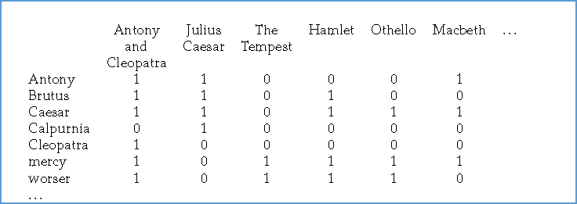

Figure : A term-document incidence matrix. Matrix element (t, d) is 1 if the play in column

d contains the word in row t, and is 0 otherwise.

To answer the query Brutus AND Caesar AND NOT Calpurnia, we take the vectors for

Brutus, Caesar and Calpurnia, complement the last, and then do a bitwise AND:

110100 AND 110111 AND 101111 = 100100

Answer : The answers for this query are thus Antony and Cleopatra and Hamlet

Let us now consider a more realistic scenario, simultaneously using the opportunity to introduce some terminology and notation. Suppose we have N = 1 million documents. By documents we mean whatever units we have decided to build a retrieval system over.

They might be individual memos or chapters of a book. We will refer to the group of

2.2

CS 6007 Information Retrieval

documents over which we perform retrieval as the COLLECTION. It is sometimes also referred to as a Corpus.

we assume an average of 6 bytes per word including spaces and punctuation, then this is a document collection about 6 GB in size. Typically, there might be about M = 500,000 distinct terms in these documents. There is nothing special about the numbers we have chosen, and they might vary by an order of magnitude or more, but they give us some idea of the dimensions of the kinds of problems we need to handle.

Advantages:

- The results of the model are very predictable and easy to explain to users.

- The operands of a Boolean query can be any document feature, not just words, so it is straightforward to incorporate metadata such as a document date or document type in the query specification.

- From an implementation point of view, Boolean retrieval is usually more efficient than ranked retrieval because documents can be rapidly eliminated from consideration in the scoring process

Disadvantages:

- The major drawback of this approach to search is that the effectiveness depends entirely on the user. Because of the lack of a sophisticated ranking algorithm, simple queries will not work well.

- All documents containing the specified query words will be retrieved, and this retrieved set will be presented to the user in some order, such as by publication date, that has little to do with relevance. It is possible to construct complex Boolean queries that narrow the retrieved set to mostly relevant documents, but this is a difficult task.

- No ranking of returned result.

Effectiveness of IR:

RELEVANCE: A document is relevant if it is one that the user perceives as containing information of value with respect to their personal information need.

2.3

CS 6007 Information Retrieval

To assess the effectiveness of an IR system (i.e., the quality of its search results), a user will usually want to know two key statistics about the system’s returned results for a query:

PRECISION: What fraction of the returned results is relevant to the information need?

RECALL: What fraction of the relevant documents in the collection were returned by the system?

INVERTED INDEX:

Each term in a document is called as index. Inverted index, or sometimes inverted file, has become the standard term in information retrieval. The basic idea of an inverted index is shown in Figure.

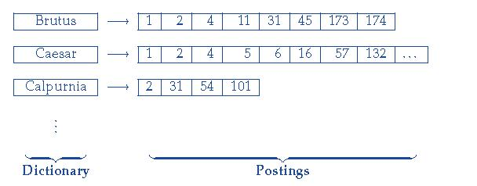

We keep a dictionary of terms (sometimes also referred to as a vocabulary or lexicon). Then for each term, we have a list that records which documents the term occurs in. Each item in the list – which records that a term appeared in a document (and, later, often, the positions in the document) – is conventionally called a posting. The list is then called a postings list (or inverted list), and all the postings lists taken together are referred to as the postings. The dictionary in above figure has been sorted alphabetically and each postings list is sorted by document ID.

Building an inverted index:

To gain the speed benefits of indexing at retrieval time, we have to build the index in advance. The major steps in this are:

1. Collect the documents to be indexed:

- Tokenize the text, turning each document into a list of tokens:

- Do linguistic preprocessing, producing a list of normalized tokens, which are the indexing terms

- Index the documents that each term occurs in by creating an inverted index, consisting of a dictionary and postings.





Within a document collection, we assume that each document has a unique serial number, known as the document identifier (docID). During index construction, we can simply assign successive integers to each new document when it is first encountered. The input to indexing is a list of normalized tokens for each document, which we can equally think of as a list of pairs of term and docID, as in following figure.

The core indexing step is sorting this list so that the terms are alphabetical, giving us the representation in the middle column of Figure. Multiple occurrences of the same term from the same document are then merged. Instances of the same term are then grouped, and the result is split into a dictionary and postings, as shown in the right column of Figure. The dictionary also records some statistics, such as the number of documents which contain each term (the Document Frequency, which is here also the length of each postings list). The postings are secondarily sorted by docID.

In the resulting index, we pay for storage of both the dictionary and the postings lists. The latter are much larger, but the dictionary is commonly kept in memory, while postings lists are normally kept on disk.

What data structure should be used for a postings list? A fixed length array would be wasteful as some words occur in many documents, and others in very few. For an in-memory postings list, two good alternatives are singly linked lists or variable length arrays. Singly linked lists allow cheap insertion of documents into postings lists (following updates, such as when recrawling the web for updated documents), and naturally extend to more

2.5

CS 6007 Information Retrieval

advanced indexing strategies such as skip lists, which require additional pointers. Variable length arrays win in space requirements by avoiding the overhead for pointers and in time requirements because their use of contiguous memory increases speed on modern processors with memory caches. Extra pointers can in practice be encoded into the lists as offsets. If updates are relatively infrequent, variable length arrays will be more compact and faster to traverse. We can also use a hybrid scheme with a linked list of fixed length arrays for each term.

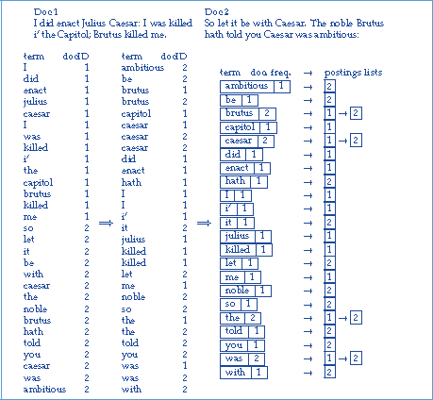

Figure: Building an index by sorting and grouping.

