UNIT IV IMPLEMENTATION TECHNIQUES
RAID – File Organization – Organization of Records in Files – Indexing and Hashing –Ordered Indices – B+ tree Index Files – B tree Index Files – Static Hashing – Dynamic Hashing – Query Processing Overview – Algorithms for SELECT and JOIN operations – Query optimization using Heuristics and Cost Estimation.

- Overview of Physical Storage Media

- Magnetic Disks

- RAID

- Tertiary Storage

- Storage Access

- File Organization

- Organization of Records in Files

Classification of Physical Storage Media

- Accessing Speed

- Cost per unit of data

- Reliability

  - data loss on power failure or system crash

  - physical failure of the storage device

- Can differentiate storage into:

  - volatile storage: loses contents when power is switched off

  - non-volatile storage:

Contents persist even when power is switched off.

Includes secondary and tertiary storage, as well as batter-backed up main-memory.

Storage Hierarchy

- The various storage media can be organized in a hierarchy accounting to their speed and their cost.

- The higher level is expensive, but is fast. As we move down the hierarchy, the cost per bit decreases, where as the access time increases.

- Storage hierarchy includes 3 main categories.

  - Primary storage: Fastest media but volatile (cache, main memory).

  - Secondary storage: next level in hierarchy, non-volatile, moderately fast access time also called on-line storage

E.g. flash memory, magnetic disks

  - Tertiary storage: lowest level in hierarchy, non-volatile, slow access time also called off-line storage

E.g. magnetic tape, optical storage
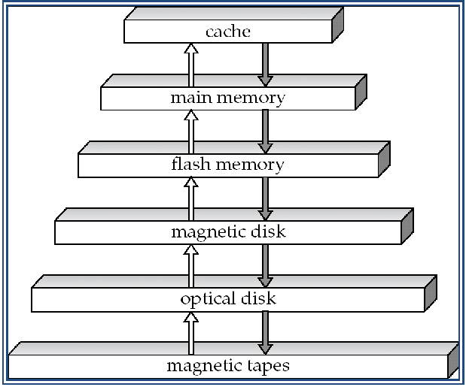

Physical Storage Media

- Cache – fastest and most costly form of storage; volatile; managed by the computer system hardware.

- Main memory:

- fast access (10s to 100s of nanoseconds; 1 nanosecond = 10^{–9} seconds)

- generally too small (or too expensive) to store the entire database capacities of up to a few Gigabytes widely used currently

Capacities have gone up and per-byte costs have decreased steadily and rapidly (roughly factor of 2 every 2 to 3 years)

  - Volatile — contents of main memory are usually lost if a power failure or system crash occurs.

- Flash memory

  - Data survives power failure

  - Data can be written at a location only once, but location can be erased and written to again

Can support only a limited number (10K – 1M) of write/erase cycles. Erasing of memory has to be done to an entire bank of memory

  - Reads are roughly as fast as main memory

  - But writes are slow (few microseconds), erase is slower

  - Cost per unit of storage roughly similar to main memory

  - Widely used in embedded devices such as digital cameras

  - Is a type of EEPROM (Electrically Erasable Programmable Read-Only Memory)

- Magnetic-disk

  - Data is stored on spinning disk, and read/written magnetically

  - Primary medium for the long-term storage of data; typically stores entire database.

  - Data must be moved from disk to main memory for access, and written back for storage

Much slower access than main memory (more on this later)

  - direct-access – possible to read data on disk in any order, unlike magnetic tape

  - Capacities range up to roughly 400 GB currently

Much larger capacity and cost/byte than main memory/flash memory

Growing constantly and rapidly with technology improvements (factor of 2 to 3 every 2 years)

  - Survives power failures and system crashes

disk failure can destroy data, but is rare

- Read-write head

- Positioned very close to the platter surface (almost touching it)

- Reads or writes magnetically encoded information.

- Surface of platter divided into circular tracks

  - Over 50K-100K tracks per platter on typical hard disks

- Each track is divided into sectors.

  - A sector is the smallest unit of data that can be read or written.

  - Sector size typically 512 bytes

  - Typical sectors per track: 500 (on inner tracks) to 1000 (on outer tracks)

- To read/write a sector

  - disk arm swings to position head on right track

  - platter spins continually; data is read/written as sector passes under head

- Head-disk assemblies

  - multiple disk platters on a single spindle (1 to 5 usually)

  - One head per platter, mounted on a common arm.

- Cylinder i consists of i^{th} track of all the platters

- Earlier generation disks were susceptible to head-crashes

  - Surface of earlier generation disks had metal-oxide coatings which would disintegrate on head crash and damage all data on disk

  - Current generation disks are less susceptible to such disastrous failures, although individual sectors may get corrupted

- Disk controller – interfaces between the computer system and the disk drive hardware.

  - accepts high-level commands to read or write a sector

  - initiates actions such as moving the disk arm to the right track and actually reading or writing the data

  - Computes and attaches checksums to each sector to verify that data is read back correctly

If data is corrupted, with very high probability stored checksum won’t match recomputed checksum

  - Ensures successful writing by reading back sector after writing it

  - Performs remapping of bad sectors

- NOTE: Diagram is schematic, and simplifies the structure of actual disk drives

- Optical storage
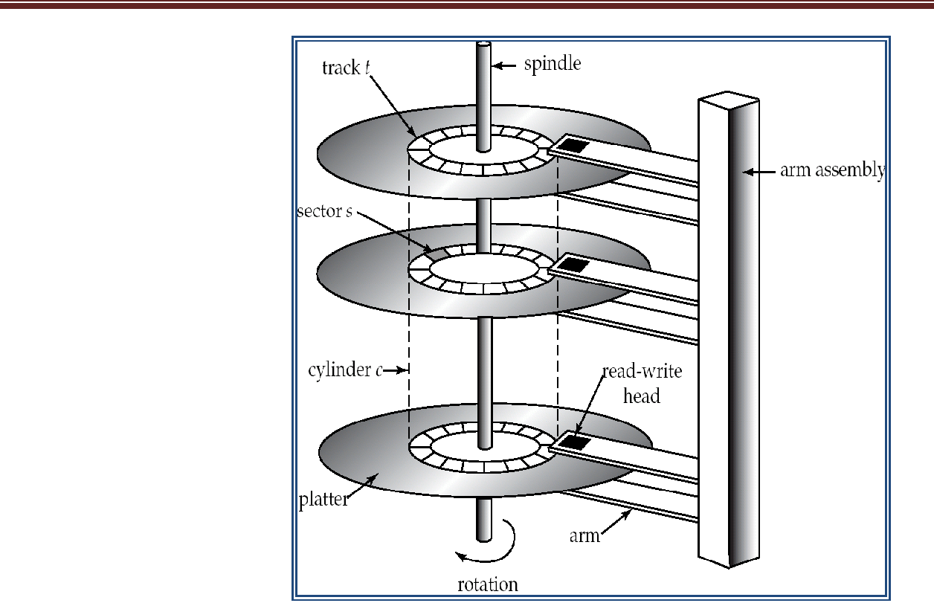

  - non-volatile, data is read optically from a spinning disk using a laser

  - CD-ROM (640 MB) and DVD (4.7 to 17 GB) most popular forms

  - Write-one, read-many (WORM) optical disks used for archival storage (CD-R, DVD-R, DVD+R)

  - Multiple write versions also available (CD-RW, DVD-RW, DVD+RW, and DVD-RAM)

  - Reads and writes are slower than with magnetic disk

  - Juke-box systems, with large numbers of removable disks, a few drives, and a mechanism for automatic loading/unloading of disks available for storing large volumes of data

- Tape storage

  - non-volatile, used primarily for backup (to recover from disk failure), and for archival data

  - sequential-access – much slower than disk

- very high capacity (40 to 300 GB tapes available)

- tape can be removed from drive storage costs much cheaper than disk, but drives are expensive

- Tape jukeboxes available for storing massive amounts of data

hundreds of terabytes (1 terabyte = 10⁹ bytes) to even a petabyte (1 petabyte = 10¹² bytes)

Disk Subsystem
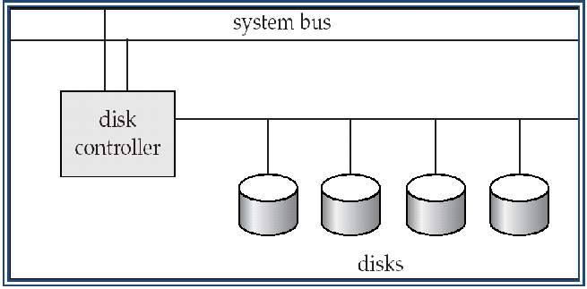

Figure Disk Subsystem

- Multiple disks connected to a computer system through a controller

  - Controllers functionality (checksum, bad sector remapping) often carried out by individual disks; reduces load on controller

- Disk interface standards families

  - ATA (AT adaptor) range of standards

  - SATA (Serial ATA)

  - SCSI (Small Computer System Interconnect) range of standards

  - Several variants of each standard (different speeds and capabilities)

- Access time – the time it takes from when a read or write request is issued to when data transfer begins. Consists of:

o Seek time – time it takes to reposition the arm over the correct track.

o Rotational latency – time it takes for the sector to be accessed to appear under the head.

- Data-transfer rate – the rate at which data can be retrieved from or stored to the disk. o 25 to 100 MB per second max rate, lower for inner tracks

- Mean time to failure (MTTF) – the average time the disk is expected to run continuously without any failure.

o Typically 3 to 5 years

- Block – a contiguous sequence of sectors from a single track

- data is transferred between disk and main memory in blocks

- sizes range from 512 bytes to several kilobytes Smaller blocks: more transfers from disk

Larger blocks: more space wasted due to partially filled blocks Typical block sizes today range from 4 to 16 kilobytes

- Disk-arm-scheduling algorithms order pending accesses to tracks so that disk arm movement is minimized

o elevator algorithm : move disk arm in one direction (from outer to inner tracks or vice versa), processing next request in that direction, till no more requests in that direction, then reverse direction and repeat

- File organization – optimize block access time by organizing the blocks to correspond to how data will be accessed

o E.g. Store related information on the same or nearby cylinders. o Files may get fragmented over time

E.g. if data is inserted to/deleted from the file

Or free blocks on disk are scattered, and newly created file has its blocks scattered over the disk

Sequential access to a fragmented file results in increased disk arm

movement

  - Some systems have utilities to defragment the file system, in order to speed up file access

- Nonvolatile write buffers speed up disk writes by writing blocks to a non-volatile RAM buffer immediately

  - Non-volatile RAM: battery backed up RAM or flash memory

Even if power fails, the data is safe and will be written to disk when power returns

  - Controller then writes to disk whenever the disk has no other requests or request has been pending for some time

  - Database operations that require data to be safely stored before continuing can continue without waiting for data to be written to disk

  - Writes can be reordered to minimize disk arm movement

- Log disk – a disk devoted to writing a sequential log of block updates

  - Used exactly like nonvolatile RAM

Write to log disk is very fast since no seeks are required No need for special hardware (NV-RAM)

- File systems typically reorder writes to disk to improve performance

  - Journaling file systems write data in safe order to NV-RAM or log disk

  - Reordering without journaling: risk of corruption of file system data

RAID

» RAID: Redundant Arrays of Independent Disks

  - disk organization techniques that manage a large numbers of disks, providing a view of a single disk of

high capacity and high speed by using multiple disks in parallel, and

high reliability by storing data redundantly, so that data can be recovered even if a disk fails

- The chance that some disk out of a set of N disks will fail is much higher than the chance that a specific single disk will fail.

- Originally a cost-effective alternative to large, expensive disks

- Redundancy – store extra information that can be used to rebuild information lost in a disk failure

- E.g., Mirroring (or shadowing)

- Duplicate every disk. Logical disk consists of two physical disks.

- Every write is carried out on both disks

Reads can take place from either disk

- If one disk in a pair fails, data still available in the other

Data loss would occur only if a disk fails, and its mirror disk also fails before the system is repaired

- Probability of combined event is very small

  - Except for dependent failure modes such as fire or building collapse or electrical power surges

- Mean time to data loss depends on mean time to failure, and mean time to repair

- Load balance multiple small accesses to increase throughput

- Parallelize large accesses to reduce response time.

- Bit-level striping – split the bits of each byte across multiple disks o In an array of eight disks, write bit i of each byte to disk i.

o Each access can read data at eight times the rate of a single disk. o But seek/access time worse than for a single disk

Bit level striping is not used much any more

- Block-level striping – with n disks, block i of a file goes to disk (i mod n) + 1

- Requests for different blocks can run in parallel if the blocks reside on different disks

- A request for a long sequence of blocks can utilize all disks in parallel

- Schemes to provide redundancy at lower cost by using disk striping combined with parity bits

o Different RAID organizations, or RAID levels, have differing cost, performance and reliability characteristics

- RAID Level 0: Block striping; non-redundant.

- Used in high-performance applications where data lost is not critical.

- RAID Level 1: Mirrored disks with block striping o Offers best write performance.

o Popular for applications such as storing log files in a database system.
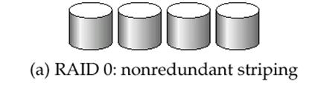
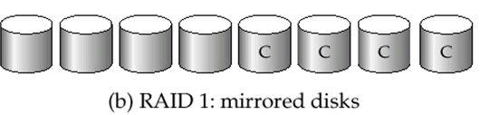

- RAID Level 2: Memory-Style Error-Correcting-Codes (ECC) with bit striping.
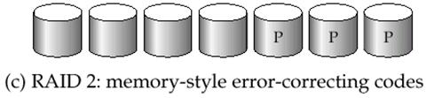

- RAID Level 3: Bit-Interleaved Parity

- a single parity bit is enough for error correction, not just detection, since we know which disk has failed

When writing data, corresponding parity bits must also be computed and written to a parity bit disk

To recover data in a damaged disk, compute XOR of bits from other disks (including parity bit disk)
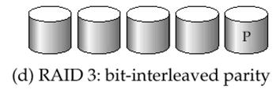

- Faster data transfer than with a single disk, but fewer I/Os per second since every disk has to participate in every I/O.

- Subsumes Level 2 (provides all its benefits, at lower cost).

- RAID Level 4: Block-Interleaved Parity; uses block-level striping, and keeps a parity block on a separate disk for corresponding blocks from N other disks.

o Provides higher I/O rates for independent block reads than Level 3

block read goes to a single disk, so blocks stored on different disks can be read in parallel

- Provides high transfer rates for reads of multiple blocks than no-striping

- Before writing a block, parity data must be computed

  - More efficient for writing large amounts of data sequentially
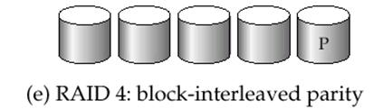

- RAID Level 5: Block-Interleaved Distributed Parity; partitions data and parity among all N + 1 disks, rather than storing data in N disks and parity in 1 disk.

o E.g., with 5 disks, parity block for nth set of blocks is stored on disk (n mod 5) + 1, with the data blocks stored on the other 4 disks.

o Higher I/O rates than Level 4.

Block writes occur in parallel if the blocks and their parity blocks are on

different disks.

  - Subsumes Level 4: provides same benefits, but avoids bottleneck of parity disk.

- RAID Level 6: P+Q Redundancy scheme; similar to Level 5, but stores extra redundant information to guard against multiple disk failures.

  - Better reliability than Level 5 at a higher cost; not used as widely.
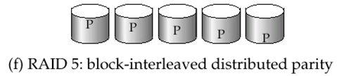

Choice of RAID Level
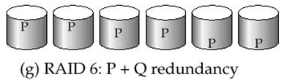

- Factors in choosing RAID level o Monetary cost

o Performance: Number of I/O operations per second, and bandwidth during normal operation

o Performance during failure

o Performance during rebuild of failed disk

Including time taken to rebuild failed disk

- RAID 0 is used only when data safety is not important

  - E.g. data can be recovered quickly from other sources

- Level 2 and 4 never used since they are subsumed by 3 and 5

- Level 3 is not used anymore since bit-striping forces single block reads to access all disks, wasting disk arm movement, which block striping (level 5) avoids

- Level 6 is rarely used since levels 1 and 5 offer adequate safety for almost all applications

- So competition is between 1 and 5 only

- Level 1 provides much better write performance than level 5

- Level 1 had higher storage cost than level 5

- Level 5 is preferred for applications with low update rate, and large amounts of data

- Level 1 is preferred for all other applications

Hardware Issues

- Software RAID: RAID implementations done entirely in software, with no special hardware support

- Hardware RAID: RAID implementations with special hardware

- Use non-volatile RAM to record writes that are being executed

- Beware: power failure during write can result in corrupted disk

E.g. failure after writing one block but before writing the second in a mirrored system

Such corrupted data must be detected when power is restored

    - Recovery from corruption is similar to recovery from failed disk

    - NV-RAM helps to efficiently detected potentially corrupted blocks o Otherwise all blocks of disk must be read and compared

with mirror/parity block

- Hot swapping: replacement of disk while system is running, without power down

  - Supported by some hardware RAID systems,

  - reduces time to recovery, and improves availability greatly

- Many systems maintain spare disks which are kept online, and used as replacements for failed disks immediately on detection of failure

  - Reduces time to recovery greatly

- Many hardware RAID systems ensure that a single point of failure will not stop the functioning of the system by using

  - Redundant power supplies with battery backup

  - Multiple controllers and multiple interconnections to guard against controller/interconnection failures

Tertiary Storage

Optical Disks

- Compact disk-read only memory (CD-ROM)

  - Disks can be loaded into or removed from a drive

  - High storage capacity (640 MB per disk)

  - High seek times or about 100 msec (optical read head is heavier and slower)

  - Higher latency (3000 RPM) and lower data-transfer rates (3-6 MB/s) compared to magnetic disks

- Digital Video Disk (DVD)

  - DVD-5 holds 4.7 GB , and DVD-9 holds 8.5 GB

  - DVD-10 and DVD-18 are double sided formats with capacities of 9.4 GB and 17

GB

  - Other characteristics similar to CD-ROM

- Record once versions (CD-R and DVD-R) are becoming popular

  - data can only be written once, and cannot be erased.

  - high capacity and long lifetime; used for archival storage

  - Multi-write versions (CD-RW, DVD-RW and DVD-RAM) also available

Magnetic Tapes

- Hold large volumes of data and provide high transfer rates

  - Few GB for DAT (Digital Audio Tape) format, 10-40 GB with DLT (Digital Linear Tape) format, 100 GB+ with Ultrium format, and 330 GB with Ampex helical scan format

  - Transfer rates from few to 10s of MB/s

- Currently the cheapest storage medium

  - Tapes are cheap, but cost of drives is very high

- Very slow access time in comparison to magnetic disks and optical disks

  - limited to sequential access.

  - Some formats (Accelis) provide faster seek (10s of seconds) at cost of lower capacity

- Used mainly for backup, for storage of infrequently used information, and as an off-line medium for transferring information from one system to another.

- Tape jukeboxes used for very large capacity storage

  - (terabyte (10¹² bytes) to petabye (10¹⁵ bytes)

Storage Access

- A database file is partitioned into fixed-length storage units called blocks. Blocks are units of both storage allocation and data transfer.

- Database system seeks to minimize the number of block transfers between the disk and memory. We can reduce the number of disk accesses by keeping as many blocks as possible in main memory.

- Buffer – portion of main memory available to store copies of disk blocks.

- Buffer manager – subsystem responsible for allocating buffer space in main memory.

- Buffer Manager

- Programs call on the buffer manager when they need a block from disk.

  - If the block is already in the buffer, the requesting program is given the address of the block in main memory

  - If the block is not in the buffer,

the buffer manager allocates space in the buffer for the block, replacing (throwing out) some other block, if required, to make space for the new block.

The block that is thrown out is written back to disk only if it was modified since the most recent time that it was written to/fetched from the disk.

Once space is allocated in the buffer, the buffer manager reads the block from the disk to the buffer, and passes the address of the block in main memory to requester.

- Buffer-Replacement Policies

- Most operating systems replace the block least recently used (LRU strategy)

- Idea behind LRU – use past pattern of block references as a predictor of future references

- Queries have well-defined access patterns (such as sequential scans), and a database system can use the information in a user’s query to predict future references

  - LRU can be a bad strategy for certain access patterns involving repeated scans of data

e.g. when computing the join of 2 relations r and s by a nested loops

for each tuple tr of r do

for each tuple ts of s do

if the tuples tr and ts match …

  - Mixed strategy with hints on replacement strategy provided by the query optimizer is preferable

- Pinned block – memory block that is not allowed to be written back to disk.

- Toss-immediate strategy – frees the space occupied by a block as soon as the final tuple of that block has been processed

- Most recently used (MRU) strategy – system must pin the block currently being processed. After the final tuple of that block has been processed, the block is unpinned, and it becomes the most recently used block.

- Buffer manager can use statistical information regarding the probability that a request will reference a particular relation

o E.g., the data dictionary is frequently accessed. Heuristic: keep data-dictionary blocks in main memory buffer

______________________________________________________________________________

File Organization

- The database is stored as a collection of files. Each file is a sequence of records. A record is a sequence of fields.

Types

- Fixed Length Record

- Variable Length Record

- Simple approach:

  - Store record i starting from byte n (i – 1), where n is the size of each record.

  - Record access is simple but records may cross blocks

Modification: do not allow records to cross block boundaries

- Deletion of record i: alternatives:

  - move records i + 1, . . ., n to i, . . . , n – 1

  - move record n to i

  - do not move records, but link all free records on a free list

Figure File Containing account record
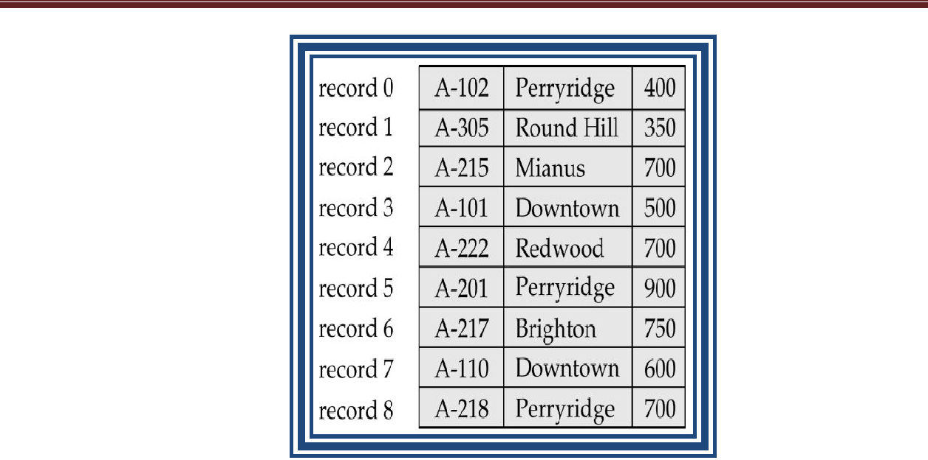

File of with Record 2 Deleted and All Records Moved
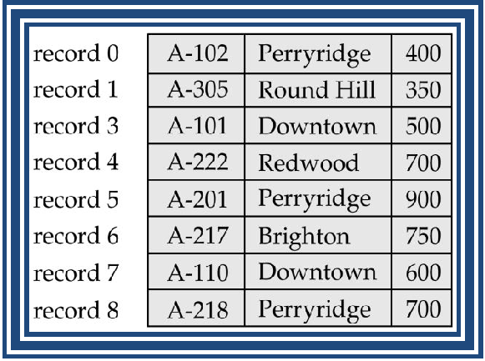

File of, with Record 2 deleted and Final Record Moved

Free Lists
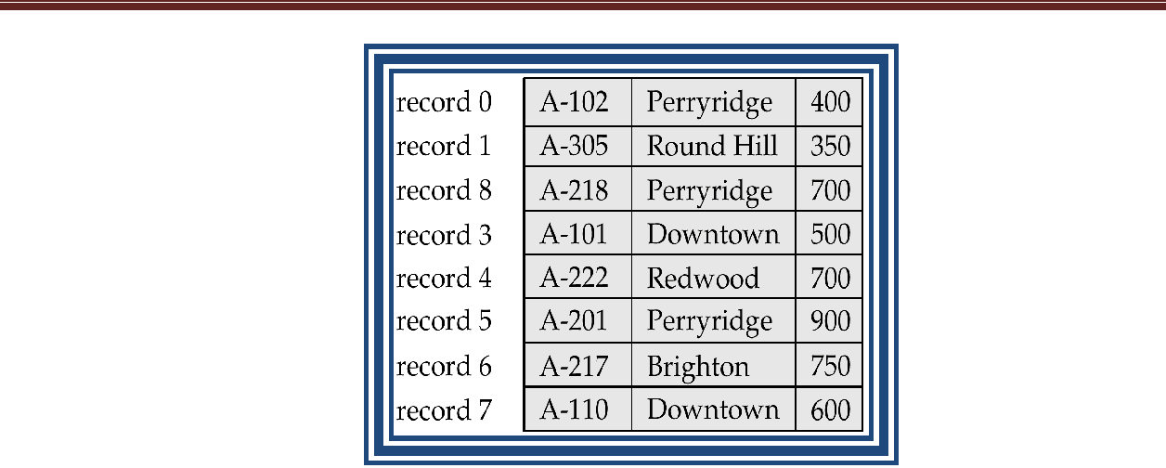

- Store the address of the first deleted record in the file header.

- Use this first record to store the address of the second deleted record, and so on

- Can think of these stored addresses as pointers since they “point” to the location of a record.

- More space efficient representation: reuse space for normal attributes of free records to store pointers. (No pointers stored in in-use records.)
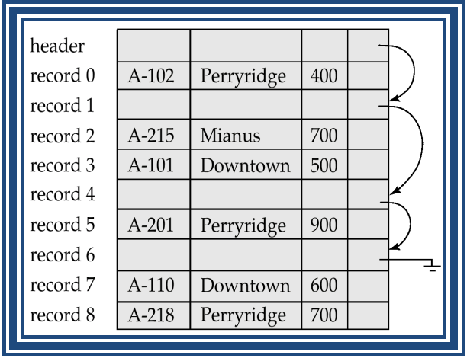

Figure File of after deletion of records 1,4 and 6.

Variable-Length Records

- Variable-length records arise in database systems in several ways: o Storage of multiple record types in a file.

  - Record types that allow variable lengths for one or more fields.

  - Record types that allow repeating fields (used in some older data models).

- Byte string representation

  - Attach an end-of-record ( ) control character to the end of each record

  - Difficulty with deletion

  - Difficulty with growth

Byte-String Representation of Variable-Length Records
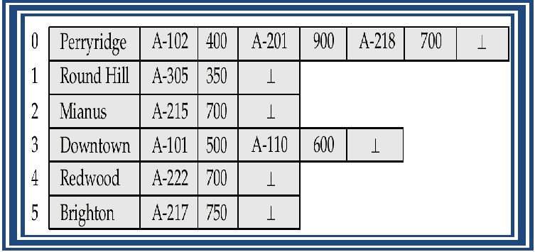

Figure Byte-String representation of variable-Length records

Variable-Length Records: Slotted Page Structure
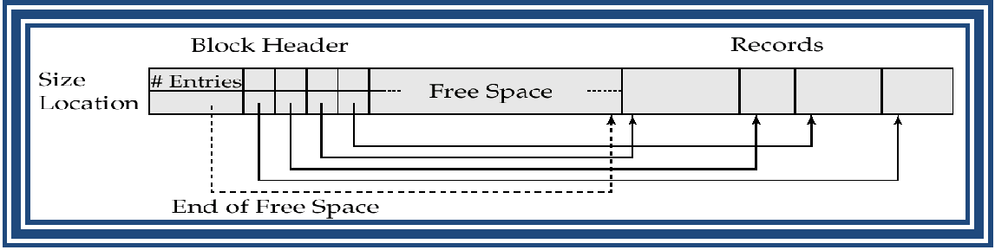

Figure Slotted Page Structure

- Slotted page header contains: o number of record entries

o end of free space in the block

  - location and size of each record

- Records can be moved around within a page to keep them contiguous with no empty space between them; entry in the header must be updated.

- Pointers should not point directly to record — instead they should point to the entry for the record in header.

  - reserved space

  - pointers

- Reserved space – can use fixed-length records of a known maximum length; unused space in shorter records filled with a null or end-of-record symbol.
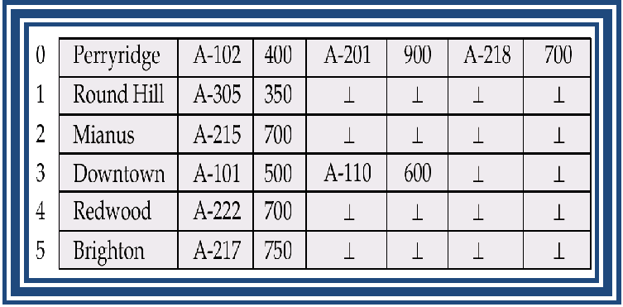

Figure File of using reserved-space method

Pointer Method
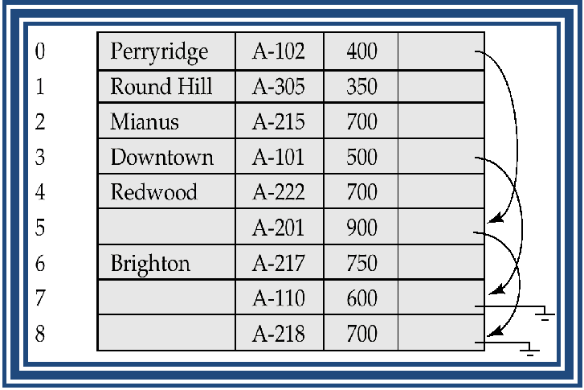

Figure File of using Linked Lists

- Pointer method

  - A variable-length record is represented by a list of fixed-length records, chained together via pointers.

  - Can be used even if the maximum record length is not known

- Disadvantage to pointer structure; space is wasted in all records except the first in an a chain.

- Solution is to allow two kinds of block in file:

  - Anchor block – contains the first records of chain

  - Overflow block – contains records other than those that are the first records of chairs.
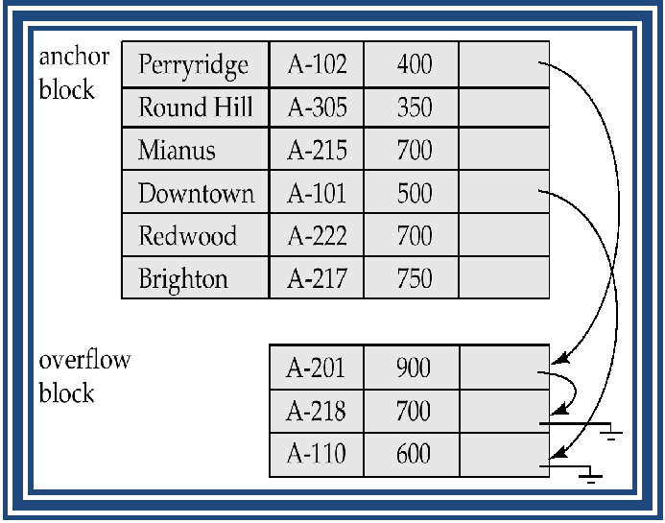

Figure Anchor-block and Overflow-block Structure Organization of Records in Files

- Heap – a record can be placed anywhere in the file where there is space

- Sequential – store records in sequential order, based on the value of the search key of each record

- Hashing – a hash function computed on some attribute of each record; the result specifies in which block of the file the record should be placed

- Records of each relation may be stored in a separate file. In a clustering file organization records of several different relations can be stored in the same file o Motivation: store related records on the same block to minimize I/O

Sequential File Organization

- Suitable for applications that require sequential processing of the entire file

- The records in the file are ordered by a search-key
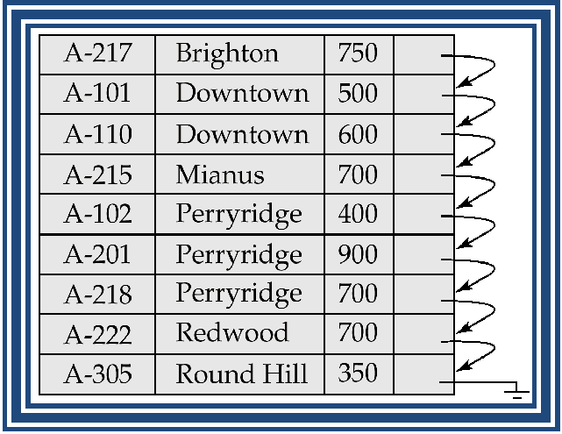

Figure Sequential file for account records

- Deletion – use pointer chains

- Insertion –locate the position where the record is to be inserted o if there is free space insert there

o if no free space, insert the record in an overflow block o In either case, pointer chain must be updated

- Need to reorganize the file from time to time to restore sequential order
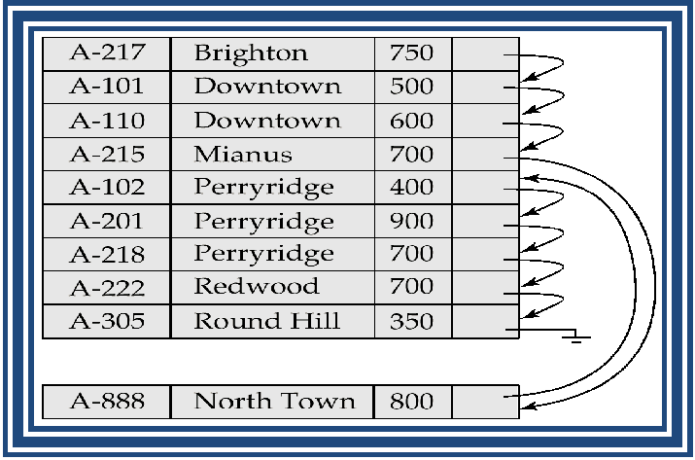

Figure Sequential file after an insertion

Clustering File Organization

- Simple file structure stores each relation in a separate file

- Can instead store several relations in one file using a clustering file organization

Example: Consider two relation

The depositor Relation
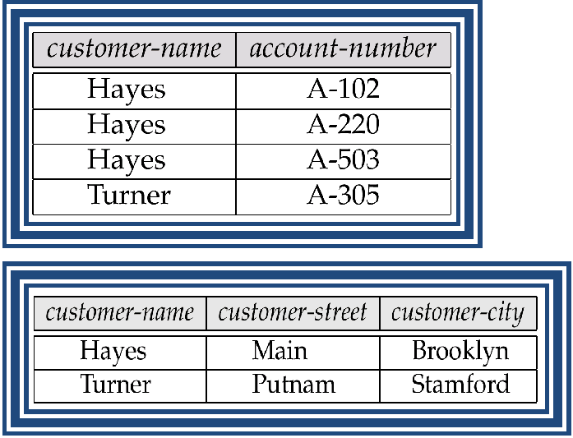

The customer Relation

- E.g., clustering organization of customer and depositor:
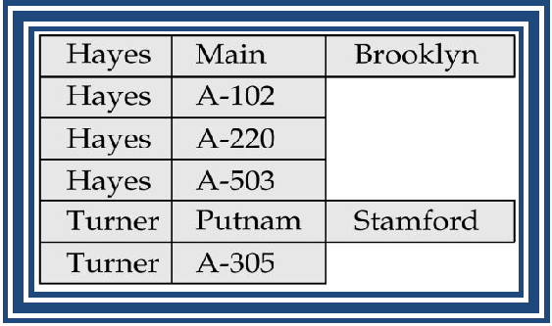

Figure Clustering file structure

- good for queries involving depositor customer, and for queries involving one single customer and his accounts

- bad for queries involving only customer

- results in variable size records

Clustering File Structure with Pointer Chains

Figure Clustering file structure with pointer chains
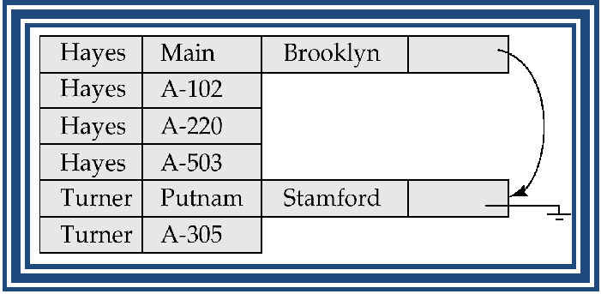

______________________________________________________________________________

Indexing and Hashing

- Basic Concepts

- Ordered Indices

- B+-Tree Index Files

- B-Tree Index Files

- Static Hashing

- Dynamic Hashing

- Comparison of Ordered Indexing and Hashing

- Index Definition in SQL

- Multiple-Key Access

Basic Concepts

- Indexing mechanisms used to speed up access to desired data. o E.g., author catalog in library

- Search Key - attribute to set of attributes used to look up records in a file.

- An index file consists of records (called index entries) of the form

- Index files are typically much smaller than the original file

- Two basic kinds of indices:

- Ordered indices: search keys are stored in sorted order

- Hash indices: search keys are distributed uniformly across “buckets” using a “hash function”.

- Access types supported efficiently. E.g.,

  - records with a specified value in the attribute

  - Or records with an attribute value falling in a specified range of values.

- Access time

- Insertion time

- Deletion time

- Space overhead

Ordered Indices

  - Indexing techniques evaluated on basis of:

- In an ordered index, index entries are stored sorted on the search key value. E.g., author catalog in library.

- Primary index: in a sequentially ordered file, the index whose search key specifies the sequential order of the file.

  - Also called clustering index

  - The search key of a primary index is usually but not necessarily the primary key.

- Secondary index: an index whose search key specifies an order different from the sequential order of the file. Also called non-clustering index.

Primary index

- Index-sequential file: ordered sequential file with a primary index. Sequential File for account Records
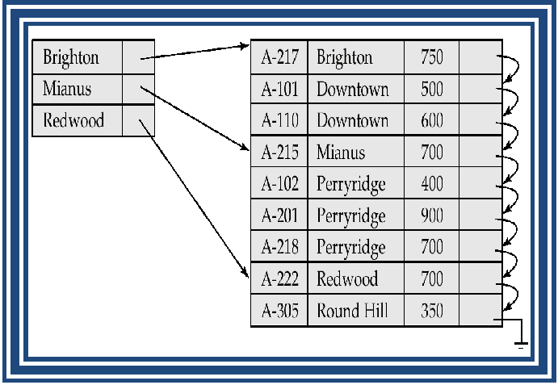

Figure Sequential file for account records

Dense and Sparse Indices

There are two types of ordered indices that we can use:

Dense Index Files

- Dense index — Index record appears for every search-key value in the file.
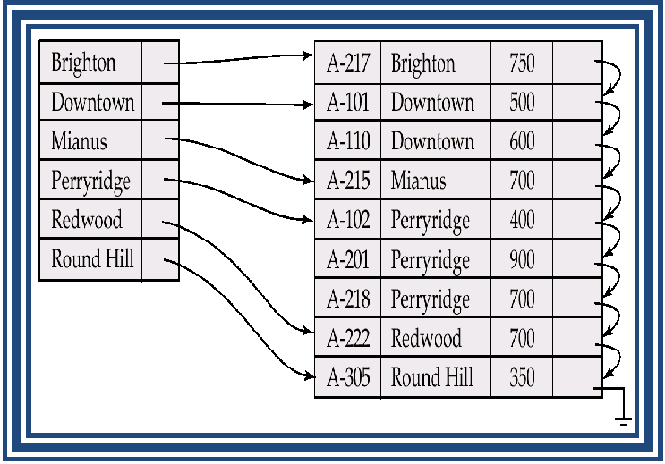

Figure Dense Index

Sparse Index Files

- Sparse Index: contains index records for only some search-key values. o Applicable when records are sequentially ordered on search-key

- To locate a record with search-key value K we:

  - Find index record with largest search-key value < K

  - Search file sequentially starting at the record to which the index record points

- Less space and less maintenance overhead for insertions and deletions.

- Generally slower than dense index for locating records.

- Good tradeoff: sparse index with an index entry for every block in file, corresponding to least search-key value in the block.

Example of Sparse Index Files

Figure Sparse Index
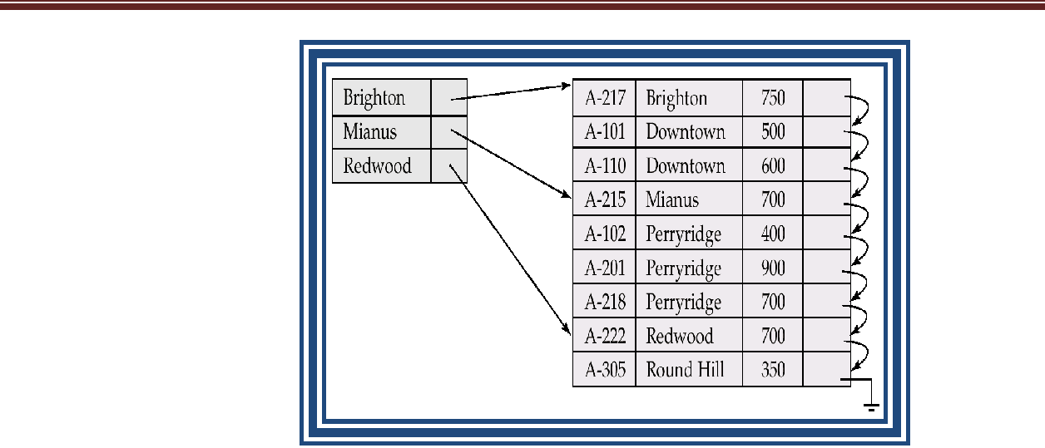

Secondary Indices

- Frequently, one wants to find all the records whose values in a certain field (which is not the search-key of the primary index satisfy some condition.

o Example 1: In the account database stored sequentially by account number, we may want to find all accounts in a particular branch

o Example 2: as above, but where we want to find all accounts with a specified balance or range of balances

- We can have a secondary index with an index record for each search-key value; index record points to a bucket that contains pointers to all the actual records with that particular search-key value.

Secondary Index on balance field of account
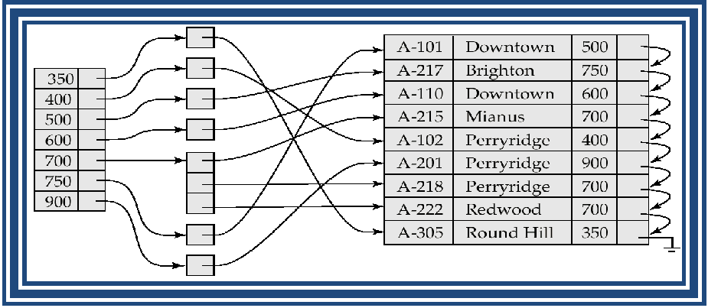

Figure Secondary Index on account file, on noncandidate key balance

Primary and Secondary Indices

- Secondary indices have to be dense.

- Indices offer substantial benefits when searching for records.

- When a file is modified, every index on the file must be updated, Updating indices imposes overhead on database modification.

- Sequential scan using primary index is efficient, but a sequential scan using a secondary index is expensive

o each record access may fetch a new block from disk

- If primary index does not fit in memory, access becomes expensive.

- To reduce number of disk accesses to index records, treat primary index kept on disk as a sequential file and construct a sparse index on it.

o outer index – a sparse index of primary index o inner index – the primary index file

- If even outer index is too large to fit in main memory, yet another level of index can be created, and so on.

- Indices at all levels must be updated on insertion or deletion from the file.
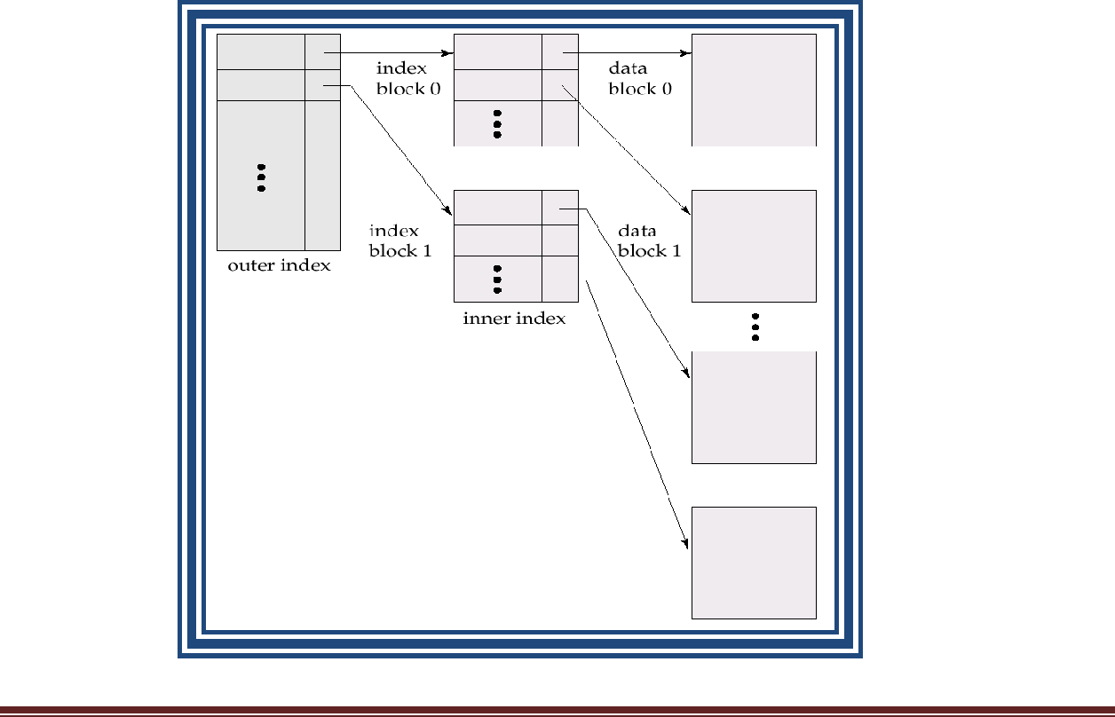

Index Update: Deletion

- If deleted record was the only record in the file with its particular search-key value, the search-key is deleted from the index also.

- Single-level index deletion:

- Dense indices – deletion of search-key is similar to file record deletion.

- Sparse indices – if an entry for the search key exists in the index, it is deleted by replacing the entry in the index with the next search-key value in the file (in search-key order). If the next search-key value already has an index entry, the entry is deleted instead of being replaced.

Index Update: Insertion

- Single-level index insertion:

  - Perform a lookup using the search-key value appearing in the record to be inserted.

  - Dense indices – if the search-key value does not appear in the index, insert it.

  - Sparse indices – if index stores an entry for each block of the file, no change needs to be made to the index unless a new block is created. In this case, the first search-key value appearing in the new block is inserted into the index.

- Multilevel insertion (as well as deletion) algorithms are simple extensions of the single-level algorithms

___________________________________________________________________________

B⁺-Tree Index Files

B⁺-tree indices are an alternative to indexed-sequential files.

- Disadvantage of indexed-sequential files: performance degrades as file grows, since many overflow blocks get created. Periodic reorganization of entire file is required.
- Advantage of B⁺-tree index files: automatically reorganizes itself with small, local, changes, in the face of insertions and deletions. Reorganization of entire file is not required to maintain performance.

- Disadvantage of B⁺-trees: extra insertion and deletion overhead, space overhead.

- Advantages of B⁺-trees outweigh disadvantages, and they are used extensively.

A B⁺-tree is a rooted tree satisfying the following properties:

- All paths from root to leaf are of the same length

- Each node that is not a root or a leaf has between [n/2] and n children.

- A leaf node has between [(n–1)/2] and n–1 values

- Special cases:

- If the root is not a leaf, it has at least 2 children.

- If the root is a leaf (that is, there are no other nodes in the tree), it can have between 0 and (n–1) values.

B⁺-Tree Node Structure

Figure typical node of a B⁺-Tree
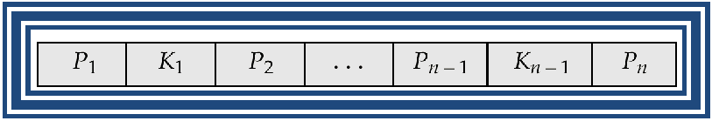

  - K_{i} are the search-key values

  - P_{i} are pointers to children (for non-leaf nodes) or pointers to records or buckets of records (for leaf nodes).

- The search-keys in a node are ordered

    - K₁ < K₂ < K₃ < . . . < K_{n–1}

Leaf Nodes in B⁺-Trees

Properties of a leaf node:

- For i = 1, 2, . . ., n–1, pointer P_{i} either points to a file record with search-key value K_{i}, or to a bucket of pointers to file records, each record having search-key value K_{i}. Only need

bucket structure if search-key does not form a primary key.

- If L_{i}, L_{j} are leaf nodes and i < j, L_{i}’s search-key values are less than L_{j}’s search-key values

- P_{n} points to next leaf node in search-key order

Figure A leaf node for account B⁺-Trees index (n=3)
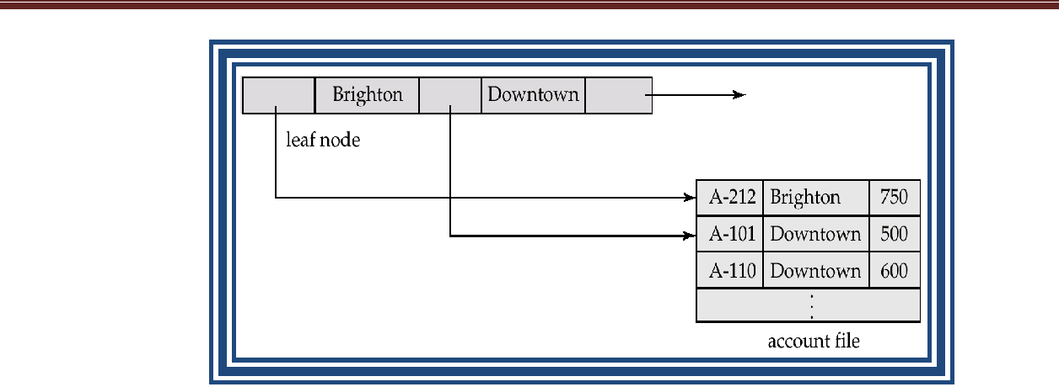

Non-Leaf Nodes in B⁺-Trees

- Non leaf nodes form a multi-level sparse index on the leaf nodes. For a non-leaf node

with m pointers:

o All the search-keys in the subtree to which P₁ points are less than K₁

o For 2 ≤ i ≤ n – 1, all the search-keys in the subtree to which P_{i} points have values greater than or equal to K_{i–1} and less than K_{m–1}
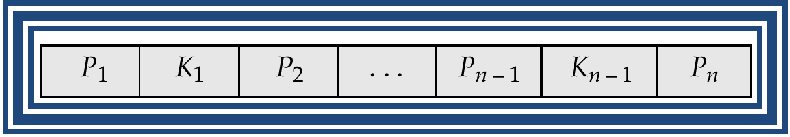

Example of a B⁺-tree
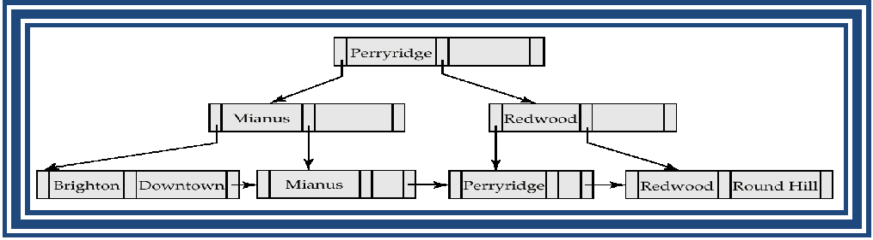

Figure B⁺-tree for account file (n = 3)

Figure B⁺-tree for account file (n = 5)
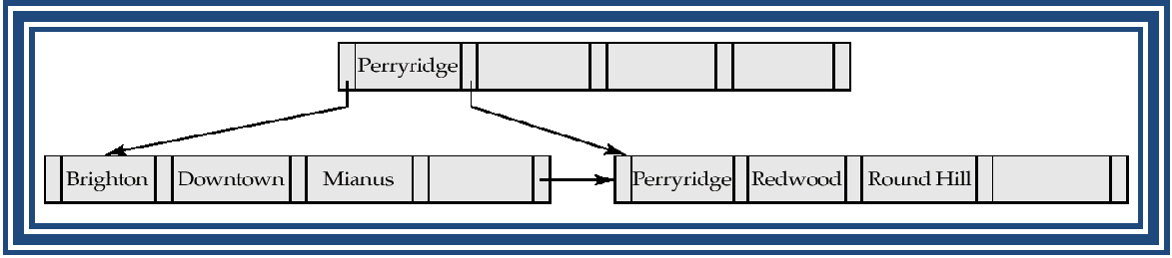

- Leaf nodes must have between 2 and 4 values ( (n–1)/2 and n –1, with n = 5).

- Non-leaf nodes other than root must have between 3 and 5 children ( (n/2 and n with n =5).

- Root must have at least 2 children.

Observations about B⁺-trees

- Since the inter-node connections are done by pointers, “logically” close blocks need not be “physically” close.

- The non-leaf levels of the B⁺-tree form a hierarchy of sparse indices.

- The B⁺-tree contains a relatively small number of levels (logarithmic in the size of the main file), thus searches can be conducted efficiently.

- Insertions and deletions to the main file can be handled efficiently, as the index can be restructured in logarithmic time.

Queries on B⁺-Trees

- Find all records with a search-key value of k. o Start with the root node

Examine the node for the smallest search-key value > k.

If such a value exists, assume it is K_{j}. Then follow P_{i} to the child node Otherwise k ≥ K_{m–1}, where there are m pointers in the node. Then follow

- If the node reached by following the pointer above is not a leaf node, repeat the above procedure on the node, and follow the corresponding pointer.

  - Eventually reach a leaf node. If for some i, key K_{i} = k follow pointer P_{i} to the desired record or bucket. Else no record with search-key value k exists.
- In processing a query, a path is traversed in the tree from the root to some leaf node.
- If there are K search-key values in the file, the path is no longer than log _{n/2} (K) .

procedure find(value V )

set C = root node

while C is not a leaf node begin

Let Ki = smallest search-key value, if any, greater than V if there is no such value then begin

Let m = the number of pointers in the node

set C = node pointed to by Pm

end

else set C = the node pointed to by Pi

end

if there is a key value Ki in C such that Ki = V

then pointer Pi directs us to the desired record or bucket else no record with key value k exists

end procedure

Updates on B⁺-Trees: Insertion

- Find the leaf node in which the search-key value would appear

- If the search-key value is already there in the leaf node, record is added to file and if necessary a pointer is inserted into the bucket.

- If the search-key value is not there, then add the record to the main file and create a bucket if necessary. Then:

o If there is room in the leaf node, insert (key-value, pointer) pair in the leaf node o Otherwise, split the node (along with the new (key-value, pointer) entry) as

discussed in the next slide.

- Splitting a node:

  - take the n(search-key value, pointer) pairs (including the one being inserted) in sorted order. Place the first n/2 in the original node, and the rest in a new node.

  - let the new node be p, and let k be the least key value in p. Insert (k,p) in the parent of the node being split. If the parent is full, split it and propagate the split further up.

- The splitting of nodes proceeds upwards till a node that is not full is found. In the worst case the root node may be split increasing the height of the tree by 1.
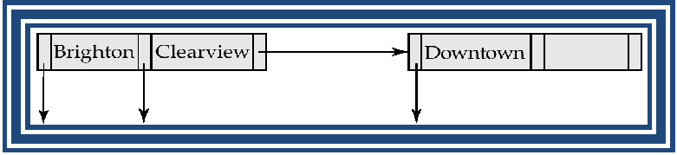

Figure Result of splitting node containing Brighton and Downtown on inserting Clearview
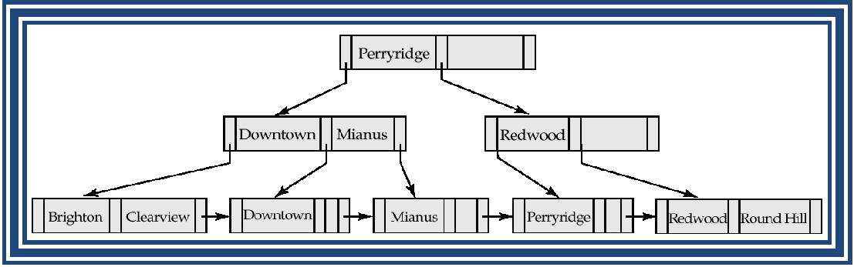

Figure B⁺-Tree before and after insertion of “Clearview” Updates on B⁺-Trees: Deletion

- Find the record to be deleted, and remove it from the main file and from the bucket (if present)

- Remove (search-key value, pointer) from the leaf node if there is no bucket or if the bucket has become empty

- If the node has too few entries due to the removal, and the entries in the node and a sibling fit into a single node, then

o Insert all the search-key values in the two nodes into a single node (the one on the left), and delete the other node.

  - Delete the pair (K_{i–1}, P_{i}), where P_{i} is the pointer to the deleted node, from its parent, recursively using the above procedure.

- Otherwise, if the node has too few entries due to the removal, and the entries in the node and a sibling fit into a single node, then

  - Redistribute the pointers between the node and a sibling such that both have more than the minimum number of entries.

  - Update the corresponding search-key value in the parent of the node.

- The node deletions may cascade upwards till a node which has n/2 or more pointers is found. If the root node has only one pointer after deletion, it is deleted and the sole child becomes the root.

Examples of B⁺-Tree Deletion
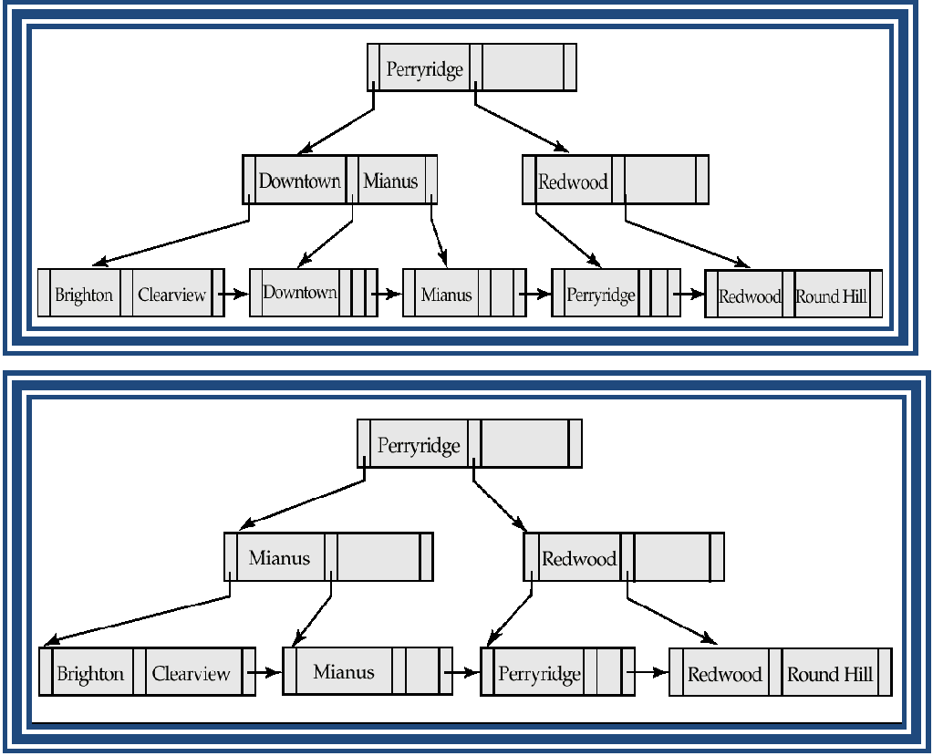

Figure Before and after deleting “Downtown”

- The removal of the leaf node containing “Downtown” did not result in its parent having too little pointers. So the cascaded deletions stopped with the deleted leaf node’s parent.

Figure Deletion of “Perryridge” from result of previous example
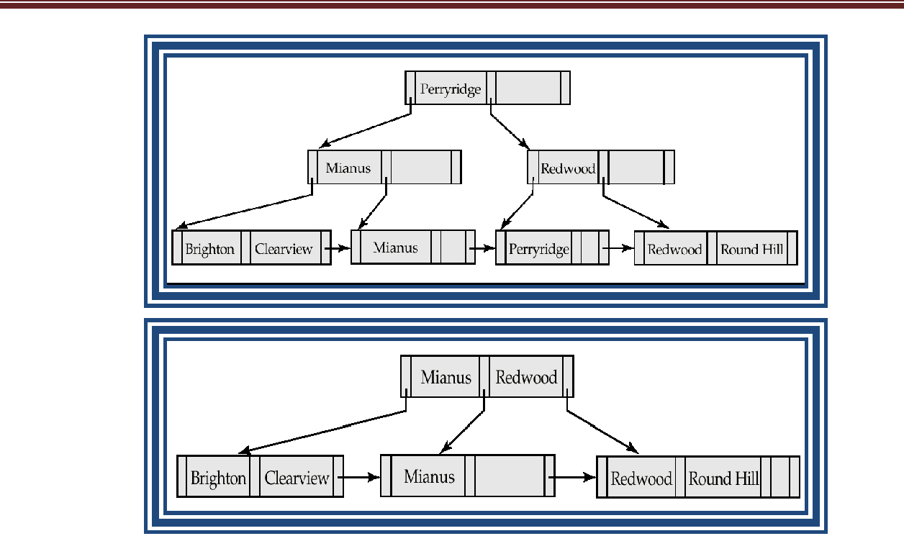

- Node with “Perryridge” becomes underfull (actually empty, in this special case) and merged with its sibling.

- As a result “Perryridge” node’s parent became underfull, and was merged with its sibling (and an entry was deleted from their parent)

- Root node then had only one child, and was deleted and its child became the new root node
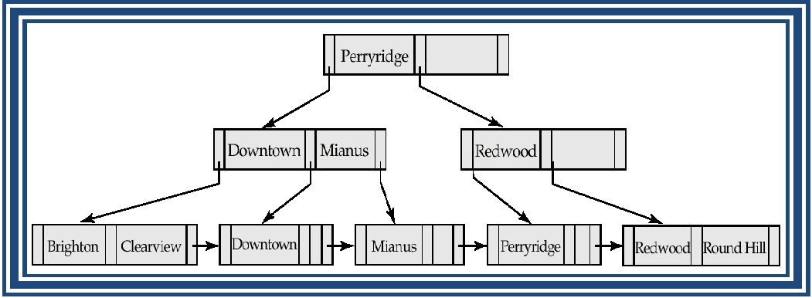

»

Figure Before and after deletion of “Perryridge” from earlier example
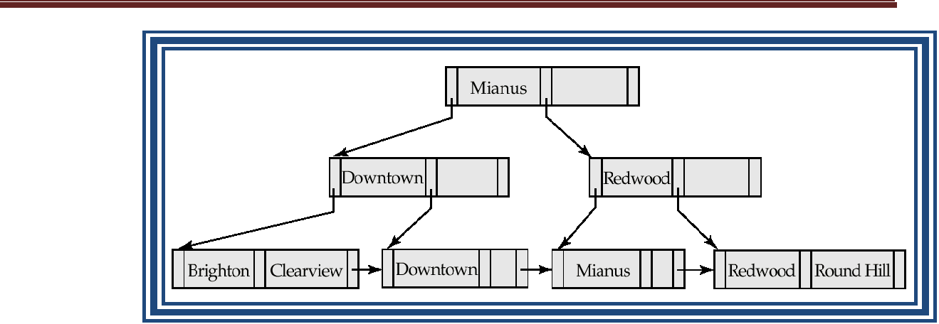

- Parent of leaf containing Perryridge became underfull, and borrowed a pointer from its left sibling

- Search-key value in the parent’s parent changes as a result

- Similar to B+-tree, but B-tree allow search-key values to appear only once; eliminates redundant storage of search keys.

- Search keys in nonleaf nodes appear nowhere else in the B-tree; an additional pointer field for each search key in a nonleaf node must be included.

- Generalized B-tree leaf node
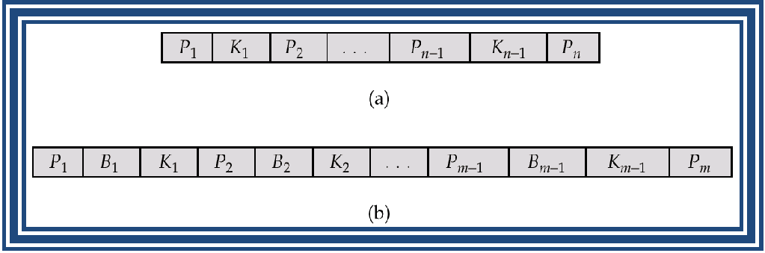

- Nonleaf node – pointers B_{i} is the bucket or file record pointers.

B-Tree Index File Example

- Advantages of B-Tree indices:
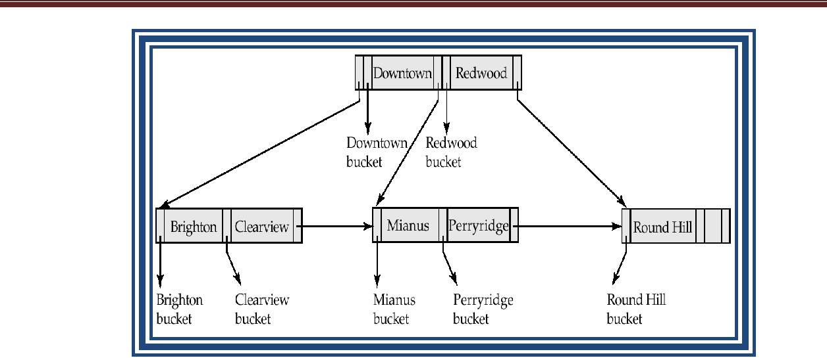

  - May use less tree nodes than a corresponding B⁺-Tree.

  - Sometimes possible to find search-key value before reaching leaf node.

- Disadvantages of B-Tree indices:

  - Only small fraction of all search-key values are found early

  - Non-leaf nodes are larger, so fan-out is reduced. Thus, B-Trees typically have greater depth than corresponding B⁺-Tree

  - Insertion and deletion more complicated than in B⁺-Trees

  - Implementation is harder than B⁺-Trees.

- Typically, advantages of B-Trees do not outweigh disadvantages.

______________________________________________________________________________

Hashing Techniques

Introduction

  - One disadvantage of sequential file organization is that we must access an index structure to locate data or must use binary search, and that results in more I/O operation.

- File Organization based on the technique of hashing allow us to avoid accessing an index structure.

- Hashing also provide a way of constructing indices.

Types

- Static Hashing

- Dynamic Hashing

Static Hashing

- A bucket is a unit of storage containing one or more records (a bucket is typically a disk block).

- In a hash file organization we obtain the bucket of a record directly from its search-key value using a hash function.

- Hash function h is a function from the set of all search-key values K to the set of all bucket addresses B.

- Hash function is used to locate records for access, insertion as well as deletion.

- Records with different search-key values may be mapped to the same bucket; thus entire bucket has to be searched sequentially to locate a record.

Hash Functions

- Worst has function maps all search-key values to the same bucket; this makes access time proportional to the number of search-key values in the file.

- An ideal hash function is uniform, i.e., each bucket is assigned the same number of search-key values from the set of all possible values.

- Ideal hash function is random, so each bucket will have the same number of records assigned to it irrespective of the actual distribution of search-key values in the file.

- Typical hash functions perform computation on the internal binary representation of the search-key.

o For example, for a string search-key, the binary representations of all the characters in the string could be added and the sum modulo the number of buckets could be returned. .

Handling of Bucket Overflows

- Bucket overflow can occur because of o Insufficient buckets

o Skew in distribution of records. This can occur due to two reasons:

multiple records have same search-key value

chosen hash function produces non-uniform distribution of key values

- Although the probability of bucket overflow can be reduced, it cannot be eliminated; it is handled by using overflow buckets.

- Overflow chaining – the overflow buckets of a given bucket are chained together in a linked list.

- Above scheme is called closed hashing.

- An alternative, called open hashing, which does not use overflow buckets, is not suitable for database applications.
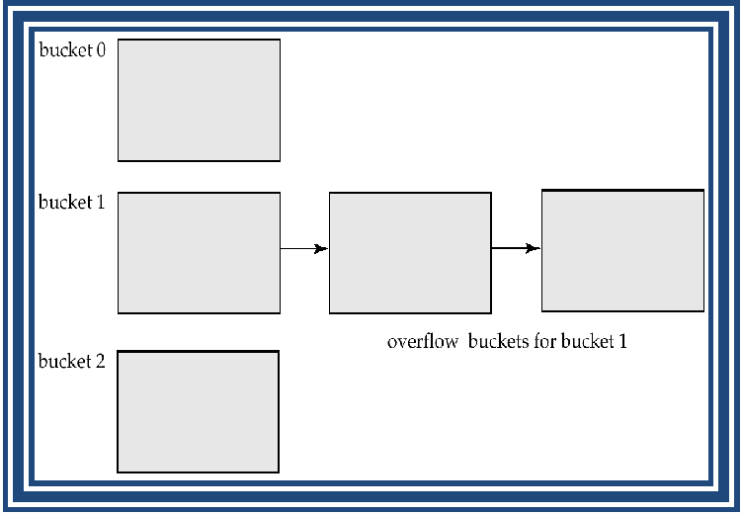

Figure Overflow chaining in a hash structure

Hash Indices

- Hashing can be used not only for file organization, but also for index-structure creation.

- A hash index organizes the search keys, with their associated record pointers, into a hash file structure.

- Strictly speaking, hash indices are always secondary indices

- if the file itself is organized using hashing, a separate primary hash index on it using the same search-key is unnecessary.

- However, we use the term hash index to refer to both secondary index structures and hash organized files.

Example of Hash Index

Figure Hash index on search key account_number of account file
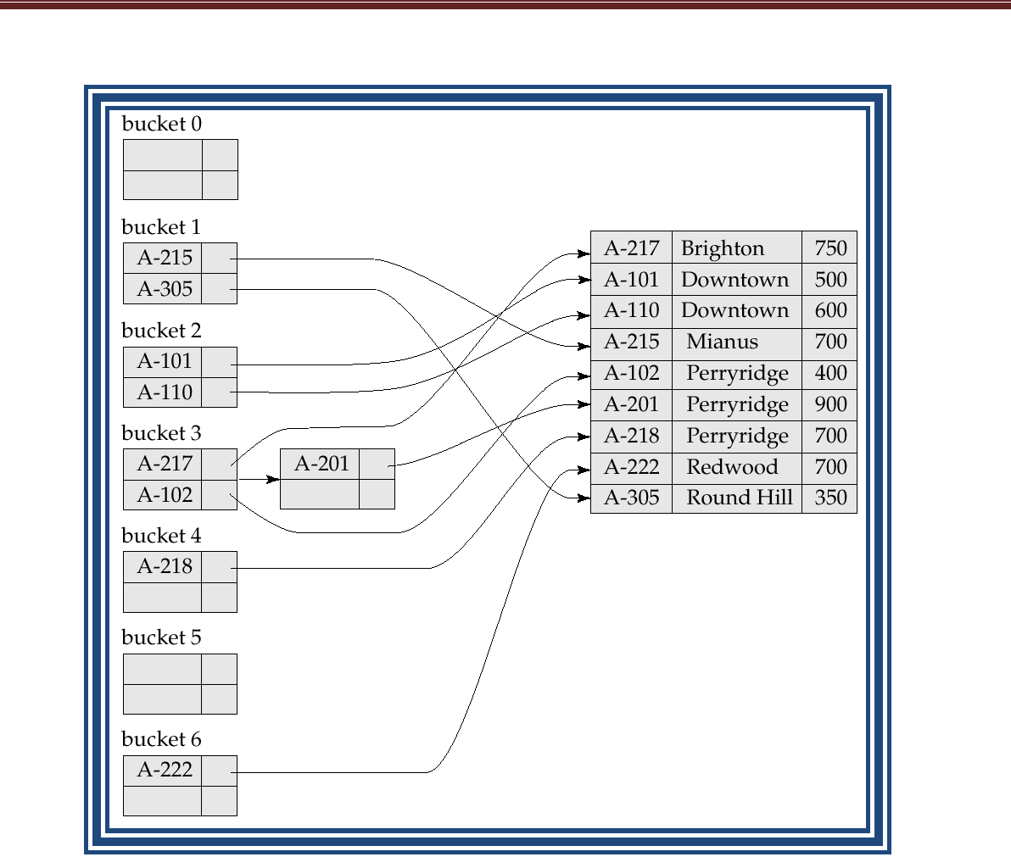

Deficiencies of Static Hashing

- In static hashing, function h maps search-key values to a fixed set of B of bucket addresses.

o Databases grow with time. If initial number of buckets is too small, performance will degrade due to too much overflows.

o If file size at some point in the future is anticipated and number of buckets allocated accordingly, significant amount of space will be wasted initially.

o If database shrinks, again space will be wasted.

o One option is periodic re-organization of the file with a new hash function, but it is very expensive.

- These problems can be avoided by using techniques that allow the number of buckets to be modified dynamically.

Dynamic Hashing

- Good for database that grows and shrinks in size

- Allows the hash function to be modified dynamically

- Extendable hashing – one form of dynamic hashing

- Hash function generates values over a large range — typically b-bit integers, with b =32.

- At any time use only a prefix of the hash function to index into a table of bucket addresses.

- Let the length of the prefix be i bits, 0 ≤ i ≤ 32.

- Bucket address table size = 2^{i.} Initially i = 0

- Value of i grows and shrinks as the size of the database grows and shrinks.

- Multiple entries in the bucket address table may point to a bucket.

- Thus, actual number of buckets is < 2^{i}

The number of buckets also changes dynamically due to coalescing and splitting of buckets.

General Extendable Hash Structure

- In this structure, i₂ = i₃ = i, whereas i₁ = i – 1
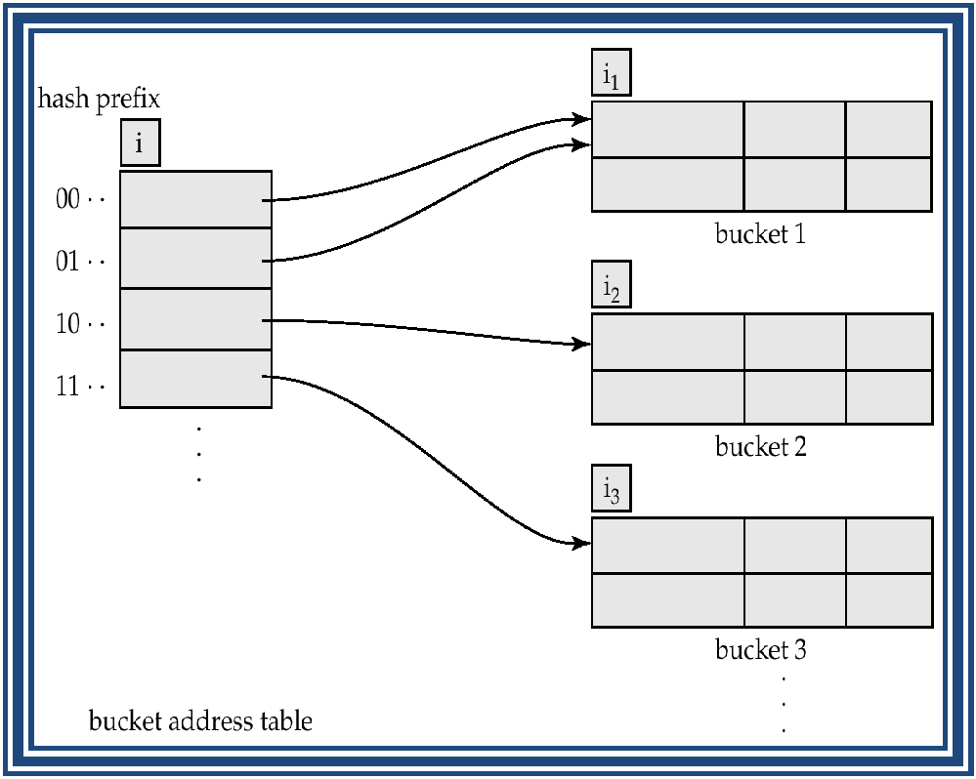

Figure General extendable hash structure

Use of Extendable Hash Structure

- Each bucket j stores a value i_{j}; all the entries that point to the same bucket have the same values on the first i_{j} bits.

- To locate the bucket containing search-key K_{j}:

  - Compute h(K_{j}) = X

- Use the first i high order bits of X as a displacement into bucket address table, and follow the pointer to appropriate bucket
- To insert a record with search-key value K_{j}

  - Follow same procedure as look-up and locate the bucket, say j.

  - If there is room in the bucket j inserts record in the bucket.

  - Else the bucket must be split and insertion re-attempted Overflow buckets used instead in some cases

  - To split a bucket j when inserting record with search-key value K_{j}:

- If i > i_{j} (more than one pointer to bucket j)

  - Allocate a new bucket z, and set i_{j} and i_{z} to the old i_{j} -+ 1.

  - make the second half of the bucket address table entries pointing to j to point to z

  - Remove and reinsert each record in bucket j.

  - recompute new bucket for K_{j} and insert record in the bucket (further splitting is required if the bucket is still full)
- If i = i_{j} (only one pointer to bucket j)

  - Increment i and double the size of the bucket address table.

  - Replace each entry in the table by two entries that point to the same bucket.

  - recompute new bucket address table entry for K_{j} Now i > i_{j} so use the first case above.

- When inserting a value, if the bucket is full after several splits (that is, i reaches some limit b) create an overflow bucket instead of splitting bucket entry table further.

- To delete a key value,

  - Locate it in its bucket and remove it.

  - The bucket itself can be removed if it becomes empty (with appropriate updates to the bucket address table).

  - Coalescing of buckets can be done (can coalesce only with a “buddy” bucket having same value of i_{j} and same i_{j} –1 prefix, if it is present)

  - Decreasing bucket address table size is also possible

Note: decreasing bucket address table size is an expensive operation and should be done only if number of buckets becomes much smaller than the size of the table

Use of Extendable Hash Structure: Example

Figure Hash Function for branch_name
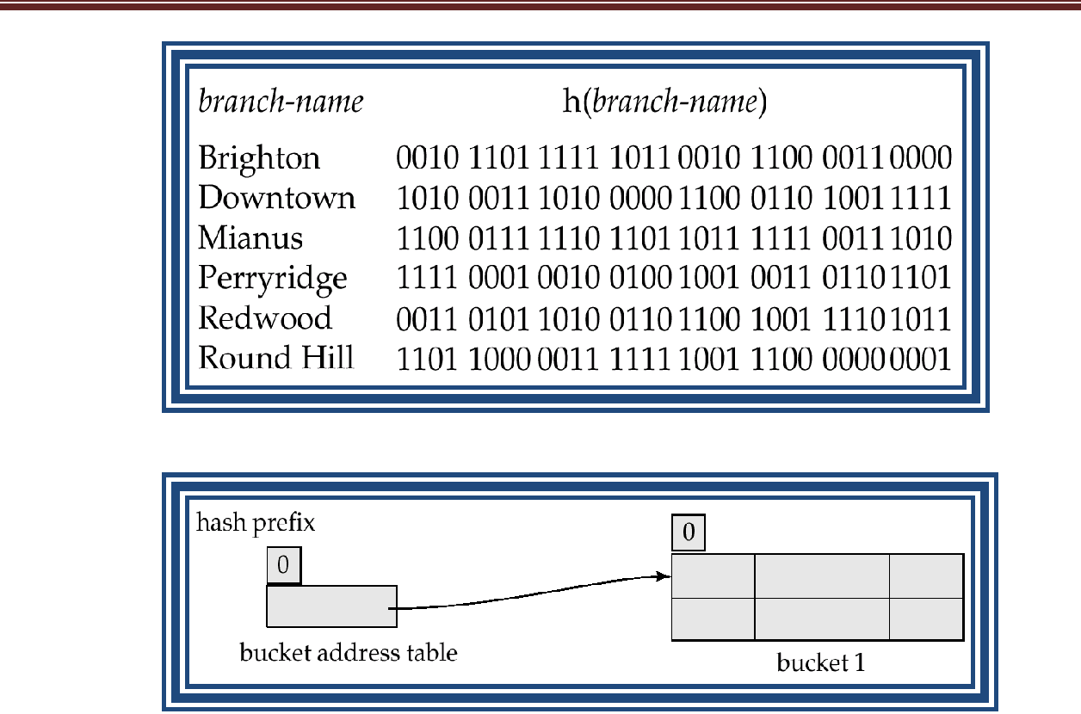

Figure Initial Hash structure, bucket size = 2

- Hash structure after insertion of one Brighton and two Downtown records
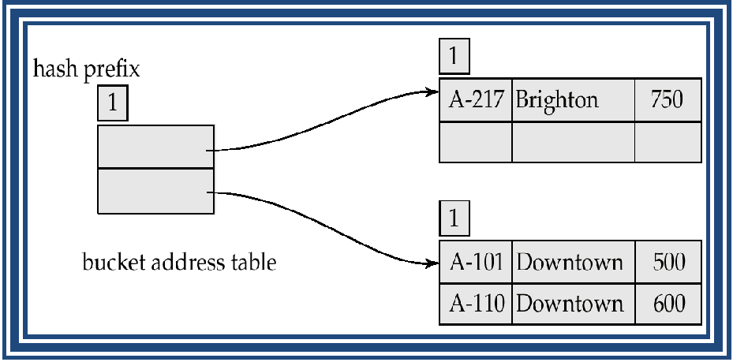

- Hash structure after insertion of Mianus record

- Hash structure after insertion of three Perryridge records
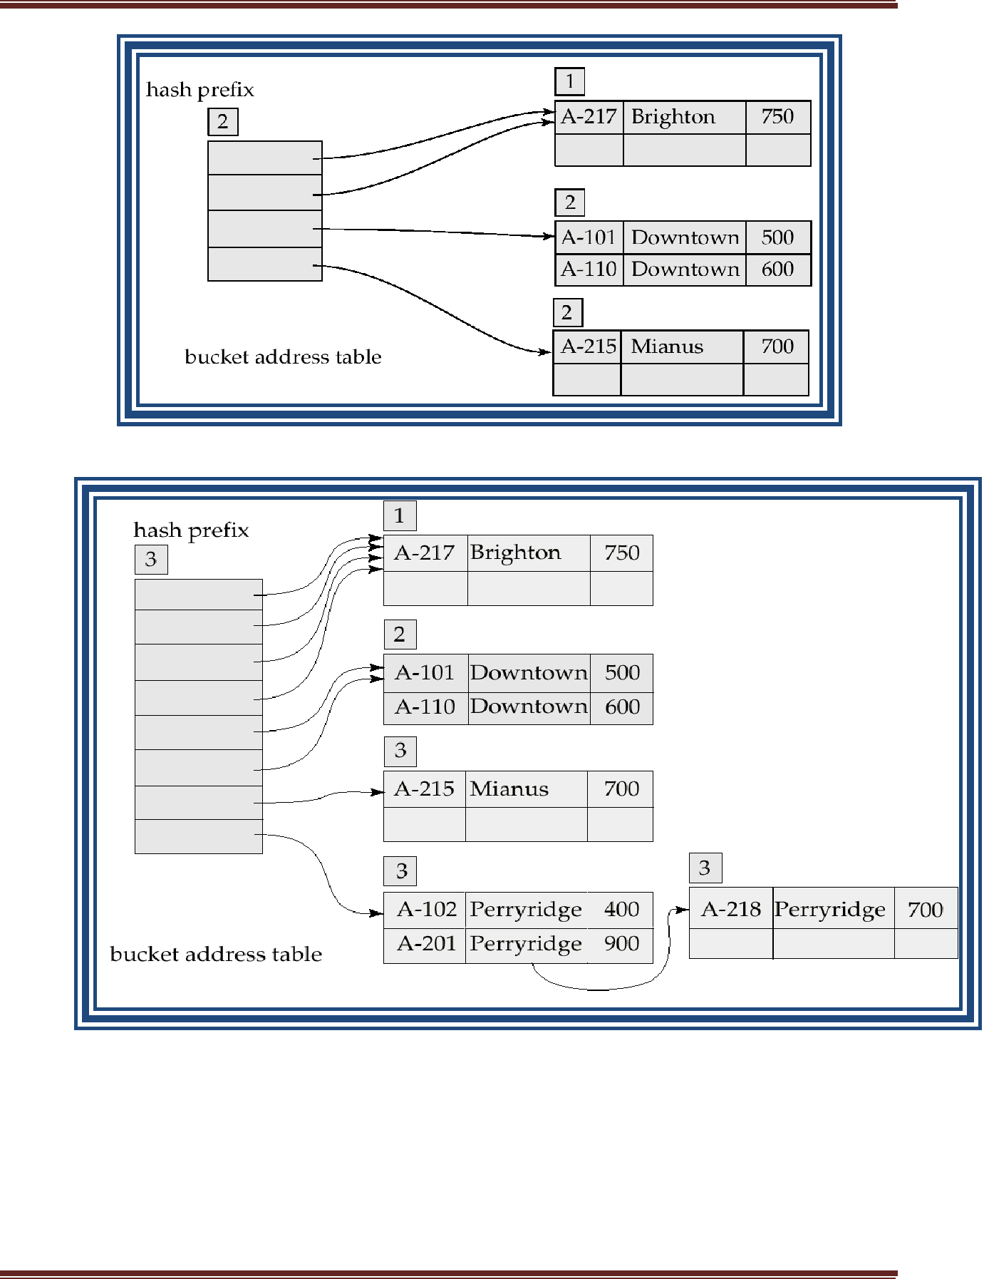

- Hash structure after insertion of Redwood and Round Hill records
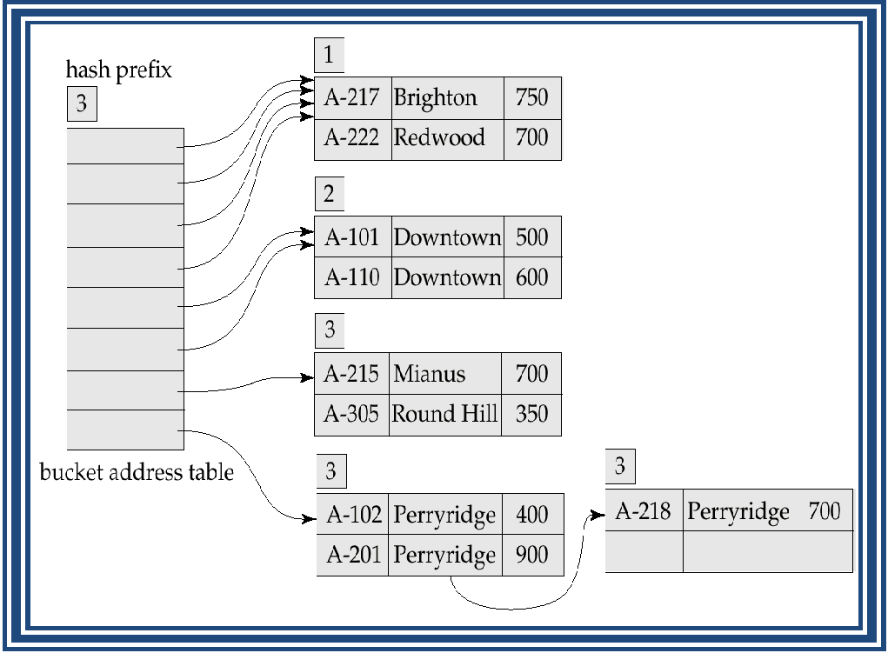

Extendable Hashing vs. Other Schemes

- Benefits of extendable hashing:

  - Hash performance does not degrade with growth of file

  - Minimal space overhead

- Disadvantages of extendable hashing

  - Extra level of indirection to find desired record

  - Bucket address table may itself become very big (larger than memory) Need a tree structure to locate desired record in the structure!
  - Changing size of bucket address table is an expensive operation

- Linear hashing is an alternative mechanism which avoids these disadvantages at the possible cost of more bucket overflows

Comparison of Ordered Indexing and Hashing

- Cost of periodic re-organization

- Relative frequency of insertions and deletions

- Is it desirable to optimize average access time at the expense of worst-case access time?

- Expected type of queries:

- Hashing is generally better at retrieving records having a specified value of the key.

- If range queries are common, ordered indices are to be preferred

Query Processing

Overview

Measures of Query Cost Selection Operation
Sorting

Join Operation

Other Operations

Evaluation of Expressions

- Parsing and translation

- Optimization

- Evaluation

- Parsing and translation
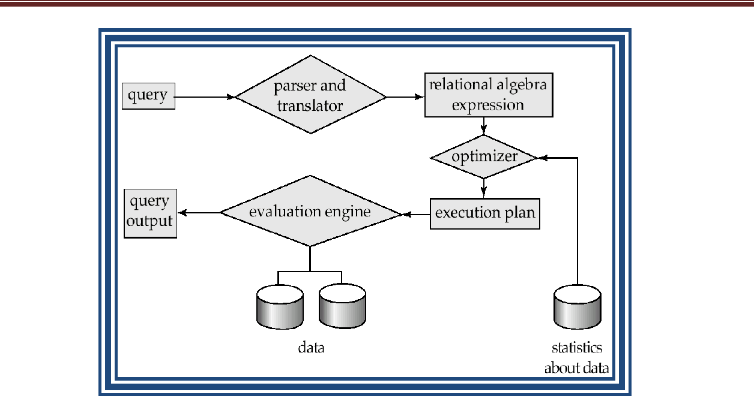

  - Translate the query into its internal form. This is then translated into relational algebra.

  - Parser checks syntax, verifies relations

- Evaluation

  - The query-execution engine takes a query-evaluation plan, executes that plan, and returns the answers to the query.

Basic Steps in Query Processing: Optimization

- A relational algebra expression may have many equivalent expressions E.g., σ_{balance<2500}(∏_{balance}(account)) is equivalent to
∏balance(σbalance<2500(account))

- Each relational algebra operation can be evaluated using one of several different algorithms

o Correspondingly, a relational-algebra expression can be evaluated in many ways.

- Annotated expression specifying detailed evaluation strategy is called an evaluation-plan.

o E.g., can use an index on balance to find accounts with balance < 2500,

or can perform complete relation scan and discard accounts with balance ≥ 2500

Figure A query evaluation plan
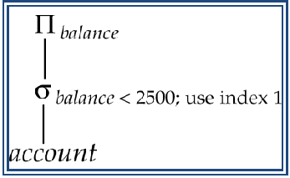

- Query Optimization: Amongst all equivalent evaluation plans choose the one with lowest cost.

o Cost is estimated using statistical information from the database catalog Example: number of tuples in each relation, size of tuples, etc.

- In this Query Processing we study

How to measure query costs

Algorithms for evaluating relational algebra operations

How to combine algorithms for individual operations in order to evaluate a complete expression

We study how to optimize queries, that is, how to find an evaluation plan with lowest estimated cost

Measures of Query Cost

- Cost is generally measured as total elapsed time for answering query o Many factors contribute to time cost

disk accesses, CPU, or even network communication

- Typically disk access is the predominant cost, and is also relatively easy to estimate. Measured by taking into account
o Number of seeks * average-seek-cost

o Number of blocks read * average-block-read-cost

- Number of blocks written * average-block-write-cost

Cost to write a block is greater than cost to read a block

    - data is read back after being written to ensure that the write was successful

- For simplicity we just use number of block transfers from disk as the cost measure

- Costs depends on the size of the buffer in main memory

- Real systems take CPU cost into account, differentiate between sequential and random I/O, and take buffer size into account

- We do not include cost to writing output to disk in our cost formulae

Selection Operation

- File scan – search algorithms that locate and retrieve records that fulfill a selection condition.

- Algorithm A1 (linear search). Scan each file block and test all records to see whether

they satisfy the selection condition.

o Cost estimate = b_{r} block transfers + 1 seek

b_{r} denotes number of blocks containing records from relation r

  - If selection is on a key attribute, can stop on finding record cost = (b_{r} /2) block transfers + 1 seek

  - Linear search can be applied regardless of selection condition or

ordering of records in the file, or availability of indices

- A2 (binary search). Applicable if selection is an equality comparison on the attribute on which file is ordered.

o Assume that the blocks of a relation are stored contiguously o Cost estimate (number of disk blocks to be scanned):

cost of locating the first tuple by a binary search on the blocks

– log₂(b_{r}) * (t_{T} + t_{S})

If there are multiple records satisfying selection

– Add transfer cost of the number of blocks containing records that satisfy selection condition

Selections Using Indices

- Index scan – search algorithms that use an index

Selection condition must be on search-key of index.

- A3 (primary index on candidate key, equality). Retrieve a single record that satisfies the

corresponding equality condition Cost = (h_{i} + 1) * (t_{T} + t_{S})

- A4 (primary index on nonkey, equality) Retrieve multiple records.

Records will be on consecutive blocks

    - Let b = number of blocks containing matching records

Cost = h_{i} * (t_{T} + t_{S}) + t_{S} + t_{T} * b

- A5 (equality on search-key of secondary index).

Retrieve a single record if the search-key is a candidate key

    - Cost = (h_{i} + 1) * (t_{T} + t_{S})

Retrieve multiple records if search-key is not a candidate key

    - each of n matching records may be on a different block

    - Cost = (h_{i} + n) * (t_{T} + t_{S})

– Can be very expensive

- Can implement selections of the form σ_{A≤V} (r) or σ_{A} ≥ _{V}(r) by using o a linear file scan or binary search,

o or by using indices in the following ways:

- A6 (primary index, comparison). (Relation is sorted on A)
For σ_{A} ≥ _{V}(r) use index to find first tuple ≥ v and scan relation sequentially

from there

For σ_{A≤V} (r) just scan relation sequentially till first tuple > v; do not use index

- A7 (secondary index, comparison).

For σ_{A} ≥ _{V}(r) use index to find first index entry ≥ v and scan index sequentially from there, to find pointers to records.

For σ_{A≤V} (r) just scan leaf pages of index finding pointers to records, till first entry > v

In either case, retrieve records that are pointed to

– requires an I/O for each record

– Linear file scan may be cheaper

Implementation of Complex Selections
Conjunction: σ_{θ1} _{θ2} . . . _{θn}(r)

- A8 (conjunctive selection using one index).

  - Select a combination of θ_{i} and algorithms A1 through A7 that results in the least cost for σ_{θi} (r).

  - Test other conditions on tuple after fetching it into memory buffer.

- A9 (conjunctive selection using multiple-key index).

  - Use appropriate composite (multiple-key) index if available.

- A10 (conjunctive selection by intersection of identifiers).

  - Requires indices with record pointers.

  - Use corresponding index for each condition, and take intersection of all the obtained sets of record pointers.

  - Then fetch records from file

  - If some conditions do not have appropriate indices, apply test in memory.

Disjunction:σ_{θ1} _{θ2} . . . _{θn} (r).

- A11 (disjunctive selection by union of identifiers).

  - Applicable if all conditions have available indices. Otherwise use linear scan.

  - Use corresponding index for each condition, and take union of all the obtained sets of record pointers.

  - Then fetch records from file
- Negation: σ_{¬θ}(r)

  - Use linear scan on file
  - If very few records satisfy ¬θ, and an index is applicable to θ

Find satisfying records using index and fetch from file

Sorting

- We may build an index on the relation, and then use the index to read the relation in sorted order. May lead to one disk block access for each tuple.

- For relations that fit in memory, techniques like quicksort can be used. For relations that don’t fit in memory, external sort-merge is a good choice.

External Sort-Merge

  - Let M denote memory size (in pages).

- Create sorted runs.

- Read M blocks of relation into memory

- Sort the in-memory blocks

- Write sorted data to run R_{i}; increment i.

Let the final value of i be N

- Merge the runs (N-way merge). We assume (for now) that N < M.

o Use N blocks of memory to buffer input runs, and 1 block to buffer output. Read the first block of each run into its buffer page

o repeat

Select the first record (in sort order) among all buffer pages

Write the record to the output buffer. If the output buffer is full write it to disk.

Delete the record from its input buffer page. If the buffer page becomes empty then

read the next block (if any) of the run into the buffer.

- until all input buffer pages are empty:

- If N ≥ M, several merge passes are required.

  - In each pass, contiguous groups of M - 1 runs are merged.

  - A pass reduces the number of runs by a factor of M -1, and creates runs longer by the same factor.

E.g. If M=11, and there are 90 runs, one pass reduces the number of runs

to 9, each 10 times the size of the initial runs

- Repeated passes are performed till all runs have been merged into one.

Example: External Sorting Using Sort-Merge
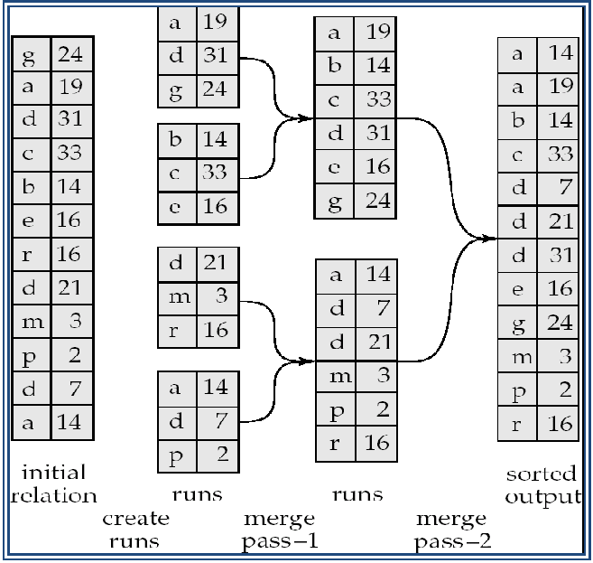

- Cost analysis:

- Total number of merge passes required: log_{M–1}(b_{r}/M) .

- Block transfers for initial run creation as well as in each pass is 2b_{r} for final pass, we don’t count write cost

    - we ignore final write cost for all operations since the output of an operation may be sent to the parent operation without being written to disk

Thus total number of block transfers for external sorting:

b_{r} ( 2 log_{M–1}(b_{r} / M) + 1)

- Cost of seeks

- During run generation: one seek to read each run and one seek to write each run

2 b_{r} / M

- During the merge phase

Buffer siz e: b_{b} (read/wwrite b_{b} blockks at a time) Need 2 b_{r} / b_{b} seeks for each merge pass

    - exccept the final one which does not reqquire a write Total number of seekss:

2 b_{r} / M + b_{r} / b_{b} (2 log_{M–1}(b_{r} / M) -1)

Join Opeeration

- Several differrent algorithms to implement joins

  - Nested-loop join

  - Block nested-loopp join

  - Indexed nested-loop join

  - Mergee-join

  - Hash-join

- Choice based on cost estimate

- E xamples usee the followiing information

o | Numbber of recordds of customeer: |  |  |  |  |  | 10,000 | depositor: 5000
o | Numbber of blockss of | customer: |  |  |  |  | 400 | depositor: 100
Nested-Loop Join
» T o compute the theta joinn |  | r |  |  |  | θ s

foor each tuple t_{r} in r do begin

for eaach tuple t_{s} in s do begiin

test pair (t_{r},t_{s}) to see if they satisfy the join conndition θ if they do, add t_{r} • t_{s} to the result.

end

e nd

- r is called the outer relation and s thhe inner relation of the join.

- Requires no indices and can be used with any kinnd of join condition.

- E xpensive sinnce it exami nes every paair of tuples in the two reelations.

- In the worst case, if there is enough memory only to hold one block of each relation, the estimated cost is

n_{r} b_{s} + b_{r}

block transfers, plus

n_{r} + b_{r}

seeks

- If the smaller relation fits entirely in memory, use that as the inner relation. o Reduces cost to b_{r} + b_{s} block transfers and 2 seeks

- Assuming worst case memory availability cost estimate is

  - with depositor as outer relation:

5000 400 + 100 = 2,000,100 block transfers, 5000 + 100 = 5100 seeks

  - with customer as the outer relation

10000 100 + 400 = 1,000,400 block transfers and 10,400 seeks

- If smaller relation (depositor) fits entirely in memory, the cost estimate will be 500 block transfers.

Block Nested-Loop Join

- Variant of nested-loop join in which every block of inner relation is paired with every block of outer relation.

- for each block B_{r} of r do begin

for each block B_{s} of s do begin

for each tuple t_{r} in B_{r} do begin

for each tuple t_{s} in B_{s} do begin

Check if (t_{r},t_{s}) satisfy the join

condition

if they do, add t_{r} • t_{s} to the

result.

end

end

end

end

- Worst case estimate: b_{r} b_{s} + b_{r} block transfers + 2 * b_{r} seeks

- Best case: b_{r} + b_{s} block transfers + 2 seeks.

Indexed Nested-Loop Join

- Index lookups can replace file scans if

  - join is an equi-join or natural join and

  - an index is available on the inner relation’s join attribute

- For each tuple t_{r} in the outer relation r, use the index to look up tuples in s that satisfy the join condition with tuple t_{r}.

- Worst case: buffer has space for only one page of r, and, for each tuple in r, we perform an index lookup on s.

- Cost of the join: b_{r} (t_{T} + t_{S}) + n_{r} c

  - Where c is the cost of traversing index

Example of Nested-Loop Join Costs

» Compute depositor customer, with depositor as the outer relation.

- Let customer have a primary B⁺-tree index on the join attribute customer-name, which contains 20 entries in each index node.

- Since customer has 10,000 tuples, the height of the tree is 4, and one more access is needed to find the actual data

- depositor has 5000 tuples

- Cost of block nested loops join

  - 400*100 + 100 = 40,100 block transfers + 2 * 100 = 200 seeks

- Cost of indexed nested loops join

  - 100 + 5000 * 5 = 25,100 block transfers and seeks.

  - CPU cost likely to be less than that for block nested loops join

Merge-Join

- Sort both relations on their join attribute (if not already sorted on the join attributes).

- Merge the sorted relations to join them

  - Join step is similar to the merge stage of the sort-merge algorithm.

  - Main difference is handling of duplicate values in join attribute — every pair with same value on join attribute must be matched

- Can be used only for equi-joins and natural joins

- Each block needs to be read only once (assuming all tuples for any given value of the join attributes fit in memory)

- Thus the cost of merge join is:

b_{r} + b_{s} block transfers + b_{r} / b_{b} + b_{s} / b_{b} seeks + the cost of sorting if relations are unsorted.

Hybrid merge-join: If one relation is sorted, and the other has a secondary B⁺-tree index on the join attribute

Hash-Join

- Applicable for equi-joins and natural joins.

- A hash function h is used to partition tuples of both relations

- h maps JoinAttrs values to {0, 1, ..., n}, where JoinAttrs denotes the common attributes

of r and s used in the natural join.

o r₀, r₁, . . ., r_{n} denote partitions of r tuples

Each tuple t_{r} r is put in partition r_{i} where i = h(t_{r} [JoinAttrs]).

- r₀,, r₁. . ., r_{n} denotes partitions of s tuples

Each tuple t_{s} s is put in partition s_{i}, where i = h(t_{s} [JoinAttrs]). Note: In book, r_{i} is denoted as H_{ri,} s_{i} is denoted as H_{si} and
n is denoted as n_{h.}

o
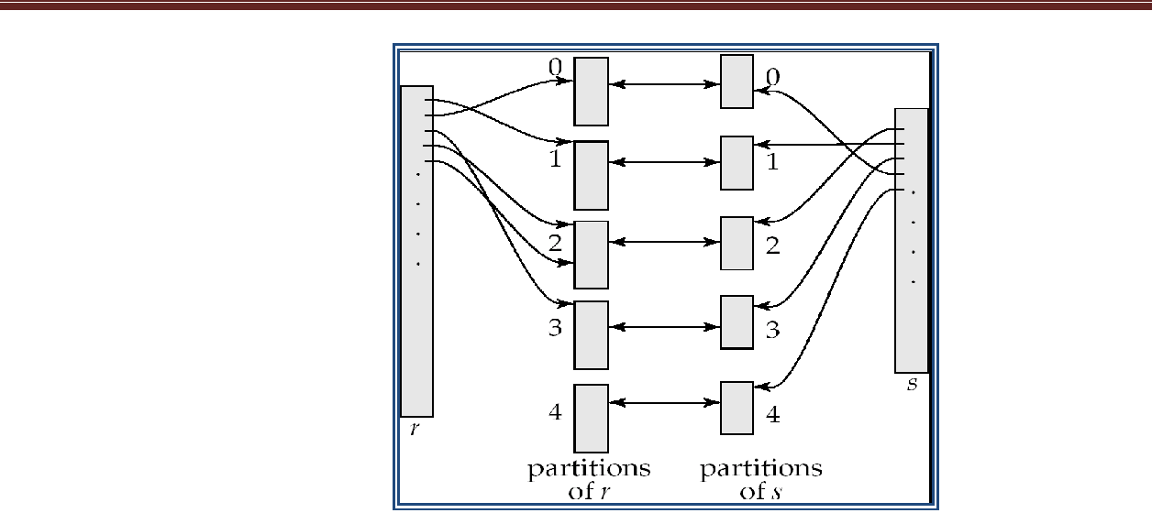

- r tuples in r_{i} need only to be compared with s tuples in s_{i} Need not be compared with s tuples in any other partition.

Hash-Join Algorithm

The hash-join of r and s is computed as follows.

  - Partition the relation s using hashing function h. When partitioning a relation, one block of memory is reserved as the output buffer for each partition.

- Partition r similarly.

- For each i:

Load s_{i} into memory and build an in-memory hash index on it using the join attribute. This hash index uses a different hash function than the
earlier one h.

Read the tuples in r_{i} from the disk one by one. For each tuple t_{r} locate each matching tuple t_{s} in s_{i} using the in-memory hash index. Output the

concatenation of their attributes.

  - Relation s is called the build input and r is called the probe input.

- The value n and the hash function h is chosen such that each s_{i} should fit in memory.

- Recursive partitioning required if number of partitions n is greater than number of pages M of memory.

Handling of Overflows

- Partitioning is said to be skewed if some partitions have significantly more tuples than some others

- Hash-table overflow occurs in partition s_{i} if s_{i} does not fit in memory. Reasons could be

  - Many tuples in s with same value for join attributes

  - Bad hash function

- Overflow resolution can be done in build phase

  - Partition s_{i} is further partitioned using different hash function.

  - Partition r_{i} must be similarly partitioned.

- Overflow avoidance performs partitioning carefully to avoid overflows during build phase

  - E.g. partition build relation into many partitions, then combine them

- Both approaches fail with large numbers of duplicates

  - Fallback option: use block nested loops join on overflowed partitions

Cost of Hash-Join

- If recursive partitioning is not required: cost of hash join is

3(b_{r} + b_{s}) +4 n_{h}

- Total cost estimate is:

2(b_{r} + b_{s} log_{M–1}(b_{s}) – 1 + b_{r} + b_{s} block transfers + 2( b_{r} / b_{b} + b_{s} / b_{b} ) log_{M–1}(b_{s}) – 1 seeks

- If the entire build input can be kept in main memory no partitioning is required

  - Cost estimate goes down to b_{r} + b_{s}.

- Useful when memory sized are relatively large, and the build input is bigger than memory.

- Main feature of hybrid hash join:

Keep the first partition of the build relation in memory.

- E.g. With memory size of 25 blocks, depositor can be partitioned into five partitions, each of size 20 blocks.

  - Division of memory:

The first partition occupies 20 blocks of memory

1 block is used for inp ut, and 1 bloock each for buffering thhe other 4 partitions.

- c ustomer is siimilarly parttitioned into five partitioons each of size 80

  - the firrst is used rigght away forr probing, instead of beinng written out

- Cost of 3(80 + 320) + 20 +80 = 1300 block transffers for

hybrid hash join, instead of 1500 witth plain hashh-join.

Complexx Joins

- Jooin with a coonjunctive condition:
• r |  |  |  | θ1 θ 2θ n s

- Eitherr use nested loops/block nested loops, or
» Comppute the result of one of the simpler joins r |  |  |  | θi s

final result comprises those tuples in the inter mediate resuult that satisfy the remaining conditions

    - θ₁ . . . θ_{i} _{–1} θ_{i} ₊₁ . . . θ_{n}

- Jooin with a diisjunctive coondition

• r θ1 θ2 ... θn s

- Eitherr use nested loops/block nested loops, or Compute as the uniion of the recordds in individual joins
• (r _{θ1} s) (r _{θ2} s) . . . (r _{θn} s)

Other Operations

- Duplicate eliimination caan be implemmented via hashing or soorting.

  - On sorting duplicates will comme adjacent to each othe r, and all bu t one set of dupliccates can be deleted.

  - Hashing is similarr – duplicatees will come into the samme bucket.

- P rojection:

  - Perforrm projection on each tuuple followedd by duplicate eliminatioon.

- Aggregation can be impllemented in a manner si milar to duplicate eliminnation.

  - Sortinng or hashingg can be used to bring tuuples in the same group together, andd then the aggregatee functions can be applieed on each group.

- Set operationns ( , ∩ andd ): can either use varriant of mergge-join after sorting, or variant of hassh-join.

- rs:

      - Add tuples in s_{i} to the hash index if they are not alread y in it.

      - At end of s_{i} add thee tuples in thhe hash indexx to the result.

    - r ∩ s:

      - output tuples in s_{i} to the result if they are allready there in the hash index

    - r – s:

      - for each tuple in s_{i}, if it is there in the hash index, delete it from thhe index.

      - At end of s_{i} add remaining tuples in the hash index to the result.

- Outer join caan be compuuted either ass

  - A joinn followed by addition of null-paddeed non-particcipating tuples.

  - by moodifying the join algorithhms.

- Modifying merge join to compute r s

  - In r s, non participating tuples are thosse in r – Π_{R}(r s)

» Modiffy merge-joiin to computte r |  |  |  | s: During merging, for every tuple t_{r}

from r that do not match any tuple in s, ouutput t_{r} padd ed with nullls.

  - Right outer-join and full outerr-join can bee computed similarly.

- Modifying haash join to coompute r s

  - If r iss probe relation, output non-matching r tuples paadded with nulls

  - If r is build relatioon, when proobing keep track of whicch r tuplles matched s tuples. Att end of s_{i} output

non-matched r tupples padded with nulls

Evaluatiion of Expreessions

- Alternatives for evaluatinng an entire expression trree

  - Materialization: generate results of an expression whose inputs are relations or are already computed, materialize (store) it on disk. Repeat.

  - Pipelining: pass on tuples to parent operations even as an operation is being executed

- We study above alternatives in more detail

Materialization

- Materialized evaluation: evaluate one operation at a time, starting at the lowest-level. Use intermediate results materialized into temporary relations to evaluate next-level operations.

- E.g., in figure below, compute and store
^{σ}balance<2500^{(account)}

then compute the store its join with customer, and finally compute the projections on customer-name.
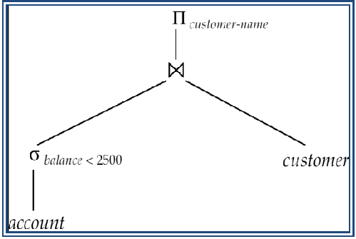

- Materialized evaluation is always applicable

- Cost of writing results to disk and reading them back can be quite high

  - Our cost formulas for operations ignore cost of writing results to disk, so Overall cost = Sum of costs of individual operations +

cost of writing intermediate results to disk

- Double buffering: use two output buffers for each operation, when one is full write it to disk while the other is getting filled

  - Allows overlap of disk writes with computation and reduces execution time

Pipelining

- Pipelined evaluation: evaluate several operations simultaneously, passing the results of one operation on to the next.

- E.g., in previous expression tree, don’t store result of
      - balance<2500 ^{(account)}

  - instead, pass tuples directly to the join.. Similarly, don’t store result of join, pass tuples directly to projection.

- Much cheaper than materialization: no need to store a temporary relation to disk.

- Pipelining may not always be possible – e.g., sort, hash-join.

- For pipelining to be effective, use evaluation algorithms that generate output tuples even as tuples are received for inputs to the operation.

- Pipelines can be executed in two ways: demand driven and producer driven

- In demand driven or lazy evaluation

  - system repeatedly requests next tuple from top level operation

  - Each operation requests next tuple from children operations as required, in order to output its next tuple

  - In between calls, operation has to maintain “state” so it knows what to return next

- In producer-driven or eager pipelining

  - Operators produce tuples eagerly and pass them up to their parents

Buffer maintained between operators, child puts tuples in buffer, parent removes tuples from buffer

if buffer is full, child waits till there is space in the buffer, and then generates more tuples

  - System schedules operations that have space in output buffer and can process more input tuples

- Alternative name: pull and push models of pipelining

- Implementation of demand-driven pipelining

  - Each operation is implemented as an iterator implementing the following operations

open()

  - E.g. file scan: initialize file scan

    - state: pointer to beginning of file

  - E.g.merge join: sort relations;

    - state: pointers to beginning of sorted relations

next()

  - E.g. for file scan: Output next tuple, and advance and store file pointer

  - E.g. for merge join: continue with merge from earlier state till next output tuple is found. Save pointers as iterator state.
close()

Evaluation Algorithms for Pipelining

- Some algorithms are not able to output results even as they get input tuples

  - E.g. merge join, or hash join

  - intermediate results written to disk and then read back

- Algorithm variants to generate (at least some) results on the fly, as input tuples are read in

  - E.g. hybrid hash join generates output tuples even as probe relation tuples in the in-memory partition (partition 0) are read in.

Pipelined join technique: Hybrid hash join, modified to buffer partition 0 tuples of both relations in-memory, reading them as they become available, and output results of any matches between partition 0 tuples

When a new r₀ tuple is found, match it with existing s₀ tuples, output matches, and save it in r₀

Symmetrically for s₀ tuples

Complex Joins

» Join involving three relations: loan depositor customer

» Strategy 1. Compute depositor customer; use result to compute loan (depositor

customer)

» Strategy 2. Computer loan depositor first, and then join the result with customer.

- Strategy 3. Perform the pair of joins at once. Build and index on loan for loan-number, and on customer for customer-name.

  - For each tuple t in depositor, look up the corresponding tuples in customer and the corresponding tuples in loan.

  - Each tuple of deposit is examined exactly once.

- Strategy 3 combines two operations into one special-purpose operation that is more efficient than implementing two joins of two relations.

