UNIT I RELATIONAL DATABASES

Purpose of Database System – Views of data – Data Models – Database System Architecture – Introduction to relational databases – Relational Model – Keys – Relational Algebra – SQL fundamentals – Advanced SQL features – Embedded SQL– Dynamic SQL

INTRODUCTION

Data: Known facts that can be recorded that have implicit meaning.

Database: collection of data.

DBMS: DBMS is a collection of interrelated data and a set of program to access those data.

The primary goal of a DBMS is to provide a way to store and retrieve database information that is both convenient and efficient.

Database System: Database and DBMS is collectively known as database system. Database Applications

Banking: All transactions, Customer Information, Accounts , Loans

Credit card transactions: Purchase on credit cards generation of monthly bills.

Telecommunication: For keeping records of calls made, generating monthly bills, maintaining balance on prepaid cards

Airlines: Reservations, Schedule information

Universities: Student information, Course registration, Grades

Sales: Customers, Products, Purchase information

Online retailers: order tracking, Sales data, Customized recommendations

Manufacturing: production, inventory, orders, supply

Human resources: Employee records, Salaries, Tax deductions

- PURPOSE OF DATABASE SYSTEM

Introduction to file and database systems

In early days, file system is used for storing and manipulating information. File processing system is supported by conventional operating system. This system store the records in various files, and it needs different application programs to extract records for the file.But this system has number of disadvantages. So Data base management system came to overcome these drawbacks.

Drawbacks of Conventional File Processing System over data base system.

- Data redundancy and inconsistency

The same information may be duplicated in several files. Because programmers create several files and these files have different structure.

For Example: The address and phone number of particular customer may appear in a personal information and also saving account records file.

This redundancy leads to higher storage and access cost.

Data inconsistency that is, the various copies of the same data may no longer agree.

For example: a changed customer address may be reflected in personal information file, but not in saving account records file.

- Difficulty in accessing data

Conventional file processing environments do not allow needed data to be retrieved in a convenient and efficient manner.

For Example: Suppose that bank officer needs to find out the names of all customers who live within the city’s 411027 zip code. The bank officer has now two choices: Either get the list of customers and extract the needed information manually, or ask the data processing department to have a system programmer write the necessary application program. Both alternatives are unsatisfactory.
- Data isolation

Since, data is scattered in various files, and files may be in different formats, it is difficult to write new application programs to retrieve appropriate data.

- Integrity problems

The data values stored in the database must satisfy certain types of consistency constrains.

For Example: The balance of a bank account may never fall below a prescribed amount (say $100).These constraints are enforced in the file system by adding appropriate code in the various application programs.

- Atomicity problems

A computer system is subject to failure.

If a failure occurs, the data should be restored to the consistent state that existed prior to the failure. This is called atomicity.

It is difficult to ensure atomicity in a file processing system.

For Example: Consider a program $50 from account A to Account B. If the system failure occurs during the execution of program, it is possible that $50 was removed from account A & it was not credited to the account B.So database will be inconsistent.

- Concurrent access anomalies

In order to improve the overall performance of the system many systems allow multiple users to update the data simultaneously.

In such environment, interaction of concurrent updates may results in inconsistent data.

For Example: Consider bank account A, with $500.If two customers with draw funds (say $50 and $100) from account A at the same time, then there will be a

wrong amount in balance that is $ 450 and $400 which is inconsistent.

- Security problems

Data security means protecting data from unauthorized access

Not every user of the database system should be able to access all the data.

For Example: In college administration system, the user may be classified into student, staff, and management. The staff may access the student’s data only not management information. Similarly the student may access only the information given to the students not staff and management.

Data base is a way to consolidate and control the operational data centrally. It is a better way to control the operational data. The advantages of having a centralized control of data are:

- Redundancy can be reduced

In non-database systems, each application or department has its own files resulting in considerable amount of redundancy of the stored data. Thus storage space is wasted. By having a centralized database most of this can be avoided.

- Inconsistency can be avoided

When the same data is duplicated and changes are made at one side, which is not propagated to the other site, then inconsistency will occur. So, if the redundancy is removed, inconsistent data are also removed.

- The data can be shared

The data stored from one application, can be used for another application. Thus, the data of database stored for one application can be shared with new applications.

- Standards can be enforced

With central control of the database, the DBA can ensure that Standards can be enforced

- Security can be enforced

DBA can define the access paths for accessing the data stored in database and he can define authorization checks whenever access to sensitive data is attempted.

- Integrity can be maintained

Integrity means that the data in the database is accurate. Centralized control of the data helps in permitting the administrator to define integrity constraints to the data in the database.

2.VIEWS OF DATA

A major purpose of a database system is to provide users with an abstract view of the data. That is, the system hides certain details of how the data are stored and maintained.

Data abstraction

Data abstraction is the process of hiding the complexity from the users to simplify user’s interaction with the system.

There are three levels of data abstraction:
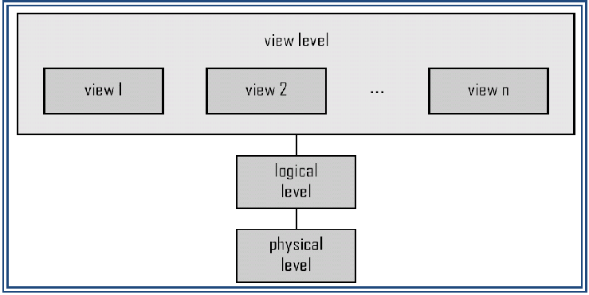

Figure The three levels of data abstraction

  - Physical level: It is the lowest level of abstraction that describes how the data are actually stored. The physical level describes complex low-level data structures in details.

- Logical level: It is the next higher level of abstraction that describes what data are stored in the database and what relationships exist among those data. Data base administrator use the logical level of abstraction.

- View level: It is the highest level of abstraction that describes only part of the entire database. This level is used to simplify the user interaction with the system.

Instances and schemas

Database change over times as information is inserted and deleted. The collection of information stored in the database at a particular moment is called an instance of the database. The overall design of the database is called the database schema.

Types of database schemas

- Physical schema: It describes the database design at the physical level.

- Logical schema: It describes the database design at the logical level.

- Subschema: A database may also have several subschemas at the view level called as subschema that describes different views of the database.

Data Independence

The ability to modify a scheme definition in one level without affecting a scheme definition in the next higher level is called data independence. There are two levels of data independence:

- Physical data independence is the ability to modify the physical schema without rewriting application programs.

- Logical data independence is the ability to modify the conceptual or logical schema without causing application programs to be rewritten.

Modifications at the conceptual level are necessary whenever the logical structure of the database is altered.

Logical data independence is more difficult to achieve than physical data independence since application programs are heavily dependent on the logical structure of the data they access.
3.DATA MODEL

Underlying structure of the database is called as data models.

It is a collection of conceptual tools for describing data, data relationships, data semantics, and consistency constraints.

Different types of data models are:

Relational model - Hierarchical model , Network model

Entity relationship model

Object based data model

Semi structured data model

- Relational Model:

Relational Model uses a collection of tables to represent both data and the relationship among these data.

Each table has multiple columns and each column has a unique name. Relational model is an example of record based model.

Each record type defines a fixed number of fields.

The column of the table corresponds to the attributes of the record type.

Eg: Customer Account_info

Custno | Name | Country
C100 | Alwin | US
C101 | John | UK
C102 | Mathan | India

Account_ no | Name | Balance
C100 | Alwin | US
C101 | John | UK
C102 | Mathan | India

Advantages

- Structural independence

- Conceptual simplicity

- Easy to design, implementation, maintenance.

- It is simple to navigate

- Greater flexibility.

Disadvantages

    - Significant hardware and software overheads.

    - May have slower processing tomes than hierarchical and network models The old record based models are

a. Network Model b. Hierarchical Model

a. Network Model

It uses two different data structure namely record type and set type to represent the data base entities and relationship between the entities.

Record type is used to represent the entity type. It is made up of number of data items that represent an entity’s attributes.

Set type is used to represent a direct relationship between two record types.

Sample network model
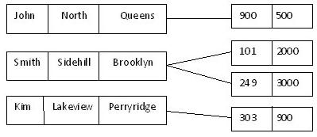

Advantages:

- Conceptual simplicity

- Capability to handle more relationship types

- Data independence

Disadvantages:

    - Detailed structural knowledge is required.

    - Lack of structural independence. b. Hierarchical Model

Hierarchical database is a database management system that links records together in

tree data structure such that each record type has only one owner

Hierarchical structures were widely used in the first main frame database management systems.

Linkages are only possible vertically but not horizontally or diagonally

Sample hierarchical database model
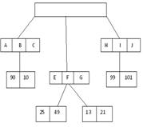

Advantages

- Easy to update.

- High speed of access to large datasets.

- Simplicity: the design of a hierarchical database is simple.

- Provides data security

- Efficient

Disadvantages

    - Implementation complexity

    - Database management problems

    - Lack of structural independence

- Entity Relationship Model

The E-R data model consists of a collection of basic objects called entities, and relationships among these objects.

Entities are an object in the real world that is distinguishable from other objects. For example, account, customer, each person is an entity.

An entity has a set of properties called attributes, and the values for some set of properties may uniquely identify an entity.

For example, a student with register_no property with value 95309205001 uniquely identifies that person.

Relationship is an association among several entities.

Eg:
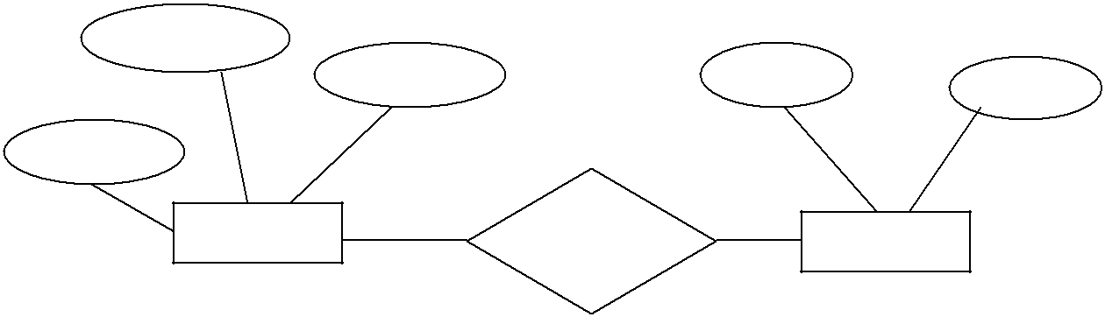

Advantages

- Easy to develop relational model using E-R model

- It specifies mapping cardinalities

- It specifies keys like primary key.

Disadvantages

        - It is just for database design not for implementation.

- Object based data model

The object based data model combines the features of object oriented data model and relational data model.

It is an extension of E-R model with the notation of encapsulation, methods and object identity

  - Semi structured data Model

Semi structured data model permit the specification of data where individual data items of same type may have different set of attributes.

The Extensible markup Language (XML) is widely used to represent Semi structured data.

          - DATABASE LANGUAGES

Database system provides a data definition language to specify the database schema and data manipulation language to express database queries and updates.

A set of definitions expressed by a special language to specify a data base schema is called data definition language.

A set of statements to specify the storage structure and access methods used by the database system is called data storage and definition language.

DDL is a set of SQL commands used to create, modify and delete database structures. These commands are normally used by the database administrator or data base designer
or application developer.

Example of DDL commands are

  - Create: To create objects in the database.

  - Alter: Alter the structure of database.

  - Drop: Deletes objects from the database.

  - Truncate: Removes all records from the table, including all spaces allocated for the records are removed.

  - Comment: Add comments to the data dictionary.

DDL gets input and generates some output. The output is placed in data dictionary. A database system consults the data dictionary before reading or modifying actual data.

Data Manipulation Language (DML):

Data Manipulation Language is a language that enables users to access or manipulate data as organized by the appropriate data model.

Types of access are

Two types of DML are

    - Procedural DML: require a user to specify what data are needed without specifying how to get those data.

    - Non-procedural DML(Declarative DML):require a user to specify what data are needed without specifying how to get those data.

A Query is a statement requesting the retrieval of information. The portion of DML for information retrieval is called a Query language.. Eg: SQL.

Example of DML commands are

Insert - insert the data into the table.

Update – Updates existing data within a table.

Delete – Deletes all records from a table.

- DATABASE SYSTEM ARCHITECTURE

A database system is partitioned into modules that deal with each of the responsibilities of the overall system.

Database System Structure:

The functional components of a database system can be broadly divided into

Storage Manager Query Processor
Storage Manager

A storage manager is a program module that provides the interface between the low level data stored in the database and the application programs and queries submitted to the system.

The storage manager is responsible for the interaction with the file manager.

The storage manager translates the various DML statements into low-level file system commands. Thus, the storage manager is responsible for storing, retrieving, and updating data in the database.

Components of the storage manager are:
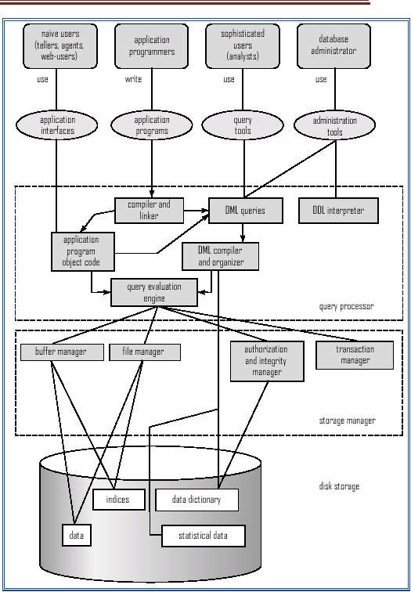

Authorization and integrity manager: It tests for satisfaction of various integrity constraints and checks the authority of users accessing the data.

Transaction manager: It ensures that the database remains in a consistent state despite system failures, and concurrent executions proceed without conflicting.

File manager: It manages the allocation of space on disk storage and the data structures used to represent information stored on disk.

Buffer manager: It is responsible for fetching data from disk storage into main memory and deciding what data to cache in main memory.

The storage manager implements several data structures as part of physical system implementation.

Data files: which store the database itself.

Data dictionary: It contains metadata that is data about data. The schema of a table is an example of metadata. A database system consults the data dictionary before reading and modifying actual data.

Indices: Which provide fast access to data items that hold particular values.

The Query Processor

The query processor is an important part of the database system. It helps the database

system to simplify and facilitate access to data.

The query processor components include:

DDL interpreter, which interprets DDL statements and records the definitions in the data dictionary.

DML compiler, which translates DML statements in a query language into an evaluation plan consisting of low-level instructions that he query evaluation engine understands.

Query evaluation engine, which executes low-level instructions generated by the DML compiler.

5.1 APPLICATION ARCHITECTURE

Data base applications are usually partitioned into 2 or 3 parts. Two-Tier Architecture:

The application is partitioned into components that reside at the client machine, which invokes data base system functionally at the server machine through query language. Fig: Two-Tier Architecture

Three-Tier Architecture

The client machine acts as a front end and does not contain any direct database calls

Instead the client communicates with an application server, usually through the interface.

The application server in turn communicates with an database system to access data.

 |  |  |  |  |  |  |  |  |  |  |  |  | !
 |  |  |  |  |  |  | !
Fig: Two-Tier Architecture |  |  |  |  |  |  |  |  |  | Fig: Three-Tier Architecture
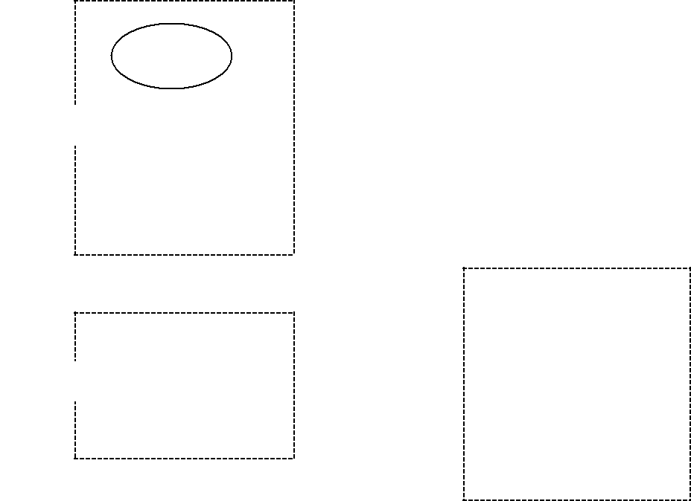

6.DATABASE USERS AND ADMINISTRATOR People who work with a database can be categorized as:

Database Users

Database administrators

Database Users

- Naïve users

Naive users who interact with the system by invoking one of the application programs that have been written previously.

Naive users are a forms interface, where the user can fill in appropriate fields of the form.

Naive users may also simply read reports generated from the database.

- Application Programmers

Application programmers are computer professionals who write application programs.

Rapid application development (RAD) tools are tools that enable an application programmer to construct forms and reports without writing a program.

- Sophisticated users

Sophisticated users interact with the system without writing programs. Instead, they form their requests in a database query language.

They submit each such query to a query processor that the storage manager understands.

They are analysts who submit queries to look at the data in the database.

- Specialized users

Specialized users are sophisticated users who write specialized database applications that do not fit into the traditional data-processing framework.

The applications are computer-aided design systems, knowledge base and expert systems, systems that store data with complex data types (Audio, Video)

Database administrators(DBA)

A person who has such central control over the system is called a database administrator.

The functions of a DBA include:

- Schema definition. The DBA creates the original database schema by executing a set of data definition statements in the DDL.

- Storage structure and access-method definition.

- Schema and physical-organization modification. The DBA carries out changes to the schema and physical organization to reflect the changing needs of the organization.

- Granting of authorization for data access. By granting different types of authorization, the database administrator can regulate which parts of the database various users can access. The authorization information is kept in a special system structure that the database system consults whenever someone attempts to access the data in the system.

- Routine maintenance. Examples of the database administrator’s routine maintenance activities are:

periodically backing up the database

Ensuring that enough free disk space

Monitoring jobs running on the database

7. ENTITY–RELATIONSHIP MODEL

The E-R data model considers the real world consisting of a set of basic objects, called entities, and relationships among these objects.

Basic Concepts

The E-R data model employs three basic notions:

Entity sets

Relationship sets Attributes

Entities

An entity is ‘thing’ or ‘object in the real world that is distinguishable from all other objects. For example, each person is an entity.

An entity has a set of properties, and the values for some set of properties may uniquely identify an entity. For example, a customer with customer-id property with value C101 uniquely identifies that person.

An entity may be concrete, such as person or a book, or it may be abstract, such as a loan, or a holiday.

Entity sets

An entity set is a set of entities of the same type that share the same properties, or attributes.

Attributes

The properties that describe an entity are called attributes. An entity is represented by a set of attributes.

The attributes of customer entity set are customer_id , customer_name and city.

Attributes are classified as

Simple

Composite

Single- valued

Multi-valued

Derived

1) Simple attribute:

Attribute composed of single component and it cannot be subdivided Example: Age, sex, Rollno

2) Composite attribute:

Attribute composed of multiple components and it can be subdivided

Example: Address: street, city, pin Code, Name: first name, middle name, last name

3) Single-valued or atomic attribute:

Attribute that hold only a single value for an entity.

Example: Cust_id

4) Multi-valued attribute:

Attribute that hold multiple values for an entity. Example: Person may have several college degrees
5) Derived attribute:

Derived attribute represent a value that is derivable from the value of a related attribute.

Example: Age can be derived from date of birth.

Stored attributes:

The attributes stored in a data base are called stored attributes.

Relationships and Relationships sets

Relationship is an association among several entities.

Relationship set is a set of relationships of the same type.

- Unary relationship: A unary relationship exists when an association is maintained within a single entity.

Boss

Manager

Worker

Figure Association between two objects of the same entity set.

- Binary relationship: A binary relationship exists when two entities are associated.
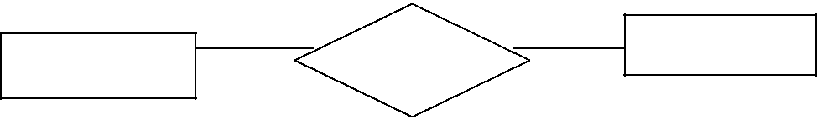

- Ternary relationship: A ternary relationship exists when there are three entities associated.
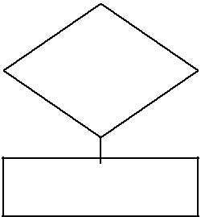

- Quaternary relationship: A quaternary relationship exists when there are four entities

associated.
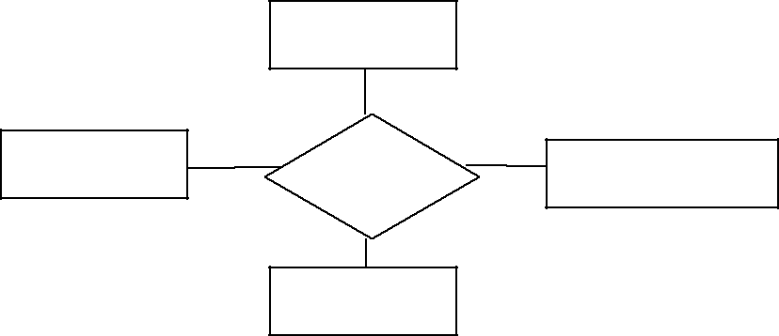

Entity role: The function that an entity plays in a relationship is called that entity’s role. A role is one end of an association.
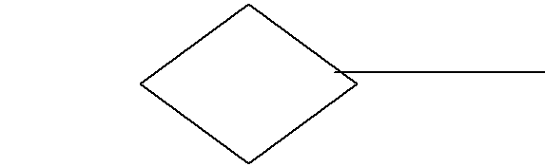

 |  | Employee |  |  | Employee

Here Entity role was Employee

Constraints

An E-R enterprise schema may define certain constraints to which the contents of a database system must conform.

Two types of constraints are

- Mapping cardinalities

- Participation constraints

Mapping cardinalities

Mapping cardinalities express the number of entities to which another entity can be associated via a relationship set.

Cardinality in E-R diagram that is represented by two ways:

i) Directed line ( ) ii) Undirected line ( )

For a binary relationship set R between entity sets A and B, the mapping cardinalities must be one of the following.

- One to one: An entity in A is associated with at most one entity in B, and an entity in B is associated with at most one entity in A.
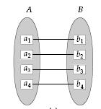

Example: A customer with single account at given branch is shown by one-to-one relationship as given below
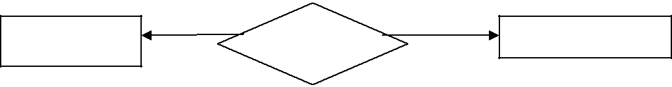

- One-to-many: An entity in A is associated with any number of entities (zero or more) in B. An entity in B, however, can be associated with at most one entity in A.
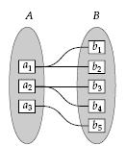

Example: A customer having two accounts at a given branch is shown by one-to-many relationship as given below.
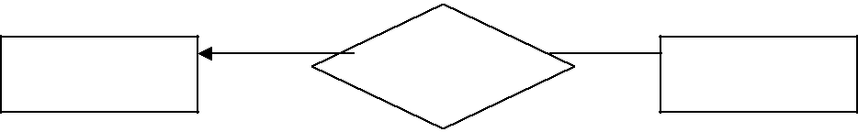

- Many-to-one: An entity in A is associated with at most one entity in B. An entity in B, however, can be associated with any number (zero or more) of entities in A.

Example: Many employees works for a company. This relationship is shown by many-to-one as given below.
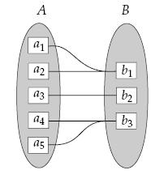
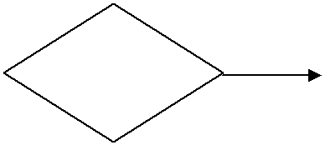

" ! #
$

- Many-to-many: An entity in A is associated with any number (zero or more) of entities in B, and an entity in B is associated with any number (zero or more) of entities in A.
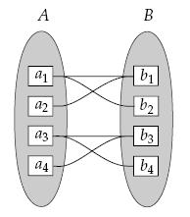

Example: Employee works on number of projects and project is handled by number of employees. Therefore, the relationship between employee and project is many-to-many as shown below.
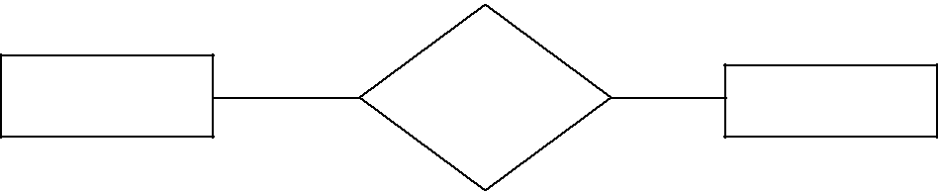
" ! #
%

Participation Constraint

Participation can be divided into two types.

1. Total 2. Partial

If every entity in E participates in at least one relationship in R. Then participation is called Total Participation

If only some entities in E participate in relationships in R. Then participation is called Partial Participation.

Keys

A key allows us to identify a set of attributes and thus distinguishes entities from each other.

Keys also help uniquely identify relationships, and thus distinguish relationships from each other.

Key Type

Superkey

Candiate Key

Primary Key

Foreign Key

Secondary Key

Definition

Any attribute or combination of attributes that uniquely identifies a row in the table.

Example: Roll_No attribute of the entity set ‘student’ distinguishes one student entity from another.

Minimal Superkey. A superkey that does not contain a subset of attributes that is itself a superkey.

Example: Student_name and Student_street,are sufficient to uniquely identify one particular student.

The candidate key selected to uniquely identify all rows and cannot contain null values and its attributes are never changed. Example: Roll_No is a primary set of ‘student’ entity set.

An attribute (or combination of attributes) in one table that must either match the primary key of another table or be null

Example: Consider in the staff relation the branch_no attribute exists to match staff to the branch office they work in. In the staff relation, branch_no is foreign key.

An attribute or combination of attributes used to make data retrieval more efficient.

  - E–R DIAGRAM

E-R diagram can express the overall logical structure of a database graphically. E-R diagram consists of the following major components:

Component name |  | Symbol |  | Description
Rectangles |  |  |  | represent entity sets
Ellipses |  |  |  | represent attributes
Diamonds |  |  |  | represent relationship sets
Lines |  |  |  | link attributes to entity sets and entity
Lines |  |  |  | sets to relationship sets
Double ellipses |  |  |  | represent multivalued attributes


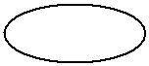

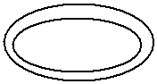

Dashed ellipses |  | represent derived attributes
 |  | Represent total participation of an
Double lines |  | entity in a relationship set

Double rectangles |  | represent weak entity sets

Summary of ER diagram notation
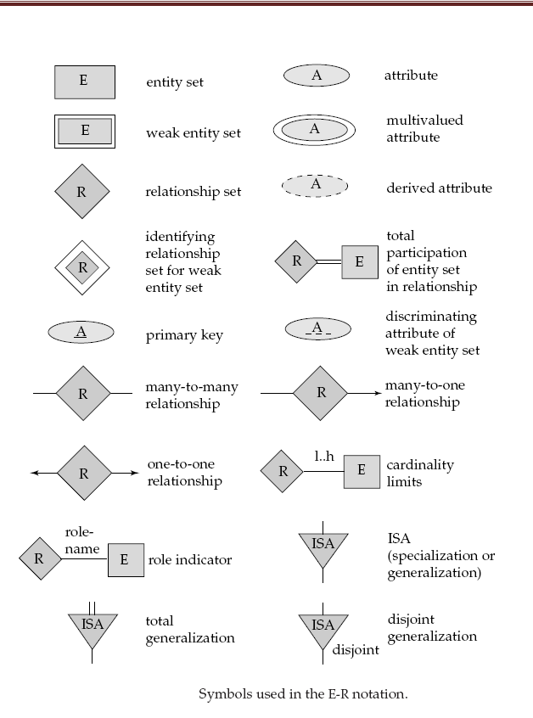

Dependency:

Existence dependencies

If the existence of entity x depends on the existence of entity y, then x is said to be existence dependent on y.

If y is deleted, so is x.

Entity y is said to be a dominant entity, and x is said to be subordinate entity.

Example: Figure shows the dominant entity set ‘loan’ which is also called Strong entity set, and subordinate entity set ‘payment’ which is also called week entity set, connected by
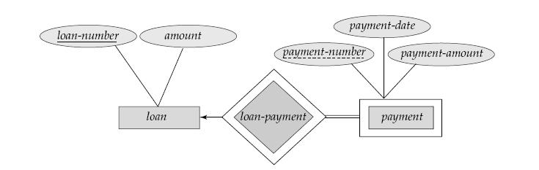

relationship ‘loan-payment’.

Definition: Strong and Weak entity sets

An Entity that is existence dependent on some other entity is called a week entity type. An entity set on which week entity set depends is called strong entity set.

Example: Figure shows weak entity set ‘Parent’ which depends on strong entity set ‘Employee’
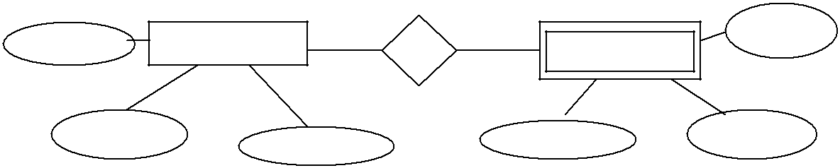

&

Representation of Role:

The function that an entity plays in a relationship is called its role.
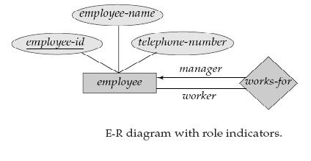

Sample E-R Diagram:

- Total participation of an entity set in a relationship set

In figure, Double line from loan to borrower indicates that each loan must have at least one associated customer
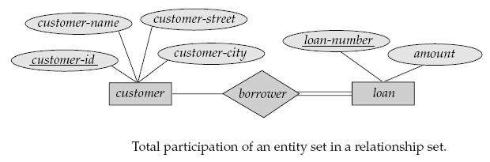

- Cardinality limits on relationship sets

In Figure, Edge between loan and borrower has a cardinality constraint of 1...1, meaning that each loan must have exactly one associated customer.

The limit 0...* on the edge from customer to borrower indicates that a customer can have zero or more loans.
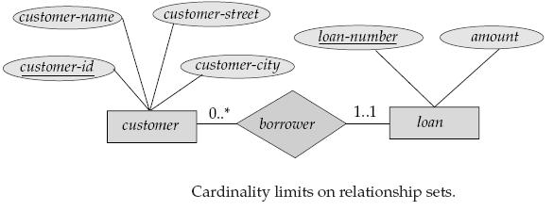

3) E-R diagram with an attribute attached to a relationship set
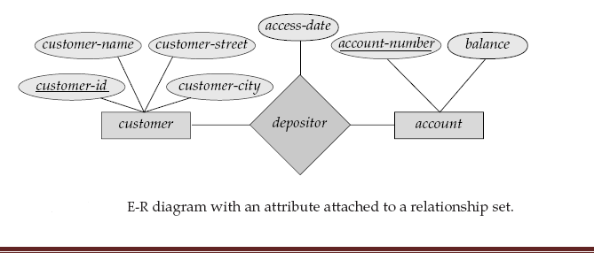

E-R diagram for a banking enterprise:
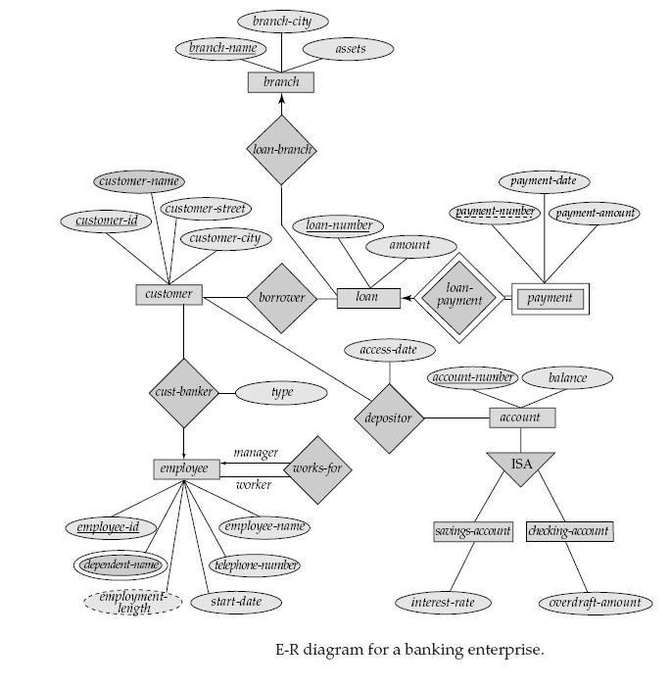

Extended E-R Features

ER model that is supported with the additional semantic concepts is called the extended entity relationship model or EER model.

EER model deals with

- Specialization

- Generalization

- Aggregation

Specialization:

The process of designating subgroupings within an entity set is called Specialization Specialization is a top-down process.

Consider an entity set person. A person may be further classified as one of the following:

  - customer

  - employee

Specialization is depicted by a triangle component labeled ISA, as Figure shows. The label ISA stands for “is a” for example, that a customer “is a” person.
The ISA relationship may also be referred to as a superclass-subclass relationship.

Generalization:
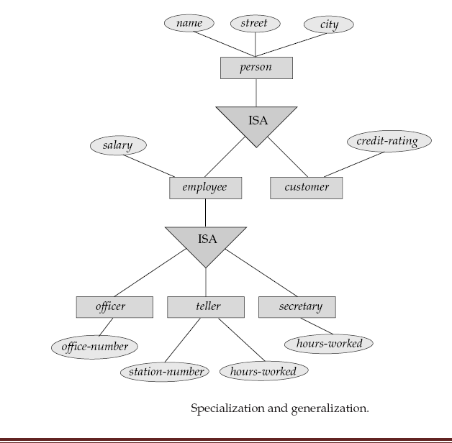

Generalization is a simple inversion of specialization.

Generalization is the process of defining a more general entity type from a set of more specialized entity types.

Generalization is a bottom-up approach.

Generalization results in the identification of a generalized super class from the original subclasses.

Person is the higher-level entity set

Customer and employee are lower-level entity sets.

The person entity set is the super class of the customer and employee subclasses.

Constraints on Generalizations

- One type of constraint determining which entities can be members of a lower-level entity set. Such membership may be one of the following:

  - Condition-defined. In condition-defined lower-level entity sets, membership is e valuated on the basis of whether or not an entity satisfies an explicit condition.

  - User-defined. User defined constraints are defined by user.

- A second type of constraint relates to whether or not entities may belong to more than one lower-level entity set within a single generalization. The lower-level entity sets may be one of the following:

  - Disjoint. A disjointness constraint requires that an entity belong to no more than one lower-level entity set.

  - Overlapping. Same entity may belong to more than one lower-level entity set within a single generalization.

- A final constraint, the completeness constraint specifies whether or not an entity in the higher-level entity set must belong to at least one of the lower-level entity sets .This constraint may be one of the following:

  - Total generalization or specialization. Each higher-level entity must belong to a lower-level entity set.

  - Partial generalization or specialization. Some higher-level entities may not belong to any lower-level entity set.

Attribute Inheritance

A property of the higher- and lower-level entities created by specialization and generalization is attribute inheritance.

The attributes of the higher-level entity sets are said to be inherited by the lower-level entity sets.

Aggregation

One limitation of the E-R model is that it cannot express relationships among relationships.

Example consider a quaternary relationship using E-R model, the redundant information in the resultant figure, Best way to model this situation is to use aggregation.
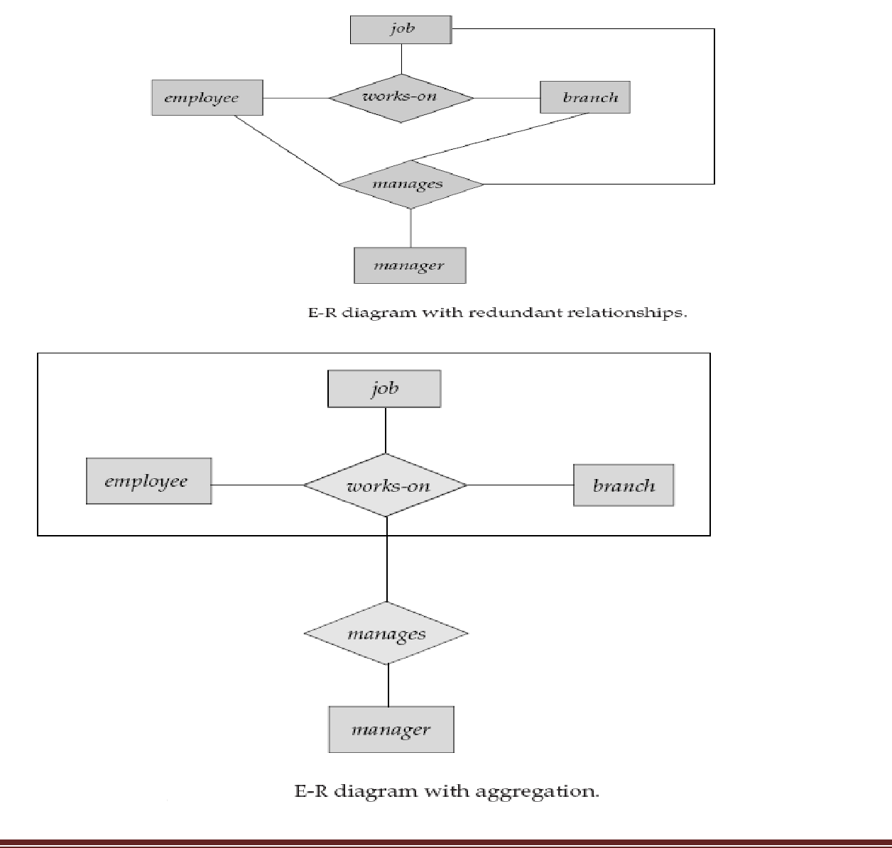

Reduction of an E-R Schema to Tables:

We can represent an E-R database by a collection of tables.

For each entity set and for each relationship set in the database, there is a unique table. Each table has multiple columns, each of which has a unique name.

Both the E-R model and the relational-database model are abstract, logical representations of real-world enterprises.

Two models employ similar design principles; we can convert an E-R design into a relational design.

Tabular Representation of Strong Entity Sets

Let E be a strong entity set with attributes a1, a2, . . . , an. We represent this entity by a table called E with n distinct columns, each of which corresponds to one of the attributes of E.

Each row in this table corresponds to one entity of the entity set E.

As an illustration, consider the entity set loan of the E-R diagram in Figure :This entity set has two attributes: loan-number and amount.
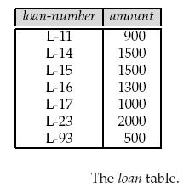

Tabular Representation of Relationship Sets

Consider the relationship set borrower in the E-R diagram of Figure. This relationship set involves the following two entity sets:

  - customer, with the primary key customer-id

  - loan, with the primary key loan-number

Since the relationship set has no attributes, the borrower table has two columns, labeled

customer-id and loan-number, as shown in Figure

Tabular Representation of Weak Entity Sets
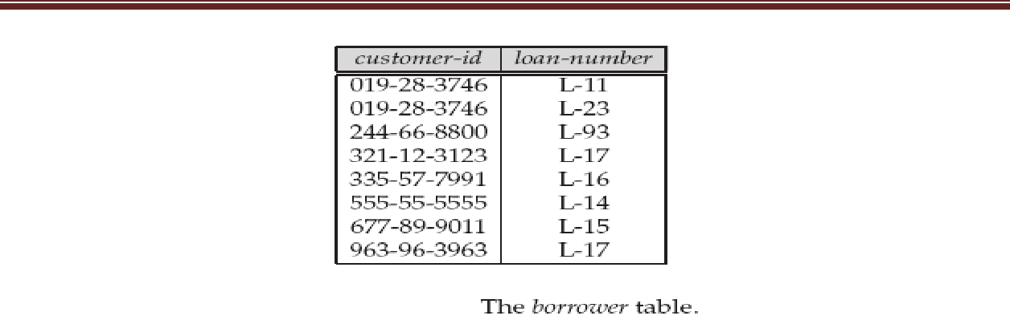

Consider the entity set payment. This entity set has three attributes: payment-number, payment-date, and payment-amount.

The primary key of the loan entity set, on which payment depends, is loan-number.

Thus, we represent payment by a table with four columns labeled loan-number, payment number, payment-date, and payment-amount, as in Figure
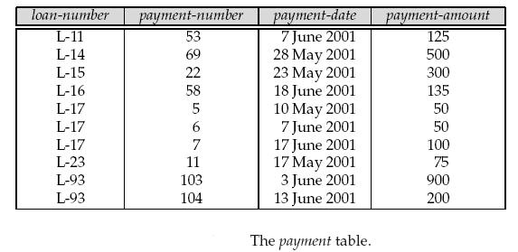

Redundancy of Tables

In general, the table for the relationship set linking a weak entity set to its corresponding strong entity set is redundant and does not need to be present in a tabular representation of an E-R diagram.

Composite Attributes

We handle composite attributes by creating a separate attribute for each of the component attributes; we do not create a separate column for the composite attribute

itself.

Multivalued Attributes

Consider an entity set employee with multivalued attribute dependent-name. For this multivalued attribute, create a separate table as dependent-info with attributes dependent-name and employee-id, which is the primary key of employee entity set.

2.9.6 Tabular Representation of Generalization

There are two different methods for transforming to a tabular form an E-R diagram that includes generalization.

Consider the generalization shown in fig. where account is a higher-level entity, while lower-level entity sets—that is, savings-account and checking-account.
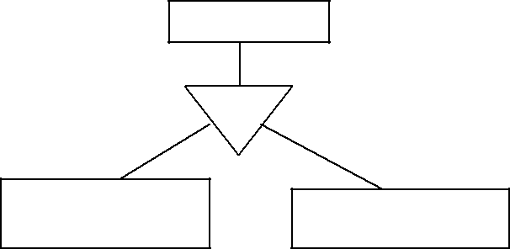

' !

- Create a table for the higher-level entity set.

For each lower-level entity set, create a separate table

Thus, for the E-R diagram of Figure .we have three tables:

- Account, with attributes account-number and balance

- Savings-account, with attributes account-number and interest-rate

- Checking-account, with attributes account-number and overdraft-amount

- An alternative representation is possible,

if the generalization is disjoint and complete

Here, do not create a table for the higher-level entity set. Then, for the E-R diagram of Figure, we have two tables.
- savings-account, with attributes account-number, balance, and interest-rate

- checking-account, with attributes account-number, balance, and overdraft amount

Tabular Representation of Aggregation

Transforming an E-R diagram containing aggregation to a tabular form is straightforward.

The table for the relationship set manages between the aggregation of works-on and the entity set manager includes a column for each attribute in the primary keys of the entity set manager and the relationship set works-

INTRODUCTION TO RELATIONAL DATABASE

The relational model was introduced by Dr. E.F.Codd in 1970.

In relational database, the user only needs to understand the logical structure of the data, not how it is physically stored. The organization of data into relational tables is known as the logical view of the database.

In this database, data is represented in simple two-dimensional tables(relations), which consist of rows(tuples) and columns(attributes).

A relational database is simply a collection of tables.

Software such as Oracle, Microsoft SQL Server which are based on the relational model.

Relational term | SQL equivalent
Relation | Table
Tuple | Row
Attribute | column
Relational Database Basic Concepts:

- Relations or Tables

A relation is defined as a set of tuples that have the same attributes. A tuple actually represent

the object and information about that object. A relation is usually described as a table which consists of rows and columns. Relation can be modified using insert, delete and update operation.

- Base and derived relations

Relations that store data are called base relation and in implementation are called “tables”.

Other relation does not share data, but are computed by applying relational operations to other relation. These relations are called derived relation. In implementation these are called “views” or “queries”.

- Tuple /Record/Row

A record holds all the information about one item or subject. Conceptually, if you collected business card from 50 people, all 50 cards would represent a table and the

information on any one of the business card would represent one record. In database table row is a record/tuple.

- Field/Column

A field holds one piece of information about an item or subject. A field is a column in a database table.

- Domain

A domain describes the set of possible values for a given attributes.

- Constraints

Constraints allow you to further restrict the domain of an attributes. For instance, a constraint can restricts attribute to values between 1 and 10.

- Data type

Every field in a database table is assigned a data type, which describes the kind of data that can be stored in the field.

- Primary Key

A primary key is a field that uniquely identifies each record in the table from every other record in the table. In our student table it is Roll_No. Each student has an Roll_No that is different from every other student in the table.

- Foreign key

A foreign key is a reference to a key in another relation, meaning that the referencing tuple has, as one of its attributes, the values of a key in the referenced tuple.

- Stored Procedure

A stored procedure is a high-end database tool that adds programming power into the database. A stored procedure is executable code that is associated with, and generally stored in the database.

- Indices

An index is one way of providing quicker access to data. Indices can be created on any combination of attributes on a relation.

- Relational operation

Some of the relational algebra mathematical operations are

Union operator

Intersection operator

Difference operator Cartesian product

The remaining operators proposed by Codd, involve special operator specific to relational database:

Selection operation Projection operation Join operation
Relational division operation

- Normalization

Normalization was first proposed by Codd as an integral part of the relational model. It is

used to eliminate the duplication of data.

- RELATIONAL MODEL

The relational model was introduced by Dr. E. F. Codd in 1970.

The relational model represents data in the form of two dimensional tables.

The organization of data into relational tables is known as the logical view of the database.

Software such as Oracle, Microsoft SQL Server, Sybase, which are based on the relational model.

The relational model eliminated all parent child relationships and instead represented all data in the database as simple row/column tables of data values.

A relation is similar to a table with rows/columns of data values.

Each table is an independent entity and there is no physical relationship between tables. Most data management systems based on the relational model have a built-in support for query languages like ANSI SQL or QBE. These queries are simple English

constructs that allow adhoc data manipulation from a table. Relational model of data management is based on set theory.

The user interface used with relational models is non-procedural because only what needs to be done is specified and not how it has to be done.

E.F. Codd’s Laws for a Fully Functional Relational Database Management System

- Relational database management

- Information representation

- Logical accessibility

- Representation of null values

- Catalog facilities

- Data language

- View updatability

- Insert, update and delete

- Physical data independence

- Logical data independence

- Integrity constraints

- Database distribution

- Non subversion

The relational model is consists of following three basic components :

- Data structure

- Data integrity

- Data manipulation

1.The Relational Data Structure

The relational data structure is shown in Fig. It is based on the employee relation.
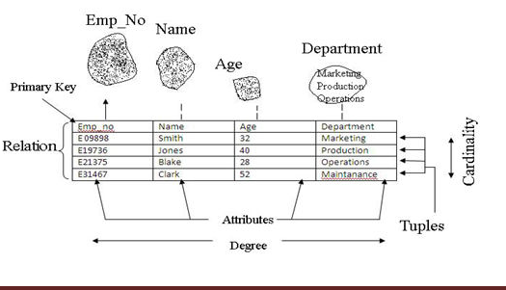

Structural terminology summary

Formal relational term | Informal Equivalence
Relation | Table
Tuple | Row or record
Cardinality | Number of rows
Attribute | Column or field
Degree | Number of columns
Primary key | Unique identifier
Domain | Pool of legal values

2. Relational Integrity

Integrity constraints means when changes made to the database by authorized users that should not result in a loss of data consistency.

There are two main types of integrity constraints.

  - Domain constraints

  - Referential integrity Domain Constraints

Domain constraints specify the set of values that can be associated with an attribute.

Domain constraints are tested easily by the system whenever a new data item is entered into the database.

Domain constraints also prohibit use of null values for particular fields.

A value that appears in one relation for a given set of attributes also appears for a certain set of attributes in another relation. This is called referential integrity.

Referential integrity in the E-R model

Referential integrity constraints arise frequently. If we derive our relational database scheme by constructing tables from E-R diagrams then every relation arising from a relationship set has referential integrity constraints.

As shown in fig, an n-array relationship set R, relating entity sets E₁,E₂,……..E_{n} . Let K_{i}
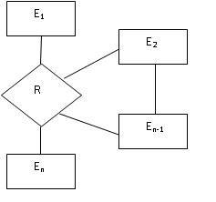

denote the primary key of E_{i}. The attributes of the relation scheme for relationship set R include set R include K₁ ∪K₂∪……∪ K_{n}. Each K_{i} in the scheme for R is a foreign key that leads to a referential integrity constraints.

Referential integrity in SQL:

Using SQL primary key, candidate key, and foreign key are defined as part of the create table statement as given below

Example:

Create table deposit (br-name char (15),acc-no char(10),cust-name car(20)not null, balance integer, primary key (acc-no, cust-name),foreign key (branch-name),Foreign

key(cist-name) references customer);

Nulls

“Null represents a value for an attribute that is currently unknown or is not applicable for this tuple.”

Other integrity constraints are:

- Entity integrity

- Enterprise constraints.

Entity Integrity

“In a base relation, no attribute of a primary key can be null”.

A primary key is used to identify tuples uniquely. This means that no subset of the primary key is sufficient to provide unique identification of tuples. Therefore, primary key should not be null.

Enterprise Constraints

These are additional rules specified by the uses or database administrators of a database. 3. Data Manipulation

The manipulate part of the relational algebra model consists of a set of operators known collectively as the relational algebra together with relational calculus.

Advantages of relational Model

- Structural independence:

- Conceptual simplicity:

- Design, implementation , maintenance and usage ease:

- Good for ad hoc requests

- It is simpler to navigate

- Greater flexibility.

- Significant hardware and software overheads.

- Not as good for transaction process modeling as hierarchical and network models.

- May have slower processing tomes than hierarchical and network models.

2.THE CATALOG

- The catalog is a place where all the schemas and the corresponding mappings are kept.

- The catalog contains detailed information also called as descriptor information or meta data.

- Descriptor information is essential for the system to perform its job properly.

- For example the authorization subsystem uses catalog information about users and security constraints to grant or deny access to a particular user.

- The catalog should be self describing.

 |  | Types (or) Domain types in SQL
1. |  |  | Char
 | (n): Fixed length character string, with user-specified length n.
2. |  |  | varcha
 | r(n): Variable length character strings, with user-specified maximum length n.
3. |  |  | int:
 | Integer (a finite subset of the integers that is machine-dependent).

4. | Smalli
nt: Small integer (a machine-dependent subset of the integer domain type).
5. | numer
ic (p,d): fixed point number, with user-specified precision of p digits, with n digits to
the right of decimal point.
6. | Real,
double precision: Floating point and double-precision floating point numbers, with
machine-dependent precision.
7. | float
(n): Floating point number, with user-specified precision of at least n digits.
8. | Date:
Dates, containing a (4 digit) year, month and date
Example: date ‘2005-7-27’
9. | Time:
Time of day, in hours, minutes and seconds.
Example: time ‘09:00:30’ | time ‘09:00:30.75’

- Timestamp: date plus time of day

- Interval: period of time Example: interval ‘1’ day

3.KEYS

A key allows us to identify a set of attributes and thus distinguishes entities from each other.

Keys also help uniquely identify relationships, and thus distinguish relationships from each other.

Key Type |  | Definition

Superkey

Candiate Key

Primary Key

Foreign Key

Secondary Key

Composite key

Any combination of attributes that uniquely identifies a row in the table. Example: {Roll_No,Name},{Rollno,name,dept},{Rollno,name,dept,year} are the superkeys for a table student with attributes Rollno,Name,dept,year.

Minimal Superkey. Minimal set of column necessary to identify a row is called candidate key.

Example: Rollno is sufficient to uniquely identify one particular student.

The candidate key selected to uniquely identify all rows and cannot contain null values and its attributes are never changed. Example: Roll_No is a primary set of ‘student’ entity set.

An attribute (or combination of attributes) in one table that must either match the primary key of another table or be null

Example: Consider in the staff relation the branch_no attribute exists to match staff to the branch office they work in. In the staff relation, branch_no is foreign key.

An attribute or combination of attributes used to make data retrieval more efficient.

Key formed by combining at least 2 or more column is called composite key.

Query Language

Query Language is a language in which user requests information from the database.

Categories

- Procedural-Eg,-Relational algebra

- Non-Procedural-Eg,-Relational Calculus.

In a procedural language, the user instructs the system to perform a sequence of operations on the database to compute the desired result.

In a nonprocedural language, the user describes the desired information without giving a specific procedure for obtaining that information.

4.THE RELATIONAL ALGEBRA

The relational algebra is a procedural query language.

It consists of a set of operations that take one or two relations as input and produce a new relation as their result.

Formal Definition

A basic expression in the relational algebra consists of either one of the following:

A relation in the database A constant relation

Let E₁ and E₂ be relational-algebra expressions; the following are all relational-algebra expressions:

σ_{p} (E₁), P is a predicate on attributes in E₁

∏_{s}(E₁), S is a list consisting of some of the attributes in E₁
- _{x} (E₁), x is the new name for the result of E₁

Operations can be divided into

Basic operations or Fundamental Operations -Select, Project, Union, rename, set difference & Cartesian product.

Additional operations that can be expressed in terms of basic operations-Set intersection, Natural join Division and Assignment.

Extended operations-Generalized projection, Aggregate operations and Outer join.

BASIC OPERATIONS OR FUNDAMENTAL OPERATION:

- The select, project, and rename operations are called unary operations, because they operate on one relation.

- The other three operations operate on pairs of relations and

are, therefore, called binary operations.

- Select

- Project

- Union

- Rename

- Set difference

- Cartesian product.

1.Select Operation( )

The select operation selects tuples that satisfy a given predicate.

Syntax

<select condition>(R)

- symbol is used to denote the select operator

- <Selection operator>is an expression specified on the attributes of the relation R.

Example

Consider following Book relation.

Book_Id | Title | Author | Publisher | Year | Price
B001 | DBMS | Korth | McGraw_Hill | 2000 | 250
B002 | Compiler | Ulman |  | 2004 | 350
B003 | OOMD | Rambaugh |  | 2003 | 450
B004 | PPL | Sabista |  | 2000 | 500

Following are the some examples of the select operation.

Example 1: Display books published in the 2000.

Query 1: _{year=2000}(Book)

The output of query 1 is shown below.

Book_Id | Title | Author | Publisher | Year | Price
B001 | DBMS | Korth | McGraw_Hill | 2000 | 250
B004 | PPL | Sabista |  | 2000 | 500

Example 2: Display all books having price greater than 300.

Query 2: _{price>300}(Book)

The output of query 2 is shown below.

Book_Id | Title | Author | Publisher | Year | Price
B002 | Compiler | Ulman |  | 2004 | 350
B003 | OOMD | Rambaugh |  | 2003 | 450
B004 | PPL | Sabista |  | 2000 | 500

Example 3: Select the tuples for all books whose publishing year is 2000 or price is greater than 300.

Query 3: (year=2000) OR (price>300)(Book)

The output of query 3 is shown below.

Book_Id | Title | Author | Publisher | Year | Price
B001 | DBMS | Korth | McGraw_Hill | 2000 | 250
B002 | Compiler | Ulman |  | 2004 | 350
B003 | OOMD | Rambaugh |  | 2003 | 450
B004 | PPL | Sabista |  | 2000 | 500

Example 4: Select the tuples for all books whose publishing year is 2000 and price is greater than 300.

Query 3: (year=2000) AND (price>300)(Book)

The output of query 4 is shown below.

Book_Id | Title | Author | Publisher | Year | Price
B004 | PPL | Sabista |  | 2000 | 500

2.Project operation( )

The project operation selects certain columns from a table while discarding others. It removes any duplicate tuples from the result relation.

Syntax

<attributelist> ( R )

- The symbol (pi) is used to denote the project operation

- Attribute list of relations from the attributes of the relation R.

Example: The following are the examples of project operation on Book relation.

Example 1: Display all titles with author name.

Query 1: _{Title, Author} ( Book )

The output of query 1 is shown below.

Title | Author
DBMS | Korth
Compiler | Ulman
OOMD | Rambaugh
PPL | Sabista

Example 2: Display all book titles with authors and price.

Query 2: Title, Author, Price ( Book )

The output of query 2 is shown below.

Title | Author | Price
DBMS | Korth | 250
Compiler | Ulman | 350
OOMD | Rambaugh | 450
PPL | Sabista | 500

Composition of select and project operations

The relational operations select and project can be combined to form a complicated

query.

Example: Display the titles of books having price greater than 300.

Query: Title,( price>300(Book))

The output of query 1 is shown below.

Title

Compiler

OOMD

PPL

3.Rename operation ( )

In relational algebra, you can rename either the relation or the attributes or both. The general rename operation can take any of the following forms:

Syntax

- s(new attribute names)( R )

- _{s}( R )

  - (new attribute names)( R )

- The symbol ‘ ’ (rho) is used to denote the RENAME operator.

- ‘S’ is the new relation

- ‘R’ is original relation.

Example 1: Renames both the relation and its attributes, the second renames the relation

only and the third renames as follows.

* Temp(Bname, Aname, Pyear, Bprice)( Book )

Example 2: Only the relation name is renamed.

* _{Temp}( Book )

Example 3: Only the attribute names are renamed

* (Bname, Aname, Pyear, Bprice)( Book )

4.Union operation (U)

The two relations/tables must contain the same number of columns (have the same

degree).

Syntax: Relation1 U Relation 2

Example: Consider the two relations:
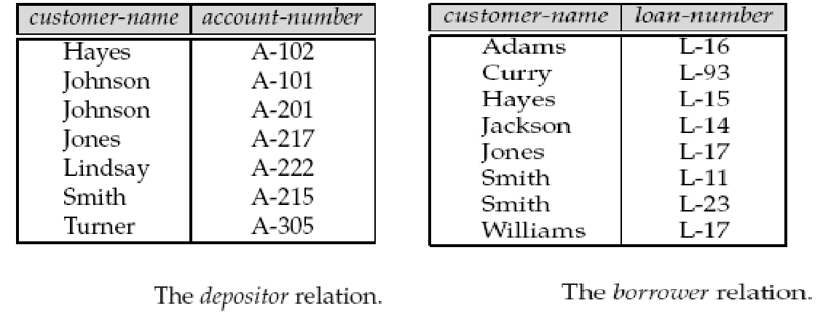

To find the names of all customers with a loan in the bank:

customer-name (borrower )

To find the names of all customers with an account in the bank:

customer-name (depositor)

union of these two sets; that is, To find customer names that appear in either or both of the two relations.

customer-name (borrower ) U customer-name (depositor)

The result relation for this query :
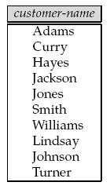

5.Set Difference Operation (-)

To find tuples that is in one relation but is not in another.

Syntax: Relation1 - Relation 2

Example: find all customers of the bank who have an account but not a loan .

customer-name (depositor) − customer-name (borrower )

The result relation for this query
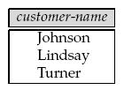

6.Cartesian-Product Operation(X)

- Cartesian product is also known as CROSS PRODUCT or CROSS JOINS.

- Cartesian product allows us to combine information from any 2 relation.

Syntax: Relation1 x Relation 2

Example: Consider following two relations publisher_info and Book_info.

Publisher_Info

Publisher_code | Name
P0001 | McGraw_Hill
P0002 | PHI
P0003 | Pearson
Book_Info
Book_ID | Title
B0001 | DBMS
B0002 | Compiler

The Cartesian product of Publisher_Info and Book_Info is given in fig .

Publisher_Info X Book_Info

Publisher_code | Name | Book_ID | Title
P0001 | McGraw_Hill | B0001 | DBMS
P0002 | PHI | B0001 | DBMS
P0003 | Pearson | B0001 | DBMS
P0001 | McGraw_Hill | B0002 | Compiler
P0002 | PHI | B0002 | Compiler
P0003 | Pearson | B0002 | Compiler

Additional operations

- Set intersection

- Natural join

- Division

4. Assignment

1.Set intersection Operation(∩)

- The result of intersection operation is a relation that includes all tuples that are in both Relation1 and Relation2.

- The intersection operation is denoted by depositor ∩ borrower.

Syntax: Relation1 ∩ Relation 2

Example:

customer-name (borrower) ∩ customer-name (depositor)

The result relation for this query:
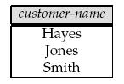

2.Natural join()

- The natural join operation performs a selection on those attributes that appear in both relation schemes and finally removes duplicate attributes.

Syntax: Relation1 |  | Relation 2
Example: consider the 2 relations
 |  |  |  |  | Salary
 |  |  |  |  | Emp_code | Salary
 | Employee
 | Employee |  |  |  | E0001 | 2000
 | Emp_code | Emp_name |  |  | E0002 | 5000
 | E0001 | Hari |  |  | E0003 | 7000
 | E0002 | Om |  |  | E0003 | 7000
 | E0002 | Om |  |  | E0004 | 10000
 | E0003 | Smith |  |  | E0004 | 10000
 | E0004 | Jay
Query: _{emp_name, salary}(employee |  |  | salary))
The output of query is:
 | Emp_name | Salary
 | Hari | 2000

 | Om |  | 5000
 | Smith |  | 7000
 | Jay |  | 10000

3.Division operation(÷)

- Division Operation is suited to queries that include the phrase ‘for all’.

Syntax: Relation1 ÷ Relation 2

Example: Consider three relations:

Account Relation Branch Relation Depositor Relation
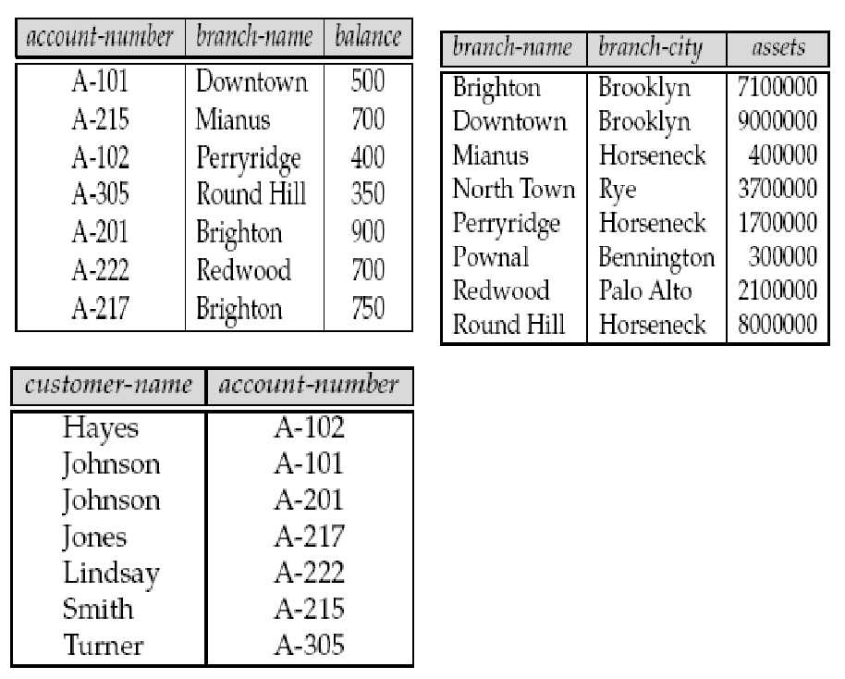

Suppose that we wish to find all customers who have an account at all the branches located in Brooklyn.

Step 1: We can obtain all branches in Brooklyn by the expression

r1 = branch-name ( branch-city =“Brooklyn” (branch))

The result relation for this expression is shown in figure.
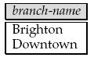

Step 2: We can find all (customer-name, branch-name) pairs for which the customer has an account at a branch by writing

r2 = customer-name, branch-name (depositor account)

Figure shows the result relation for this expression.
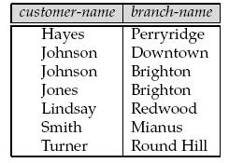

Now, we need to find customers who appear in r2 with every branch name in r1. The operation that provides exactly those customers is the divide operation. Thus, the query is

customer-name, branch-name (depositor account)

÷ branch-name ( branch-city =“Brooklyn” (branch))

The result of this expression is a relation that has the schema (customer-name) and that contains the tuple (Johnson).

4.The Assignment Operation ( )

The assignment operation works like assignment in a programming language.

Example:
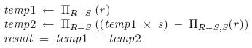

- Result of the expression to the right of the is assigned to the relation variable on the left of the .

- With the assignment operation, a query can be written as a sequential program consisting of a series of assignments followed by an expression whose value is displayed as the result of the query.

EXTENDED RELATIONAL-ALGEBRA OPERATIONS

- Generalized projection

- Aggregate operations

- Outer join.

1.Generalized projection

- The generalized-projection operation extends the projection operation by allowing arithmetic functions to be used in the projection list.

- The generalized projection operation has the form

F1,F2,...,Fn(E)

Where E is any relational-algebra expression, and each of F1, F2, . . . , Fn is an arithmetic

expression involving constants and attributes in the schema of E.

Example: Suppose we have a relation credit-info, as in Figure
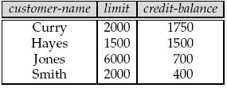

Query: customer-name, (limit − credit-balance) as credit-available (credit-info)

Result of this query:
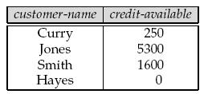

2.Aggregate Functions

Aggregate functions take a collection of values and return a single value as a result. Few Aggregate Function are,

- Avg

- Min

- Max

- Sum

- Count

1.Avg: The aggregate function avg returns the average of the values.

Example: Use the pt-works relation in Figure
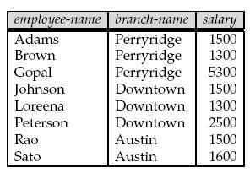

Suppose that we want to find out the average of salaries.

The relational-algebra expression for this query is:

Gavg(salary)(pt-works)

The symbol G is the letter G in calligraphic font; read it as “calligraphic G.”

Result:

Salary

2062.5

2. Min and Max

Min: Return the minimum values in a collection

Max: Return the Maximum values in a collection

Example: branch-name Gsum(salary) as sum-salary, max(salary) as max-salary (pt-works)

Result:

3.Sum: The aggregate function sum returns the total of the values.
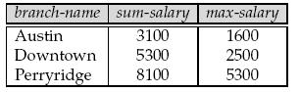

Example: Suppose that we want to find out the total sum of salaries.

Gsum(salary)(pt-works)

The symbol G is the letter G in calligraphic font; read it as “calligraphic G.”

Result:

Salary

16500

4.Count: Returns the number of the elements in the collection,

Example: Gcount-distinct(branch-name)(pt-works)

Result: The result of this query is a single row containing the value 3.

3.Outer join

Joins are classified into three types namely:

- Inner Join

- Outer Join

- Natural Joint

Inner Join()

Inner Join returns the matching rows from the tables that are being jointed.

Example: Consider the two relations

Example: 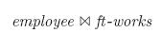
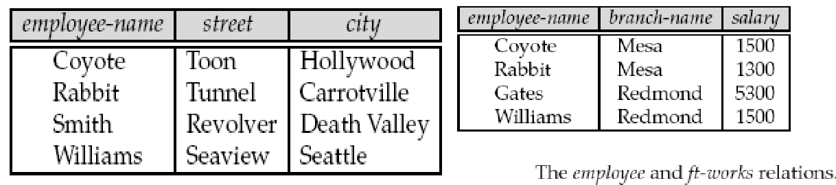

Result:
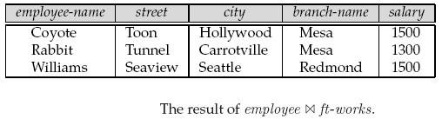

Outer Join

The outer-join operation is an extension of the join operation to deal with missing information. Outer-join operation to avoid loss of information.

Outer Joins are classified into three types namely:

- Left Outer Join

- Right Outer Join

- Full Outer Join

1.Left Outer Join ()

The left outer join () takes all tuples in the left relation that did not match with any tuple in the right relation, pads the tuples with null values for all other attributes from the right relation, and adds them to the result of the natural join.

Example:

Result:

2.Right Outer Join ()
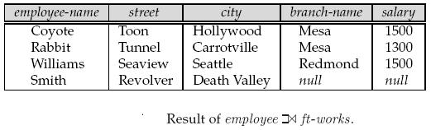

The right outer join () is symmetric with the left outer join: It pads tuples from the right relation that did not match any from the left relation with nulls and adds them to the result of the natural join.
Example:

Result:
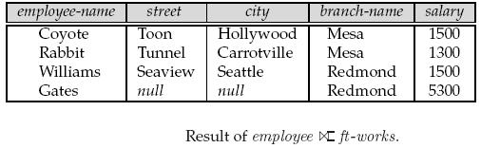

3.Full Outer Join ()

The full outer join( ) does both of those operations, padding tuples from the left relation that did not match any from the right relation, as well as tuples from the right relation that did not match any from the left relation, and adding them to the result of the join.
Example:

Result:

Modification of the Database
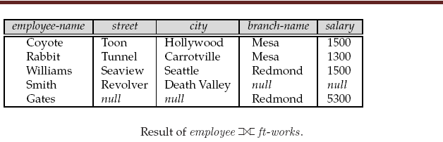

- The content of the database may be modified using the following operations:

  - Deletion

  - Insertion

  - Updating

- All these operations are expressed using the assignment operator.

1.Deletion

- A delete request is expressed similarly to a query, except instead of displaying tuples to the user, the selected tuples are removed from the database.

- Can delete only whole tuples; cannot delete values on only particular attributes

- A deletion is expressed in relational algebra by:

r ← r – E

where r is a relation and E is a relational algebra query.

Deletion Examples

- Delete all account records in the Perryridge branch

account ← account – σ _{branch_name = “Perryridge”} (account )

- Delete all loan records with amount in the range of 0 to 50

loan ← loan – σ amount ≥ 0 and amount ≤ 50 (loan)

- Delete all accounts at branches located in Needham.

r1 ← σ branch_city = “Needham” (account | branch )
r2 ← ∏ account_number, branch_name, balance (r1)
r3 ← ∏ customer_name, account_number (r2 | depositor)
account ← account – r₂

depositor ← depositor – r₃

2.Insertion

- To insert data into a relation, we either:

specify a tuple to be inserted

write a query whose result is a set of tuples to be inserted in relational algebra, an insertion is expressed by:

r ← r ∪ E

where r is a relation and E is a relational algebra expression.

- The insertion of a single tuple is expressed by letting E is a constant relation containing one tuple.

  - Insert information in the database specifying that Smith has $1200 in account A-973 at the Perryridge branch.

account ← account ∪ {(“A-973”, “Perryridge”, 1200)} depositor ← depositor ∪ {(“Smith”, “A-973”)}

- Provide as a gift for all loan customers in the Perryridge branch, a $200 savings account. Let the loan number serve as the account number for the new savings account.

r1 ← (σbranch_name = “Perryridge” (borrower loan))

account ← account ∪ ∏loan_number, branch_name, 200 (r1)

depositor ← depositor ∪ ∏customer_name, loan_number (r1)

3.Updating

- A mechanism to change a value in a tuple without charging all values in the tuple

- Use the generalized projection operator to do this task

- Each F_{i} is either

the i ^{th} attribute of r, if the i ^{th} attribute is not updated, or,

if the attribute is to be updated F_{i} is an expression, involving only constants and the attributes of r, which gives the new value for the attribute

- Make interest payments by increasing all balances by 5 percent.

account ← ∏ account_number, branch_name, balance * 1.05 (account)

- Pay all accounts with balances over $10,000 6 percent interest and pay all others 5 percent

account ← ∏ account_number, branch_name, balance * 1.06 (σ BAL > 10000 (account ))

∪ ∏ account_number, branch_name, balance * 1.05 (σBAL ≤ 10000 (account))

Relational Calculus

- Relational Calculus is a formal query language where we can write one declarative expression to specify a retrieval request and hence there is no description of how to retrieve it.

- Here query is expressed as a formula consisting of a number of variables and an expression involving these variables.

- A calculus expression specifies what is to retrieved rather than how to retrieve it.

- Relational Calculus is considered to be non procedural language.

- Relational Calculus can be divided into

Tuple Relational Calculus

Domain Relational Calculus

6.TUPLE RELATIONAL CALCULUS

In Tuple relational calculus, the variables represent the tuples from the specified relations.It is

  - A nonprocedural query language, where each query is of the form {t | P (t ) }

  - It is the set of all tuples t such that predicate P is true for t

  - t is a tuple variable, t [A ] denotes the value of tuple t on attribute A

  - t ∈ r denotes that tuple t is in relation r

- P is a formula similar to that of the predicate calculus

- Set of attributes and constants

- Set of comparison operators: (e.g., <, ≤, =, ≠, >, ≥)

- Set of connectives: and (∧), or (v)‚ not (¬)

- Implication ( ): xy, if x is true, then y is true

- Set of quantifiers:

∃ t ∈ r (Q (t )) ≡ ”there exists” a tuple in t in relation r such that predicate Q (t ) is true

∀t ∈ r (Q (t )) ≡ Q is true “for all” tuples t in relation r

- branch (branch_name, branch_city, assets )

- customer (customer_name, customer_street, customer_city )

- account (account_number, branch_name, balance )

- loan (loan_number, branch_name, amount )

- depositor (customer_name, account_number )

- borrower (customer_name, loan_number )

1.Find all tuples from the depositor relation

{ t | t∈ depositor }

  - Find the loan_number, branch_name, and amount for loans of over $1200 {t | t ∈ loan ∧ t [amount ] > 1200}

- Find the loan number for each loan of an amount greater than $1200

{t | ∃ s ∈ loan (t [loan_number ] = s [loan_number ] ∧ s [amount ] > 1200)}

We can read it as ‘The set of tuples t such that there exists a tuple s in relation Loan for which the values of t and s for the loan_no attribute are equal,and amount>$1200.

Notice that a relation on schema [loan_number ] is implicitly defined by the query 4. Find the names of all customers having a loan, an account, or both at the bank

{t | ∃s ∈ borrower ( t [customer_name ] = s [customer_name ]) ∨ ∃u ∈ depositor

    - t [customer_name ] = u [customer_name ])

- Find name and account numbers of all customers.

{ t | ∃s ∈ depositor(t[customer_name]=s[customer_name] ∧ t [accountnumber]= s[account_number)

6. Find the names of all customers who have a loan and an account at the bank

{t | ∃s ∈ borrower ( t [customer_name ] = s [customer_name ])

∧ ∃u ∈ depositor ( t [customer_name ] = u [customer_name] )

7. Find the names of all customers having a loan at the Perryridge branch

{t | ∃s ∈ borrower (t [customer_name ] = s [customer_name ] ∧ ∃u ∈ loan

(u [branch_name ] = “Perryridge”∧ u [loan_number ] = s [loan_number ]))}

- Find all customers who have an account at the bank but do not have a loan from the bank. {t | ∃u ∈ depositor (t [customer_name ] = u [customer_name ]

∧ ∃s ∈ borrower (t[customer_name ] = s [customer_name ])}

It is possible to write tuple calculus expressions that generate infinite relations.

For example, { t | ¬ t ∈ r } means tuples that are not in loan. It results in an infinite relation To protect against the problem, we restrict the set of allowable expressions to safe

expressions.

An expression {t | P (t )} in the tuple relational calculus is safe if every component of t appears in one of the relations, tuples, or constants that appear in P.

A nonprocedural query language equivalent in power to the tuple relational calculus

It uses the domain variables that take on values from an attribute domain, rather than entire tuple.

Each query is an expression of the form:

{ < x₁, x₂, …, x_{n} > | P (x₁, x₂, …, x_{n})}

  - x₁, x₂, …, x_{n} represent domain variables

  - Prepresents a formula similar to that of the predicate calculus

- Find the loan_number, branch_name, and amount for loans of over $1200

{< l, b, a > | < l, b, a > ∈ loan ∧ a > 1200}

- Find all loan numbers for loans with an amount greater than $1200. { < l > | ∃ b,a (< l, b, a > ∈ loan ∧ a > 1200}

- Find the names of all customers who have a loan of over $1200

{< c > | ∃ l, b, a (< c, l > ∈ borrower ∧ < l, b, a > ∈ loan ∧ a > 1200)}

- Find the names of all customers who have a loan from the Perryridge branch and find the loan amount:

{< c, a > | ∃ l (< c, l > ∈ borrower ∧ ∃b (< l, b, a > ∈ loan ∧ o b = “Perryridge”))}

{< c, a > | ∃ l (< c, l > ∈ borrower ∧ < l, “ Perryridge”, a > ∈ loan)}

- Find the names of all customers having a loan, an account, or both at the Perryridge branch:

{< c > | ∃ l ( < c, l > ∈ borrower ∧ ∃ b,a (< l, b, a > ∈ loan ∧ b = “Perryridge”)) ∨ ∃ a (< c, a > ∈ depositor ∧ ∃ b,n (< a, b, n > ∈ account ∧ b =

“Perryridge”))}

The expression: { < x₁, x₂, …, x_{n} > | P (x₁, x₂, …, x_{n} )} is safe if all of the following hold:

- All values that appear in tuples of the expression are values from dom (P) (that is, the values appear either in P or in a tuple of a relation mentioned in P).

- For every “there exists” subformula of the form ∃ x (P₁(x)), the subformula is true if and only if there is a value of x in dom (P₁)such that P₁(x) is true.

- For every “for all” sub formula of the form ∀_{x} (P₁ (x)), the subformula is true if and only if P₁(x) is true for all values x from dom (P₁).

SQL STRUCTURED QUERY LANGUAGE

Introduction

SQL is a standard command set used to communicate with the relational database management systems.

All

tasks related to relational data management-creating tables, querying, modifying, and

granting access to users, and so on.

SQL is
a high level language that provides a greater degree of abstraction than procedural
languages.

SQL
enables the end-users and systems personnel to deal with a number of database
management systems where it is available.
Applic
ation written in SQL can be easily ported across systems.
SQL
specifies what is required and not how it should be done.
SQL
was simple and easy to learn can handle complex situations.
All

SQL operations are performed at a set level.

Parts of SQL

The SQL language has several parts:

Data-definition language (DDL). The SQL DDL provides commands for defining relation schemas, deleting relations, and modifying relation schemas.

Interactive data-manipulation language (DML). The SQL DML includes a query language based on both the relational algebra and the tuple relational calculus. It includes also commands to insert tuples into, delete tuples from, and modify tuples in the database.

View definition. The SQL DDL includes commands for defining views.

Transaction control. SQL includes commands for specifying the beginning and ending of transactions.

Embedded SQL and dynamic SQL. Embedded and dynamic SQL define how SQL statements can be embedded within general-purpose programming languages, such as C, C++, Java, PL/I, COBOL, Pascal, and FORTRAN.

Integrity. The SQL DDL includes commands for specifying integrity constraints that the data stored in the database must satisfy. Updates that violate integrity constraints are disallowed.

Authorization. The SQL DDL includes commands for specifying access rights to relations and views.

Domain Types in SQL

- Char (n): Fixed length character string, with user-specified length n.

- varchar(n): Variable length character strings, with user-specified maximum length n.

- int: Integer (a finite subset of the integers that is machine-dependent).

- Smallint: Small integer (a machine-dependent subset of the integer domain type).

- numeric (p,d): fixed point number, with user-specified precision of p digits, with n digits to the right of decimal point.

- Real, double precision: Floating point and double-precision floating point numbers,

- float (n): Floating point number, with user-specified precision of at least n digits.

- Date: Dates, containing a (4 digit) year, month and date

- Time: Time of day, in hours, minutes and seconds.

- Timestamp: date plus time of day

- Interval: period of time Example: interval ‘1’ day

  - Data definition language(DDL)

  - Data manipulation language(DML)

  - Data query language(DQL)

  - Data control language(DCL)

- Data Definition Language

It is used to create a table, alter the structure of a table and also drop the table.

DDL Commands:

- CREATE – Command used for creating tables.

Syntax: create table <table name> (columnname1 data type (size), Columnname 2 data type(size),.., columnname n data type(size));

Example: create table customer (cust_name varchar2(15), social_security_no number(11),cust_street varchar2(7),cust_city varchar2(10));
- DESC – Command used to view the table structure.

Syntax: desc <table name>;

Example: desc customer;

- ALTER – Command used for modifying table structure.

  - Syntax : alter table <table name> modify (columnname data type (new size));

- Syntax: alter table <table name> modify (columnname new data type (size));

Example : alter table customer modify (social_security_no varchar2(11));

- Syntax : alter table <table name> add (new columnname data type (size));

- Syntax : alter table<table name> drop (column name);

Example : alter table customer drop(acc_no); 4.RENAME – used to change the name of the table.

Syntax : rename <Old table name> to <New table name>;

Example : rename cust to cust1;

5.DROP – Command used for removing an existing table.

Syntax: drop table <table name>;

Example: drop table cust1;

6.TRUNCATE-Truncating a table is removing all records from the table.It releases storage space occupied by the table.

Syntax: truncate table <table name>;

Example: truncate table cust1;

2. Data Manipulation Language

Data Manipulation language commands let user to insert, modify and delete the data from database.

DML Commands:

1.INSERT – To insert one or more number of Rows

Syntax 1 : insert into <table name> values (List of Data Values)

Syntax 2 : insert into <table name> (column names) values (list of data values) Insert command using User interaction

Syntax 3: insert into <Table name> values (&columnname1,&columnname2…) 2.SELECT – To display one or more rows

Syntax 1: select * from <table name>;

Syntax 2: select columnname1,columnname 2 from <table name>;

Syntax 3: select * from <table name> where <condition>;

Example:

  - Find the names of all branches in the loan table select branch_name from loan;

- List all account numbers made by brighton branch

select acc_no from account where branch_name = 'brighton'; c) List the customers who are living in the city harrison

select cust_name from customer where cust_city = 'harrison'; 3.UPDATE – Used to alter the column values in a table

Syntax: update <table name> set column_name=new_value where <condition>;

Example: update the account table to replace the balance value 500 to 450.

Query: update account set balance=450 where acc_no=’A-101’;

- DELETE – Used to delete one or more rows.

- Data query language

Data query Language statements enable the users to query one or more tables to get the information they want.

SQL has only one data query statements ‘Select’.

- Data control language

Data control language consists of commands that control the user access to the database objects.

Various DCL commands are: Commit, Rollback, save point, Grant, Revoke.

Transaction control Language

The TCL statements give you flexibility to undo transactions or write transaction to the disk.

Transaction provides consistency in case of a system failure.

We have 3 TCL statements

- COMMIT-Ends the current transaction and writes all changes permanent to the disk.

- SAVE POINT-Marks a point in the current transaction

- ROLL BACK-Ends the current transaction by undoing all changes if a TO SAVEPOINT clause is not used. It rolls back to the save point if the clause is used ,removing the save point and any change after the save point.

Basic Structure of SQL Expression:

SQL expression consists of three clauses:

Select: The select clause corresponds to projection operation of the relational algebra. It is used to list the attributes desired in the result of a query.

From: The from clause corresponds to the Cartesian product operation of the relational algebra .It lists the relations to be scanned in the evaluation of the expression.

Where :The where clause corresponds to the selection predicate of the relations that appear in the form clause.

General form of SQL query

Select A1, A2…………., An

From R1, R2……………, Rm

Where P

Where, A1-represent an attribute

R1-represent relation

P-is a predicate

The Select Clause:

This command is used to display all fields or set of selected fields from a relation. Eg: Select cust_name from customer;

Select * from customer

The where Clause:

It is used to select specific rows satisfying given predicate.SQL uses logical connectives

and , or , not and between in the where clause.

Eg: select title from book where pubyear=’2004’

Select title from book where price between 300 to 400 Select title from book where price > 300 ;

The from clause:

The from clause defines a Cartesian product of the relations in the clause.

Eg:

Example: Find the name, loan number and loan amount of all customers;

Select Customer_name , borrower.loan_number, amount from borrower , loan where borrower.loan_number = loan.loan_number

Rename Operation

The SQL allows renaming relations and attributes using the as clause:

Old-name as new-name

Example: Find the name, loan number and loan amount of all customers; rename the column name loan_number as loan_id.

Select Customer_name ,borrower.loan_number as loan_id , amount from borrower , loan where borrower.loan_number = loan.loan_number

Tuple Variables

Tuple

variables are defined in the from clause via the use of the as clause.

Example: Find the customer names and their loan numbers for all customers having a loan at some branch.

select customer_name, T.loan_number, S.amount from borrower as T, loan as S where T.loan_number = S.loan_number

String Operation

SQL includes a string-matching operator for comparisons on character strings.The

operator “like” uses patterns that are described using two special characters:
percent
(%). The % character matches any substring.
unders
core (_). The _ character matches any character.
Example: Select * from customer where customer_name like ’j%’;
Select * from customer where customer_Street like ’_a%’;
‘computer%’ – matches any string beginning with computer.
‘ _s%’ - matches any string with second character ‘s’

‘- - - ‘-matches any string of exactly 3 charateters.
‘- - - %‘-matches any string of atleast 3 charateters.
Ordering the Display of Tuples
Order
by clause is used to display the tuples in sorted order.
List in
alphabetic order the names of all customers having a loan in Perryridge branch
Example:select distinct customer_name from loan order by customer_name

We may specify desc for descending order or asc for ascending order, for each attribute; ascending order is the default.

Example: select customer_name , loan_no from borrower order by customer_name desc

- Union – returns all distinct rows selected by either query.

Example: Find all customers having a loan, an account or both at the bank

Query: select cust_name from depositor union select cust_name from borrower;

- Union all - returns all rows selected by either query

Example: Find all customers having a loan and an account at the bank

Query: select cust_name from depositor union all select cust_name from borrower;

- Intersect – returns only rows that are common to both the Queries

Example: Find all customers who have both a loan, and an account at the bank.

Query: select cust_name from depositor intersect select cust_name from borrower;

- Minus – returns all distinct rows selected only by the first Query and not by the second. Example: To find all customers who have an account but no loan at the bank. Query: select cust_name from depositor minus select cust_name from borrower;

These functions operate on the multiset of values of a column of a relation, and return a value

- AVG - To find the average of values.

Example: Find the average of account balance from the account table

Query: select avg (balance) from account;

- SUM – To find the sum of values.

- MAX – Returns the maximum value.

Example: Find the Maximum value of account balance from the account table.

Query: select max (balance) from account;

- MIN - Returns the minimum value.

Example: Find the Minimum value of account balance from the account table.

Query: select min (balance) from account;

- COUNT – Returns the number of rows in the column or table. Example 1: Find the number rows in the customer table. Query: select count (*) from customer;

Example 2: Find the number of rows in the balance column of account table. Query: select count (balance) from account;

- GROUP BY-used to group the rows based on certain condition

Group by is usually used along with aggregate functions like sum,max,min,avg.

Example 1: Find the average account balance at each branch.

Query:select branch_name, avg (balance) from account group by branch_name;

- HAVING CLAUSE -Having clause is equivalent to the where clause and is used to specify the search condition when group by is used.

Example 2: Find the average account balance at brighton branch.

Query: select branch_name, avg (balance) from account group by branch_name

having branch_name=’brighton’;

Null Values

It is possible for tuples to have a null value, denoted by null, for some of their attributes Null signifies an unknown value or that a value does not exist.

The predicate is null can be used to check for null values.

The predicate is not null can be used to check the absence of null values

• Exam

ple: Find all loan number which appears in the loan relation with null values for amount.

select loan_number from loan where amount is null Nested Subqueries

SQL provides a mechanism for the nesting of subqueries.

A subquery is a select-from-where expression that is nested within another query.

Subqueries are used to perform tests for set membership, set comparisons, and set cardinality.

Example 1: Find all the information of customer who has an account number is A-101. Query: select * from customer where cust_name=(select cust_name

from depositor where acc_no='A-101');

Example 2:Find all customers who have a loan from the bank, find their names and loan numbers.

Query: select cust_name, loan_no from borrower where loan_no in

(select loan_no from loan);

1.

Set

memberships

•

IN E

xample: Select * from customer where customer_name in(‘Hays’,Jones’);

•

IN Example:

Select

* from

customer

where

NOT

customer_name not

in(‘Hays’,Jones’);

2.

Set

comparisons

SQL uses various comparison operators such as <, <=, = ,> ,>=, <>, any, all, some ,>some ,>any etc to compare sets.

 | Title | price | p-year
 | DBMS | 399 | 2010
 | Oracle | 400 | 2009

Unix 450 2010

Example Select title from book where price > some (select price from book where p_year =’2010’)

Some meant for atleast one

Title

Oracle

Unix

3. |  |  |  |  |  |  |  |  |  |  |  |  | Test
 |  | for Empty Relation
 |  |  |  | Exists is a test for non empty set
 |  | Example: Consider 2 relations.
 |  | i. |  |  |  |  |  |  |  |  |  |  | book=
 |  | {book_id, title, a_name, p_name, P-year}
 |  | ii. |  |  |  |  |  |  |  |  |  |  | order=
 |  | { Order_no, book_id, date, price}
 |  | book
 |  | book_id |  | Title |  | a_name |  | p_name |  |  | P-year
 | 101 |  |  | DBMS |  | Seema |  | technical |  |  | 2010
 | 102 |  |  | Oracle |  | sinha |  | PHI |  |  | 2009
 | 103 |  |  | Unix |  | basu |  | charulatha |  |  | 20008
 |  | Order
 |  | Orderno |  | book_id, |  |  | date |  |  | price
 |  | 1 |  | 101 |  |  | 1-02-2010 |  |  | 399
 |  | 2 |  | 102 |  |  | 10-01-2003 |  |  | 400

Query to get the names of all books for which order is placed.

Title

Select title from |  | book where exists(select * from order where
Select title from | DBMS | book where exists(select * from order where
book.book- |  | id=order.book_id);
book.book- | Oracle | id=order.book_id);

Similar to exists we can use not exists also.

Example: Select title from book where not exists(select * from order where book.book-id=order.book_id);

Complex Queries

Complex queries are impossible to write as a single SQL block. There are two ways of composing multiple SQL blocks to express a complex query.

  - Derived relations

  - With clause.

- Derived Relations

SQL allows a subquery expression to be used in the from clause. If we use such an expression, then we must give the name of result relation, and we can rename the attributes. For renaming as clause is used

For example: “Find the average account balance of those branches where the average account balance is greater than $1200.”

Select branch-name, avg_balance from (select branch-name, avg (balance) from account group by branch-name)as branch-avg (branch-name, avg_balance )where avg-balance

- 1200

Here subquery result is named as branch-avg with attributes of branch-name and avg-

balance.

- With clause.

The with clause provides a way of defining a temporary view, whose definition is available only to the query in which the with clause occurs.

Consider the following query, which selects accounts with the maximum balance; if there are many accounts with the same maximum balance, all of them are selected.

with max-balance (value) as select max(balance) from account ;

select

account-number

from

account,

max-balance

where

account.balance

=

max-

balance.value

Views

•

A

View is an object that gives the user a logical view of data from an underlying tables or tables.

• Views

restrict the user to see only few attributes / columns from the table.

• Securit

y consideration may require that certain data be hidden from users.

• Any

relation that is not part of the logical model, but is made visible to a user as a virtual

relation, is called as view

Views may be created for the following reasons:

1. To

provide data security

2.

Query

simplicity

3.

Structu

re simplicity

Creating of Views

VIEW:-is an imaginary table.

Syntax:Create view <view name>as select columnname from tablename where condition

Eg. Query: create view custall as (Select cust_name, city from customer); Assigning Names to Columns

Example: create view custall (customername, city) as (Select cust_name, city from
customer);
Selecting data from view: Display the view: select * from custall;
Updation of a View
• | Views can be used for data manipulation i.e, the
user can perform insert, Update, and the delete operations on the view.

• | The views on which data manipulation can be
 | done are called updatable Views, the views that do not allow data manipulation are
 | called Readonly Views.

Destroying a view
A view can be dropped by using the drop view command.
Syntax: drop view view_name;
Example: drop view custall;
Modification to the database
1. |  | Delete
2. |  | Insert
3. |  | Updat
e
1.Deletion

A delete request is expressed in much the same way as a query.

We can delete only whole tuples; we cannot delete values on only particular attributes. SQL expresses a deletion by

Delete from r Where P

Where P predicate and r relation.

Examples:

- Delete all account tuples in the Perryridge branch.

delete from account where branch-name = ’Perryridge’

- Delete all loans with loan amounts between $1300 and $1500. delete from loan where amount between 1300 and 1500

- Delete all account tuples at every branch located in Needham.

delete from account where branch-name in (select branch-name from branch where branch-city = ’Needham’)

  - Delete the records of all accounts with balances below the average at the bank. delete from account where balance < (select avg (balance) from account)

- Insertion

To insert data into a relation, we either specify a tuple to be inserted or write a query whose result is a set of tuples to be inserted.

Example:

- Insert the fact that there is an account A-9732 at the Perryridge branch and that is has a balance of $1200.

insert into account values (’A-9732’, ’Perryridge’, 1200)

- insert statements are identical in function to the preceding one:

insert into account (account-number, branch-name, balance) values (’A-9732’, ’Perryridge’, 1200)

- Consider two relations student={roll_no,name,dept},student_new= {rollno,Name} Insert into student_new select rollno,name from student where dept=’IT’

3.Updates

Using Update, We can change a value in a tuple or all the tuples in the relation.

Examples:

- Update all balances are to be increased by 5 percent. update account set balance = balance * 1.05

- If interest is to be paid only to accounts with a balance of $1000 or more

update account set balance = balance * 1.05 where balance >= 1000

- “Pay 5 percent interest on accounts whose balance is greater than average”

update account set balance = balance * 1.05 where balance > select avg (balance) from account

  - syntax of case-using case we can perform update based on more than one condition. case

when condition1 then result1 when condition2 then result2 ……..

When condition then result End

- an account with a balance just under $10,000 would receive 5 percent interest otherwise 6 percent interest

update account set balance = case
when balance <= 10000 then balance * 1.05

else balance * 1.06

end

Joins

Join operations take two relations and return another relation as a result.

Join operation matches the data from two or more tables, based on the values of one or more columns in each table.

Join operation in SQL consists of join type and join condition.

Join condition – defines which tuples in the two relations match, and what attributes are present in the result of the join.

Join type – defines how tuples in each relation that do not match any tuple in the other relation (based on the join condition) are treated.
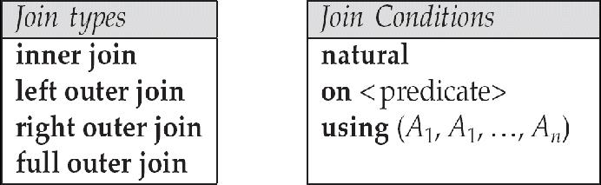

Inner join: It returns matching rows from the tables that are being joined

Examples:

Relation loan

Relation borrower
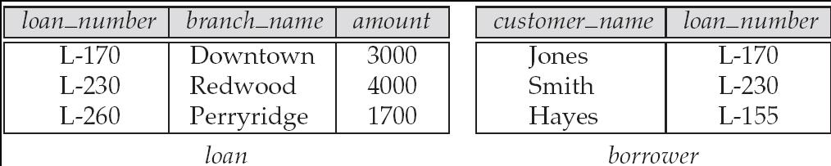

Note: borrower information missing for L-260 and loan information missing for L-155

loan inner join borrower on loan.loan_number = borrower.loan_number
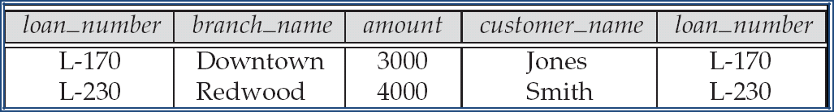

Outer join: It returns matching and non-matching rows from the tables that are being joined Types of outer join- 1.Left outer join

- Right outer join

- Full outer join

1.Left outer join:

Left outer join returns matching rows from the tables being joined, and also non matching rows from the left table in the result and places null values in the attributes that come from the right table.

loan left outer join borrower on loan.loan_number = borrower.loan_number
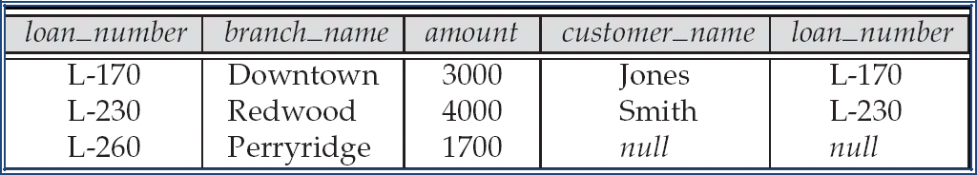

select loan.loan_no, branch_name, customer_name from loan left outer join borrower on loan.loan_no= borrower. loan_no

loan_no | branch_name | customer_name
L-170 | Downtown | Jones
L-230 | Redwood | Smith
L-260 | Perryridge | Null

2. Right outer join

Right outer join returns matching rows from the tables being joined, and also non matching rows from the right table in the result and places null values in the attributes that come from the left table.

loan natural right outer join borrower
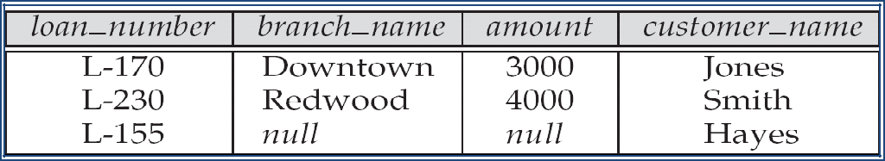

select loan.loan_no, branchname, customer_name from loan right outer join borrower on loan.loan_no= borrower. loan_no

loan_no | branch_name | customer_name
L-170 | Downtown | Jones
L-230 | Redwood | Smith
L-155 | Null | Hayes

3. Full outer join

Full outer join returns matching rows from the tables being joined, and also non matching rows from both left and right table in the result.

loan full outer join borrower using (loan_number)
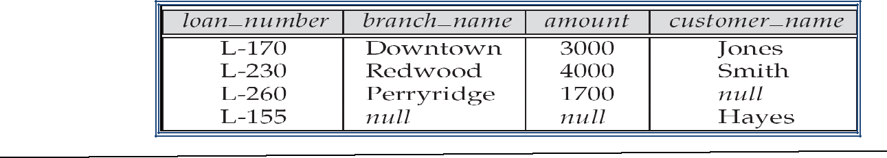

 |  | EMBEDDED SQL
 |  |  | Embed
 | ded SQL are SQL statements included in the programming language
 |  |  | A
 | language to which SQL queries are embedded is referred to as a host language, and the
 | SQL structures permitted in the host language comprise embedded SQL.
 |  |  | Some
 | of the host languages are C,COBOL, Pascal, PL/I etc.
Embedded SQL features:
• |  |  | The
 | embedded SQL statements appear in the host language.
• |  |  | Embed
 | ded SQL statements are prefixed by a delimiter-EXEC SQL so that they can be
 | differentiated from the host language.
• |  |  | Every
 | Embedded SQL statement is terminated with a delimiter. In COBOL it is END-EXEC. In
 | C, Pascal, PL/I it is a semicolon

• | SQL
 | statements can include reference to host variables. Such reference must be prefixed with:
 | (colon).
• | Host
 | variables and SQL columns can have the same name.
Advantages of embedded SQL programs:
• | Embed
 | ded SQL programs is an efficient way to merge the strength of two programming
 | environments that is SQL and host language.SQL is used for database access and
 | manipulation and Programming language provides flow of controls, conditional
 | branching and looping,I/O functions etc.
• | The

executable program will be very efficient in CPU usage.

Cursors:

A cursor is used to retrieve rows from a query that has multiple rows in its result set. A cursor is an identifier for the SQL query.

- Cursor declaration

From within a host language, find the names and cities of customers with more than the variable amount dollars in some account.

Specify the query in SQL and declare a cursor for it

EXEC SQL

declare c cursor for

select depositor.customer_name, customer_city

from depositor, customer, account

where depositor.customer_name = customer.customer_name and depositor account_number = account.account_number and
account.balance > :amount

END_EXEC

ii. Open

cursor statement:

EXEC SQL open c END_EXEC

This statement causes the database to execute the query and to save the results within a temporary relation. The query has a host variable (:amount),the query uses the value of the variable at the time the open statement was executed.

iii. The

fetch statement

An embedded SQL programs executes a series of fetch statements to retrieve tuples of the result. The fetch statement causes the values of one tuple in the query result to be placed on host language variable for each attribute of the result relation.

EXEC SQL fetch c into :cn, :cc END_EXEC Repeated calls to fetch get successive tuples in the query result
iv. The

close statement causes the database system to delete the temporary relation that holds the

result of the query.

EXEC SQL close c END_EXEC

Updates Through Cursors

Can

update tuples fetched by cursor by declaring that the cursor is for update

declare c cursor for select * from account

where branch_name = ‘Perryridge’

for update

To

update tuple at the current location of cursor c

update account set balance = balance + 100 where current of c

DYNAMIC SQL

Allows programs to construct and submit SQL queries at run time. Example of the use of dynamic SQL from within a C program.

char * sqlprog = “update account set balance = balance * 1.05 where account_number

= ?”

EXEC SQL prepare dynprog from :sqlprog;

char account [10] = “A-101”;

EXEC SQL execute dynprog using :account;

The dynamic SQL program contains a? which is a place holder for a value that is provided when the SQL program is executed.

MISSING INFORMATION

- There are 3 types of missing information. They are

    - Non-existent value: The attribute is inapplicable for the particular tuple.

  - Unknown value: There is a value but we don’t know it

  - No-information value: We don’t know whether there is a value or not.

- One possibility is to use a special value. Eg: if age is unknown, use 0.If social security number is unknown, use 999999999.

- This is not a proper solution to missing information.

- The proper solution to this problem is, use a value that is not in the domain. This is called null value.

- Primary keys must not have null values.

INTEGRITY

Integrity Constraints

It is mechanism used to prevent invalid data entry into the table.

Types
1. | Domai
 | n integrity Constraints
2. | Entity
 | integrity Constraints
3. | Refere

ntial integrity Constraints

Domain integrity Constraints

A Domain is a set of values that may be assigned to an attribute. All values that appear in a column of a relation (table) must be taken from the same domain.

Types

Not

Null Constraints

Check

Constraints

- NOT NULL – It will not allow null values.

Syntax : create table <table name>(columnname data type (size)

constraint constraint_name not null);

- CHECK - Use the CHECK constraint when you need to enforce integrity rules that can be evaluated based on a condition (logical expression).

Syntax : create table <table name>(columnname data type (size) constraint constraint_name check (check_condition));

Entity integrity Constraints

The entity integrity constraints state that no primary key value can be null. This is because the primary key value is used to identify individual tuples in a relation.

Types

Unique

Constraint

Primar

y key Constraint

- UNIQUE – Avoid duplicate values

Syntax : create table <table name>(columnname data type (size) constraint constraint_name unique);

- Composite UNIQUE – Multicolumn unique key is called composite unique key Syntax : create table <table name>(columnname1 data type (size), columnname2 data type (size), constraint constraint_name

unique (columnname1, columnname2));

- PRIMARY KEY – It will not allow null values and avoid duplicate values. Syntax : create table <table name>(columnname data type (size) constraint constraint_name primary key);

or

create table <table name>(columnname data type (size) primary key);

- Composite PRIMARY KEY – Multicolumn primary key is called composite primary key

Syntax : create table <table name>(columnname1 data type (size), columnname2 data type (size), constraint constraint_name primary key (columnname1, columnname2));

Ensures that a value appears in one relation for a given set of attributes also appears for a certain set of attributes in another relation. This condition is called referential integrity Reference key (foreign key) – Its represent relationships between tables.

Foreign key is a column whose values are derived from the primary key of the same or some other table.

Syntax: create table <table name>(columnname data type (size) constraint constraint_name foreign key references parent_table_name);

Let r₁(R₁) and r₂(R₂) be relations with primary keys K₁ and K₂ respectively.

The subset α of R₂ is a foreign key referencing K₁ in relation r₁, if for every t₂ in r₂ there must be a tuple t₁ in r₁ such that t₁[K₁] = t₂[α].

Referential integrity constraint also called subset dependency since its can be written as
∏_{α} (r₂) ⊆ ∏_{K1} (r₁)

Consider relationship set R between entity sets E₁ and E₂. The relational schema for R includes the primary keys K₁ of E₁ and K₂ of E₂.

Then K₁ and K₂ form foreign keys on the relational schemas for E₁ and E₂ respectively. Weak entity sets are also a source of referential integrity constraints.
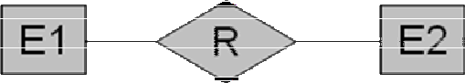

For the relation schema for a weak entity set must include the primary key attributes of the entity set on which it depends

TRIGGERS
A

trigger is a statement that is executed automatically by the system as a side effect of a modification to the database.

To

design a trigger mechanism, we must:

o

Specif

y the conditions under which the trigger is to be executed.

o

Specif

y the actions to be taken when the trigger executes.

Trigger

s introduced to SQL standard in SQL: 1999, but supported even earlier using non-standard syntax by most databases.

Create Or Replace Trigger <Trigger Name> [Before /After] [Insert /update/delete] on <Tablename> referencing new row as newname [For Each statement/for each row] [ When <Condition>]

Trigger Example

Consider the following tables

Library

BNO | BNAME | NCOPY
------- | ----------- | -----------
1 | vc++ | 10
2 | c++ | 15
3 | oracle | 20
Summary
BNO | NCOPY
------ | ----------

1 | 10
2 | 15
3 | 20

- When we Insert or update library table we need to simultaneously update the number of copies in the summary table .In that situation we can use trigger.

- Here trigger condition is Insert or update on library table

- Trigger action to be taken is update the number of copies in the summary table

Create Trigger for updating the number of copies in the summary table when we insert or update library table.

create or replace trigger lib_trg after insert or update on library referencing new row as

new for each row

begin

update summary set ncopy=ncopy+:new.ncopy where :new.bno=bno; end;

If we insert the tuple (2,’c++’, 5) into the relation library then the trigger is executed and it automatically updates the summary table.

BNO | NCOPY
------ | ----------
1 | 10
2 | 20
3 | 20

Triggering Events and Actions in SQL
Trigger
ing event can be insert, delete or update
Trigger
s on update can be restricted to specific attributes
Values
of attributes before and after an update can be referenced

o | refere
 | ncing old row as : for deletes and updates
o | refere
 | ncing new row as : for inserts and updates
 | Trigger

s can be activated before an event, which can serve as extra constraints. E.g.

convert blanks to null.

create trigger setnull-trigger before update on library referencing new row as nrow for each row when nrow.ncopy = ‘ ‘ set nrow.ncopy = null Statement Level Triggers

Instead

of executing a separate action for each affected row, a single action can be

executed for all rows affected by a transaction

o

Use

for each statement instead of for each row

o Use referencing old table or referencing new table to refer to temporary tables (called transition tables) containing the affected rows

o Can be

more efficient when dealing with SQL statements that update a large

number of rows

When Not To Use Triggers

Trigger

s should be written with great care, since a trigger error detected at run time

causes the failure of insert/ delete/ update statement that set off the trigger.

The

action of one trigger can start another trigger.

In

worst case, this could lead to an infinite chain of triggering.

SECURITY

- Security of data is important concept in DBMS because it is essential to protect the data against any unwanted users.

- It is a protection from unauthorized users to steal or modify data.

1. Database system level

Authentication and authorization mechanism allow the users to access only the required data.

- Operating system level

  - Protection from invalid logins

  - File-level access protection

  - Protection from improper use of “super user” authority.

  - Protection from improper use of privileged machine instructions.

- Network level

    - Each site must ensure that it communicates with trusted sites.

    - Links must be protected from theft or modification of messages.

  - Identification protocol (password based)

  - Cryptography

- Physical level

  - Protection of equipment from floods, power failure etc.

  - Protection of disks from theft, removal, physical damage etc.

  - Protection of network and terminal cables from wire tapes, on-invasive electronic eavesdropping, physical damage, etc.

Solution

  - Replication hardware-mirrored disks, dual busses etc.

  - Multiple access paths between every pair of devices.

  - Physical security by locks, police etc.

- Human level

  - Protection from stolen passwords, damage etc.

Solution

1. |  | Frequent change of passwords.
2. |  | Use of “non-guessable” passwords.
3. |  | Log all invalid access attempts.
4. |  | Data audits.
 |  |  | AUTHORIZATION
 | Forms of authorization on parts of the database:
 |  |  |  | Read
 | authorization - allows reading, but not modification of data.
 |  |  |  | Insert

authorization - allows insertion of new data, but not modification of existing data.

Update
authorization - allows modification, but not deletion of data.
Delete
authorization - allows deletion of data
Forms of authorization to modify the database schema:
Index
authorization - allows creation and deletion of indices.
Resour
ces authorization - allows creation of new relations.
Alterat
ion authorization - allows addition or deletion of attributes in a relation.
Drop
authorization - allows deletion of relations.
Authorization and Views

Users can be given authorization on views, without being given any authorization on the relations used in the view definition

Ability of views to hide data serves both to simplify usage of the system and to enhance security by allowing users access only to data they need for their job

A combination or relational-level security and view-level security can be used to limit a user’s access to precisely the data that user needs.

