UNIT III | TRANSACTIONS

Transaction Concepts – ACID Properties – Schedules – Serializability – Concurrency Control – Need for Concurrency – Locking Protocols – Two Phase Locking – Deadlock – Transaction Recovery - Save Points – Isolation Levels – SQL Facilities for Concurrency and Recovery.

______________________________________________________________________________

Definition of transaction Collection of operation that forms a single unit of work is called transaction.

During transaction execution the database may be temporarily inconsistent.

When the transaction completes successfully (is committed), the database must be consistent.

After a transaction commits, the changes it has made to the database persist, even if there are system failures.

Multiple transactions can execute in parallel. Two main issues to deal with:

  - Failures of various kinds, such as hardware failures and system crashes

  - Concurrent execution of multiple transactions

The transaction consists of all operation executed between the begin transaction and End transaction.

Transaction Properties ACID Properties

A transaction is a unit of program execution that accesses and possibly updates various data items. A transaction must ensure 4 properties

Atomicity Either all operations of the transaction are properly reflected in the database or none are.

Consistency Execution of a transaction in isolation preserves the consistency of the database. Isolation Although multiple transactions may execute concurrently, each transaction must be unaware of other concurrently executing transactions. Intermediate transaction results must be hidden from other concurrently executed transactions.

- That is, for every pair of transactions T_{i} and T_{j}, it appears to T_{i} that either T_{j}, finished execution before T_{i} started, or T_{j} started execution after T_{i} finished.

Durability After a transaction completes successfully, the changes it has made to the database persist, even if there are system failures.

Transactions access data using two operations:

read(X), which transfers the data item X from the database to a local buffer belonging to the transaction that executed the read operation.

write(X), which transfers the data item X from the the local buffer of the transaction that executed the write back to the database.

Example of Fund Transfer

Transaction to transfer $50 from account A to account B:

read(A)

A:=A–50

write(A)

read(B)

B:=B+50

write(B)

Each of the ACID requirements are:

Consistency requirement – the sum of A and B is unchanged by the execution of the transaction.

Atomicity requirement — Suppose, before the execution of transaction Ti the values of accounts A and B are $1000 and $2000, respectively. Now suppose, during the execution of transaction Ti, a failure, suppose that the failure happened after the write (A) operation but before the write(B) operation. In this case, the values of accounts A and B reflected in the database are $950 and

$2000. Thus sum A + B is no longer preserved. To avoid this, atomicity should be ensured.

To ensure atomicity database system keeps track of the old values of any data on which a transaction performs a write, and, if the transaction does not complete its execution, the database system restores the old values

Atomicity is handled by transaction-management component.

Durability requirement — once the user has been notified that the transaction has completed (i.e., the transfer of the $50 has taken place), the updates to the database by the transaction must persist despite failures.

Ensuring durability is the responsibility of a component called the recovery-management component.

Isolation requirement —If several transactions are executed concurrently, their operations may interleave in some undesirable way, resulting in an inconsistent state.

For example, The database is temporarily inconsistent while the transaction to transfer funds from A to B is executing, If a second concurrently running transaction reads A and B at this intermediate point and computes A+B, it will observe an inconsistent value. Furthermore,

if this second transaction performs updates on A and B, the database may be left in an inconsistent state even after both transactions have completed.

To avoid the problem of concurrently executing, transactions should be execute in isolation.

The isolation property of a transaction ensures that the concurrent execution of transactions results in a system state that could have been obtained if transactions executed serially i.e.one after the other.

Ensuring the isolation property is the responsibility of concurrency-control component,

TRANSACTION STATE

The transaction must be the one of the following state.

Active – the initial state; the transaction stays in this state while it is executing

Partially committed – after the final statement has been executed.

Failed -- after the discovery that normal execution can no longer proceed.

Aborted – after the transaction has been rolled back and the database restored to its state prior to the start of the transaction. Two options after it have been aborted:

- Restart the transaction; can be done only if there is software or hardware error.

- kill the transaction if there is internal logical error

Committed – after successful completion.

Figure State diagram of a transaction
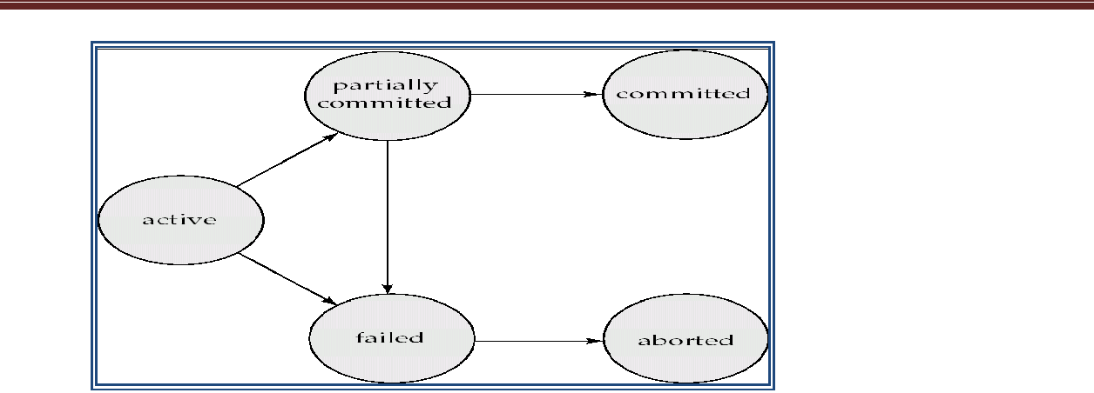

TRANSACTION RECOVERY

Transaction recovery is “the process of removing the undesired effects of specific transaction from the database”.

Traditional recovery is at the database object level: for example, at the data space, table space or index level. When performing a traditional recovery, a specific database object is chosen. Then the backup copy of that object is applied, followed by reapplying log entries for changes that occurred after the image copy was taken. As all the changes made to a relational database are captured in the database log, the change details can be read from the log, recovery can be achieved by reversing, the impact of the logged changes.

A transaction begins with the successful execution of BEGIN TRANSACTION statement, and it end with successful execution of either a COMMIT or ROLLBACK statement. COMMIT establish a commit point. A commit point corresponds to the end of logical unit of work, and hence to the point at which the database is or should be in a consistent state. ROLLBACK rolls the database back to the state it was in at BEGIN TRANSACTION, which means back to the previous commit point.

When a commit point is established:

- All updates made by the executing program since the previous commit point are committed, that is they are stored permanently in the database.

- All database partitioning is lost and all the tuple locks are released. Database positioning means the idea that at given time an executing program will typically have addressability to certain tuple, this addressability is lost at a commit point.

SYSTEM RECOVERY

The system must be prepared to recover from logical failure; such as overflow condition within an individual transaction, and global failures such as power failure.

A local failure only affects the transaction in which it is occurred. A global failure affects all the transactions in progress at the time of the failure. Such failure fall in two categories:

- System Failure

- Media failure

System Failure: Example of such a failure is power failure. Such failure affects all the transaction currently in progress but do not physically damage the database. A system failure is also called as soft crash.

In system failure the contents of the main memory are lost. Therefore, the state of any transaction that was in progress at the time of the failure is therefore no longer known. So such transaction cannot be successfully completed and hence required to be undone i.e) rolled back when the system restarts.

Media failure: Example of such a failure is head crash on the disk. These failures do cause damage to the database, or to some portion of it, and affect at least those transactions currently using that portion. A media failure is also called head crash.

MEDIA RECOVERY

A media failure is a failure such as disk head crash, or a disk controller failure.

Recovery from such a failure involves reloading the database from a backup copy (or dump), and then the log redo all transactions that completed since that backup copy was taken.

For performing media recovery there is need of dump restore utility. The dump portion of that utility is used to make backup copies of the database on demand. Such copies are kept on the tape or other archival storage.

After media failure, the restore portion of the utility is used to recreate the database from a specified backup copy.

------------------------------------------------------------------------------------------------------------

TWO-PHASE COMMIT

Two-phase commit is a transaction protocol designed for the complications that arise with distributed resources managers.

With a two-phase commit protocol, the distributed transaction manager employs a co-coordinator to manage the individual resource managers.

The commit processes proceed as follows:

- Phase 1:

Each participating resource manager coordinates local operation and forces all log records out:

If successful, respond “OK”

Else, either allow a time-out or “Not OK”

- Phase 2:

If all participants respond “OK”:

Co-ordinator instructs participating resource manager to “COMMIT”. Otherwise

Co-ordinator instructs participating resource manager to “ROLLBACK”.

----------------------------------------------------------------------------------------------------------

- Multiple savepoints can exist within a single transaction

- Savepoints are useful for implementing complex error recovery in database applications. If an error occurs in the middle of a multiple-statement transaction, the application may be able to recover from the error by rolling back to a savepoint without needing to abort the entire transaction.

- You create a savepoints using the SAVE TRANSACTION savepoint_name statement.

Practical Example:

Consider that a person walking and after passing some distance of the road is split into two tracks. The person were not sure to choose which track, so before randomly selecting one track he make a signal flag, so that if the track was not the right one he can roll back to signal flag and select the right track. In this example signal flag becomes the Savepoint.

Signal flag
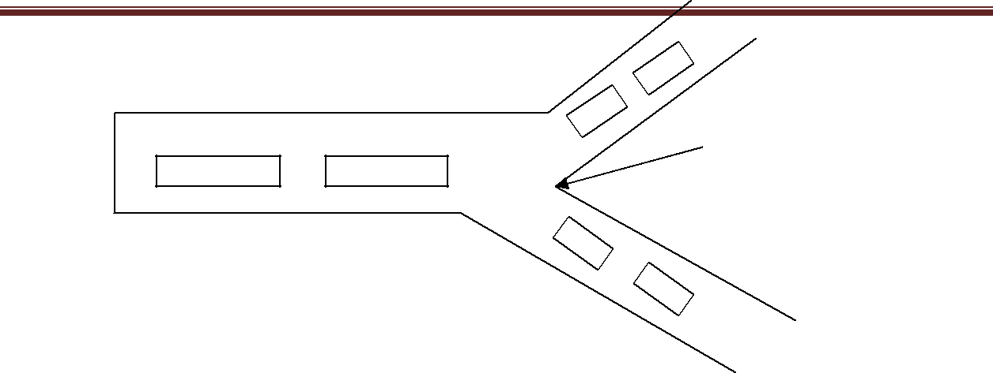

The syntax for declaring a savepoint is given below:

SQL> SAVEPOINT Name_of_Savepoint

Example: before deleting the records of employee whose age is above 60, we are not sure that whether we are given work to actually delete the records of employee whose age is above 60 yrs or 58 yrs. So before proceeding further we should create

savepoint and then use delete command to delete the employee records. It is given below:

SQL: savepoint DeleteEmp;

SQL: delete Emp_age>60;

The above command deletes the records of those employees whose age is above 60 yrs. After some time, the manager orders to not delete any employee’s record, then we can undo the earlier changes by using the roll back to save point command as given below

SQL: rollback to DeleteEmp;

SQL FACILITIES FOR RECOVERY

SQL uses following statement to recover from transaction failure.

1)COMMIT Command

The commit command saves all transaction to the database since the last COMMIT or ROLLBACK command was issued.

Syntax: commit[work];

The keyword commit is the only mandatory part of the syntax. Keyword work is optional;

Example:

SQL> delete from Emp Where Emp_age> 60;

The above command deletes the records of those employees whose age is above 60 yrs. To store changes permanently in database commit command is used. SQL> COMMIT WORK;

2)ROLLBACK Command

The rollback command is the transactional control command used to undo transaction that have not already been saved to the database. The rollback command can only be used to undo transaction since the last COMMIT or ROLLBACK command was issued.

Syntax:

SQL>rollback[work];

The keyword rollback is the only mandatory part of the syntax. Keyword work is optional;

Example:

SQL> delete from emp Where emp_age > 60;

The above command deletes the records of those employees whose age is above 60 yrs. To discard the changes made on database rollback command is used.

SQL>ROLLBACK WORK;

3)SAVEPOINT Command

Savepoints offer a mechanism to roll back portions of transactions.

4)SET TRANSACTION Command

Establish properties for the current transaction. This command sets the transaction isolation level.

Syntax: SET TRANSCATION <OPTION COMMALIST>; Where the <OPTION COMMALIST> specifies an access mode.

The access mode is either READ ONLY or READ WRITE.

The isolation level takes the form ISOLATION LEVEL <isolation> where <isolation> is READ UNCOMMITED, READ COMMITED, REPEATABLE READ,SERIALIZABLE READ.

CONCURRENCY OR CONCURRENT EXECUTION

The users are accessing different part of the database, their transaction can run without a problem. However, when two users try to make updates simultaneously on the same data, or one updates while another reads the same data, there may be conflicts. To avoid such a conflicts, there is a need for concurrency control mechanism.

- Process of managing simultaneous operations on the database without having them interfere with one another

  - Prevents interference when two or more users are accessing database simultaneously and at least one is updating data.

NEED FOR CONCURRENCY

Multiple transactions are allowed to run concurrently in the system. Advantages are:

o Improved throughput and resource utilization, leading to better transaction throughput: one transaction can be using the CPU while another is reading from or writing to the disk

“Throughput is number of transactions executed in a given amount of time” o Reduced waiting time for transactions: short transactions need not wait behind

long ones.

Concurrency control schemes – Mechanisms to achieve isolation; that is, to control the interaction among the concurrent transactions in order to prevent them from destroying the consistency of the database

Schedule – a sequences of instructions that specify the chronological order in which instructions of concurrent transactions are executed

o a schedule for a set of transactions must consist of all instructions of those transactions

o Must preserve the order in which the instructions appear in each individual transaction.

A transaction that successfully completes its execution will have a commit instructions as the last statement (will be omitted if it is obvious)

A transaction that fails to successfully complete its execution will have an abort instructions as the last statement (will be omitted if it is obvious)

Schedule 1

Let T₁ transfer $50 from A to B, and T₂ transfer 10% of the balance from A to B. A serial schedule in which T₁ is followed by T₂:

Schedule 2
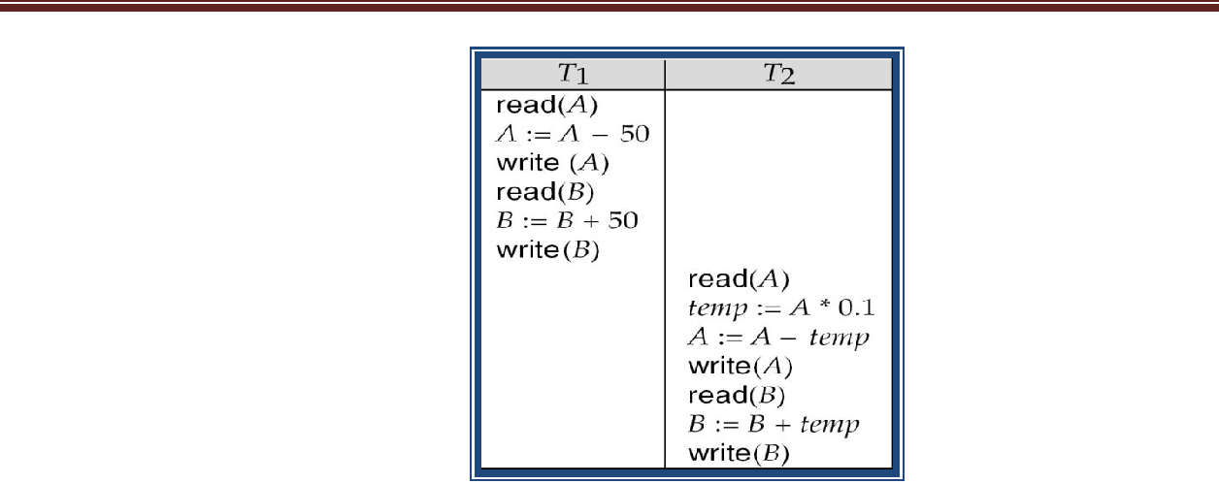

A serial schedule where T₂ is followed by T₁
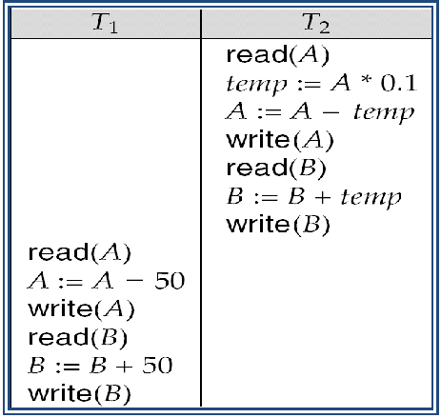

Schedule 3

Let T₁ and T₂ be the transactions defined previously. The following schedule is not a
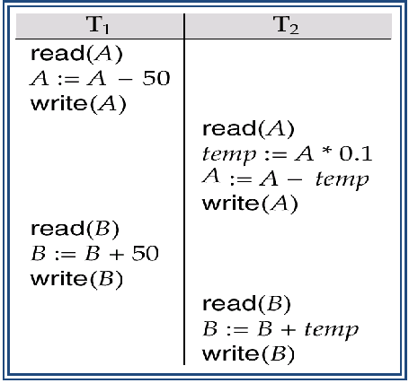

Serial schedule, but it is equivalent to Schedule 1.

In Schedules 1, 2 and 3, the sum A + B is preserved.

Schedule 4

The following concurrent schedule does not preserve the value of (A + B).
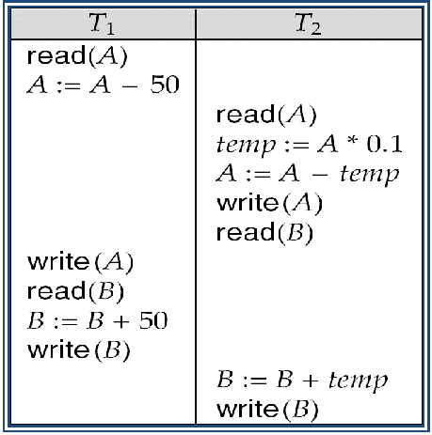

---------------------------------------------------------------------------------------------------------------------

SERIALIZABILITY

Serialization of concurrent tranbsaction is the process of managing the execution of a set of transactions in such a way that their concurrent executions produce the same result as if they were run serially.

Basic Assumption – Each transaction preserves database consistency.

Thus serial execution of a set of transactions preserves database consistency.

A (possibly concurrent) schedule is serializable if it is equivalent to a serial schedule. Different forms of schedule equivalence give rise to the notions of:

  - Conflict serializability

  - View serializability

Instructions l_{i} and l_{j} of transactions T_{i} and T_{j} respectively, conflict if and only if there exists some item Q accessed by both l_{i} and l_{j}, and at least one of these instructions is a

write(Q) operation.

  - l_{i} = read(Q), l_{j} = read(Q). l_{i} and l_{j} don’t conflict.

    - l_{i} = read(Q), l_{j} = write(Q). They conflict.

  - l_{i} = write(Q), l_{j} = read(Q). They conflict

  - l_{i} = write(Q), l_{j} = write(Q). They conflict

Intuitively, a conflict between l_{i} and l_{j} forces a (logical) temporal order between them.

- If l_{i} and l_{j} do not conflict, their results would remain the same even if they had been interchanged in the schedule.

If a schedule S can be transformed into a schedule S´ by a series of swaps of non-conflicting instructions, we say that S and S´ are conflict equivalent.

We say that a schedule S is conflict serializable if it is conflict equivalent to a serial

schedule

Schedule 3 can be transformed into Schedule 6, a serial schedule where T₂ follows T₁, by series of swaps of non-conflicting instructions.

o Therefore Schedule 3 is conflict serializable.
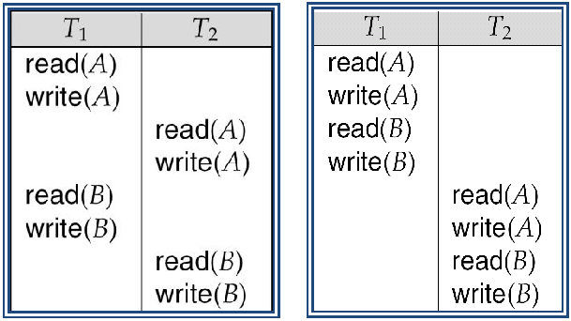

Schedule 3 Schedule 6

Example of a schedule that is not conflict serializable:
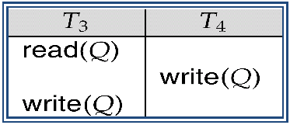

We are unable to swap instructions in the above schedule to obtain either the serial schedule < T₃, T₄ >, or the serial schedule < T₄, T₃ >.

View Serializability

Let S and S´ be two schedules with the same set of transactions. S and S´ are view equivalent if the following three conditions are met:

  - For each data item Q, if transaction T_{i} reads the initial value of Q in schedule S, then transaction T_{i} must, in schedule S´, also read the initial value of Q.

  - For each data item Q if transaction T_{i} executes read(Q) in schedule S, and that value was produced by transaction T_{j} (if any), then transaction T_{i} must in schedule S´ also read the value of Q that was produced by transaction T_{j} .

  - For each data item Q, the transaction (if any) that performs the final write(Q) operation in schedule S must perform the final write(Q) operation in schedule S´.

As can be seen, view equivalence is also based purely on reads and writes alone. A schedule S is view serializable it is view equivalent to a serial schedule.

Every conflict serializable schedule is also view serializable.

Below is a schedule which is view-serializable but not conflict serializable.
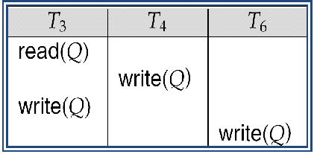

Every view serializable schedule that is not conflict serializable has blind writes.

Here T4 & T6 performs write operations with out performing read (Q).This kind of writes are called blind writes.

The schedule below produces same outcome as the serial schedule < T₁, T₅ >, yet is not conflict equivalent or view equivalent to it.
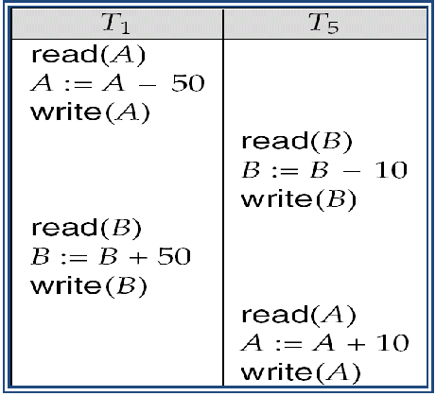

Determining such equivalence requires analysis of operations other than read and write.

Testing for Serializability

Connsider some schedule of a set of trannsactions T₁, T₂, ..., T_{n}

Preecedence graph — a dirrect graph where the vertices are the transactionss (names).

We draw an arc from T_{i} to T_{j} if the tw o transactio n conflict, and T_{i} accessed the data item on which the coonflict arose earlier.

We may label the arc by the item that was accessedd. Exaample 1

Exaample Schedule (Scheddule A) + Prrecedence Graph
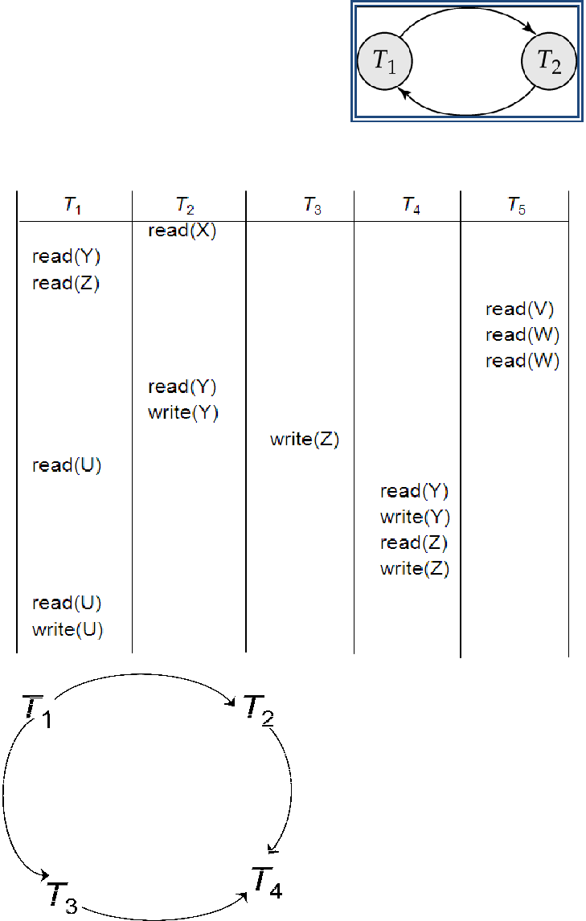

Test for Conflict Serializabilityy

A schedule is conflict serializable if and only if its precedence graph is acyyclic.

Cycle-detection algorithms exist which take order n² time, where n is the number of vertices in the graph.

o (Better algorithms take order n + e where e is the number of edges.)

If precedence graph is acyclic, the serializability order can be obtained by a topological

sorting of the graph.

- This is a linear order consistent with the partial order of the graph.

o For example, a serializability order for Schedule A would be T₅→T₁→T₃→T₂→T₄
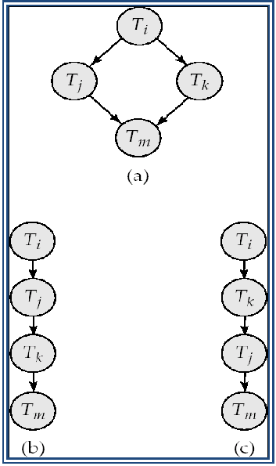

Test for View Serializability

The precedence graph test for conflict serializability cannot be used directly to test for view serializability.

Here Labelled precedence graph is used for testing view serializability.

Recoverability

If a transaction Ti fails, we need to undo the effect of this transaction to ensure the atomicity property of the transaction. In a system that allows concurrent execution, it is necessary to ensure that any transaction Tj that is dependent on Ti should also be also aborted. To achieve this ,we need to place restrictions on the type of schedules permitted in the system.

Types of schedules that are acceptable from the view point of recovery from transaction failure are:

- Recoverable schedules

- Cascadeless schedules

Need to address the effect of transaction failures on concurrently running transactions.

Recoverable schedule — if a transaction T_{j} reads a data item previously written by a transaction T_{i} , then the commit operation of T_{i} appears before the commit operation of T_{j}.
The following schedule (Schedule 11) is not recoverable if T₉ commits immediately after

the read
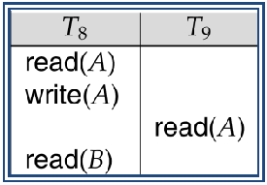

If T₈ should abort, T₉ would have read (and possibly shown to the user) an inconsistent database state. Hence, database must ensure that schedules are recoverable.

Cascading rollback – a single transaction failure leads to a series of transaction rollbacks. Consider the following schedule where none of the transactions has yet committed (so the schedule is recoverable)
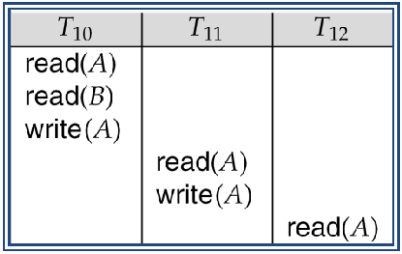

If T₁₀ fails, T₁₁ and T₁₂ must also be rolled back.

CONCURRENCY CONTROL Lock-Based Protocols Timestamp-Based Protocols

Concurrency Control

The system must control the interaction among the concurrent transactions; this control is achieved through one of concurrency-control schemes.

The concurrency-control schemes are based on the serializability property.Now we will consider the management of concurrently executing transaction.

Different types of protocols/schemes used to control concurrent execution of transaction

are:

Lock-Based Protocols

A lock is a mechanism to control concurrent access to a data item Data items can be locked in two modes :

  - exclusive (X) mode. Data item can be both read as well as written. X-lock is requested using lock-X instruction.

  - shared (S) mode. Data item can only be read.

Lock requests are made to concurrency-control manager. Transaction can proceed only after request is granted.

Lock-compatibility matrix

A transaction may be granted a lock on an item if the requested lock is compatible with locks already held on the item by other transactions

Any number of transactions can hold shared locks on an item,
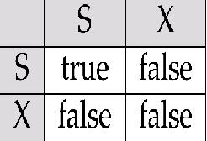

  - but if any transaction holds an exclusive on the item no other transaction may hold any lock on the item.

If a lock cannot be granted, the requesting transaction is made to wait till all incompatible locks held by other transactions have been released. The lock is then granted.

Example of a transaction performing locking:

T1: lock-X(B);

read(B);

- :=B−50;

write(B);

unlock(B);

lock-X(A);

read(A);

A:=A+50;

write(A);

unlock(A).

T₂: lock-S(A);

read (A);

unlock(A);

lock-S(B);

read (B);

unlock(B);

display(A+B)

Locking as above is not sufficient to guarantee serializability — if A and B get updated in-between the read of A and B, the displayed sum would be wrong.

A locking protocol is a set of rules followed by all transactions while requesting and releasing locks. Locking protocols restrict the set of possible schedules.

Pitfalls of Lock-Based Protocols

Consider the partial schedule
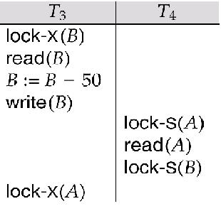

Neither T₃ nor T₄ can make progress — executing lock-S(B) causes T₄ to wait for T₃ to release its lock on B, while executing lock-X(A) causes T₃ to wait for T₄ to release its

lock on A.

Such a situation is called a deadlock.

o To handle a deadlock one of T₃ or T₄ must be rolled back and its locks released.

The potential for deadlock exists in most locking protocols. Deadlocks are a necessary evil.

Starvation is also possible if concurrency control manager is badly designed. For example:

o A transaction may be waiting for an X-lock on an item, while a sequence of other transactions request and are granted an S-lock on the same item.

o The same transaction is repeatedly rolled back due to deadlocks. Concurrency control manager can be designed to prevent starvation.

----------------------------------------------------------------------------------------------------

This is a protocol which ensures conflict-serializable schedules.

Phase 1: Growing Phase

  - transaction may obtain locks

  - transaction may not release locks

Phase 2: Shrinking Phase

  - transaction may release locks

  - transaction may not obtain locks

Initially, a transaction is in the growing phase. The transaction acquires locks as needed. Once the transaction releases a lock, it enters the shrinking phase, and it cannot issue more lock requests.

For example, transactions T3 is two phase.

T3: lock-X(B);

read(B);

B:=B−50;

write(B);

lock-X(A);

read(A);

A:=A+50;

write(A);

unlock(B);

unlock(A).

Figure Transaction T3.

Advantage:

- The protocol assures serializability. It can be proved that the transactions can be serialized in the order of their lock points (i.e. the point where a transaction acquired its final lock).

- Two-phase locking does not ensure freedom from deadlocks

- Cascading roll-back is possible under two-phase locking. Consider schedule shown in figure
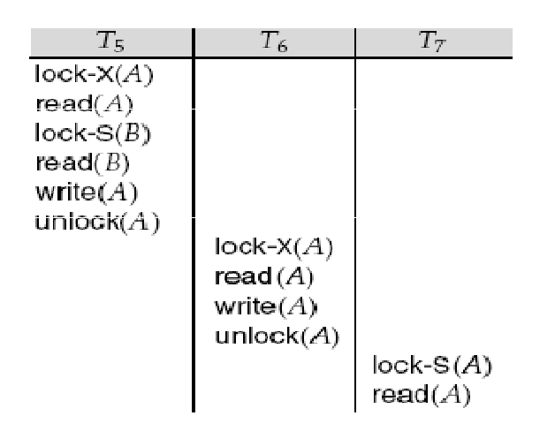

Figure Partial schedule under two-phase locking

Here, the transaction T5,T6 and T7 are two phase, but failure of T5 after the read(A) instruction of T7 leads to cascading rollback of T6 and T7

Cascading roll-back is possible under two-phase locking. To avoid this, follow a modified protocol called strict two-phase locking. Here a transaction must hold all its exclusive locks till it commits/aborts.

Rigorous two-phase locking is even stricter: here all locks are held till commit/abort. In this protocol transactions can be serialized in the order in which they commit.

There can be conflict serializable schedules that cannot be obtained if two-phase locking is used.

However, in the absence of extra information (e.g., ordering of access to data), two-phase

locking is needed for conflict serializability in the following sense:

Given a transaction T_{i} that does not follow two-phase locking, we can find a transaction T_{j} that uses two-phase locking, and a schedule for T_{i} and T_{j} that is not conflict serializable.

Two-phase locking with lock conversions:

First Phase:

  - can acquire a lock-S on item

  - can acquire a lock-X on item

  - can convert a lock-S to a lock-X (upgrade)

Second Phase:

  - can release a lock-S

  - can release a lock-X

  - can convert a lock-X to a lock-S (downgrade)

This protocol assures serializability. But still relies on the programmer to insert the various locking instructions.

A lock manager can be implemented as a separate process to which transactions send lock and unlock requests

The lock manager replies to a lock request by sending a lock grant messages (or a message asking the transaction to roll back, in case of a deadlock)

The requesting transaction waits until its request is answered

The lock manager maintains a data-structure called a lock table to record granted locks and pending requests

The lock table is usually implemented as an in-memory hash table indexed on the name of the data item being locked

Lock Table
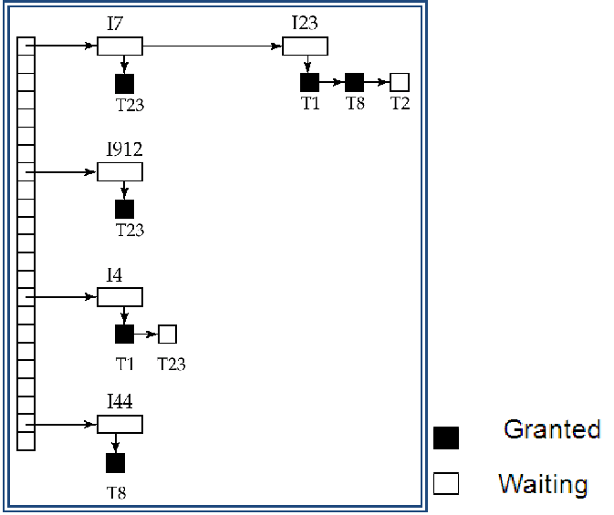

Black rectangles indicate granted locks, white ones indicate waiting requests Lock table also records the type of lock granted or requested

New request is added to the end of the queue of requests for the data item, and granted if it is compatible with all earlier locks

Unlock requests result in the request being deleted, and later requests are checked to see if they can now be granted

If transaction aborts, all waiting or granted requests of the transaction are deleted

- lock manager may keep a list of locks held by each transaction, to implement this

efficiently

----------------------------------------------------------------------------------------------------------

Each transaction is issued a timestamp when it enters the system.

If an old transaction T_{i} has time-stamp TS(T_{i}), a new transaction T_{j} is assigned time-stamp TS(T_{j}) such that TS(T_{i}) <TS(T_{j}).

There are two simple methods for implementing this scheme:

  - Use the value of the system clock as the timestamp; that is, a transaction’s timestamp is

equal to the value of the clock when the transaction enters the system.

  - Use a logical counter that is incremented after a new timestamp has been assigned; that is, a transaction’s timestamp is equal to the value of the counter when the transaction enters the system.

The timestamps of the transactions determine the serializability order.

The protocol manages concurrent execution such that the time-stamps determine the serializability order.

In order to assure such behavior, the protocol maintains for each data Q two timestamp values:

o W-timestamp (Q) is the largest time-stamp of any transaction that executed write(Q) successfully.

o R-timestamp (Q) is the largest time-stamp of any transaction that executed read(Q) successfully.

The timestamp ordering protocol ensures that any conflicting read and write operations are executed in timestamp order.
Suppose a transaction T_{i} issues a read(Q)

  - If TS(T_{i}) ≤ W-timestamp(Q), then T_{i} needs to read a value of Q that was already

overwritten.

o Hence, the read operation is rejected, and T_{i} is rolled back.

  - If TS(T_{i})≥ W-timestamp(Q), then the read operation is executed, and R-timestamp(Q) is set to max(R-timestamp(Q), TS(T_{i})).

Suppose that transaction T_{i} issues write (Q).

  - If TS(T_{i}) < R-timestamp(Q), then the value of Q that T_{i} is producing was needed

previously, and the system assumed that that value would never be produced. n Hence, the write operation is rejected, and T_{i} is rolled back.

  - If TS(T_{i}) < W-timestamp(Q), then T_{i} is attempting to write an obsolete value of Q. n Hence, this write operation is rejected, and T_{i} is rolled back.

  - Otherwise, the write operation is executed, and W-timestamp(Q) is set to TS(T_{i}).

Example Use of the Protocol

A partial schedule for several data items for transactions with timestamps 1, 2, 3, 4, 5

Correctness of Timestamp-Ordering Protocol
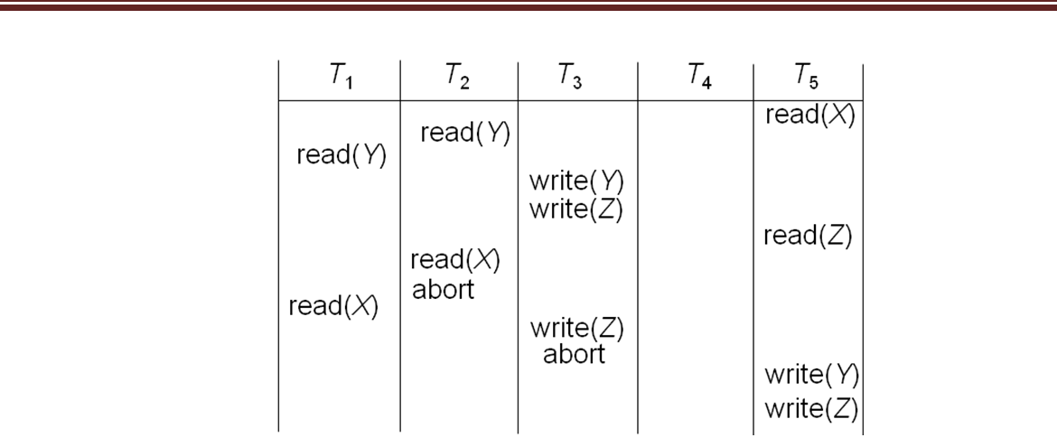

The timestamp-ordering protocol guarantees serializability since all the arcs in the precedence graph are of the form:

Thus, there will be no cycles in the precedence graph

Timestamp protocol ensures freedom from deadlock as no transaction ever waits. But the schedule may not be cascade-free, and may not even be recoverable.

Problem with timestamp-ordering protocol:

- Suppose T_{i} aborts, but T_{j} has read a data item written by T_{i}

- Then T_{j} must abort; if T_{j} had been allowed to commit earlier, the schedule is not recoverable.
- Further, any transaction that has read a data item written by T_{j} must abort

- This can lead to cascading rollback --- that is, a chain of rollbacks

- A transaction is structured such that its writes are all performed at the end of its processing

- All writes of a transaction form an atomic action; no transaction may execute while a transaction is being written

- A transaction that aborts is restarted with a new timestamp

Solution 2: Limited form of locking: wait for data to be committed before reading it

Solution 3: Use commit dependencies to ensure recoverability

Thomas’ Write Rule

Modified version of the timestamp-ordering protocol in which obsolete write operations

may be ignored under certain circumstances.

When T_{i} attempts to write data item Q, if TS(T_{i}) < W-timestamp(Q), then T_{i} is attempting

to write an obsolete value of {Q}.

o Rather than rolling back T_{i} as the timestamp ordering protocol would have done, this {write} operation can be ignored.

Otherwise this protocol is the same as the timestamp ordering protocol. Thomas' Write Rule allows greater potential concurrency.

- Allows some view-serializable schedules that are not conflict-serializable.

_____________________________________________________________________________

Deadlock

Deadlock

A system is in a deadlock state if there exists a set of transactions such that every transaction in the set is waiting for another transaction in the set. In other words, there exists a set of waiting transactions {T0, T1, . . ., Tn} such that T0 is waiting for a data item that T1 holds, and T1 is waiting for a data item that T2 holds, and . . ., and Tn−1 is waiting for a data item that Tn holds, and Tn is waiting for a data item that T0 holds. In such a situation, none of transaction can make progress.

There are two principal methods for dealing with the deadlock problem.

- Deadlock prevention This approach ensure that the system will never enter in deadlock

state.

- Deadlock detection and deadlock recovery This approach tries to recover from deadlock if system enters in deadlock state.

Deadlock Handling

Consider the following two transactions:

T₁:write (X) | T₂: write(Y)
write(Y) | write(X)
Schedule with deadlock

System is deadlocked if there is a set of transactions such that every transaction in the set is waiting for another transaction in the set.
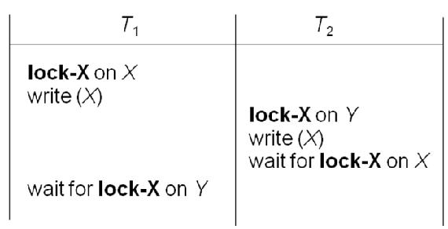

Deadlock prevention protocols ensure that the system will never enter into a deadlock state.

Some prevention strategies :

- Require that each transaction locks all its data items before it begins execution (predeclaration).

- Impose partial ordering of all data items and require that a transaction can lock data items only in the order specified by the partial order (graph-based protocol).

Following schemes use transaction timestamps for the sake of deadlock prevention alone.

wait-die scheme — non-preemptive

  - older transaction may wait for younger one to release data item. Younger transactions never wait for older ones; they are rolled back instead.

  - a transaction may die several times before acquiring needed data item wound-wait scheme — preemptive

  - older transaction wounds (forces rollback) of younger transaction instead of waiting for it. Younger transactions may wait for older ones.

  - may be fewer rollbacks than wait-die scheme.

Both in wait-die and in wound-wait schemes, a rolled back transaction is restarted with its original timestamp. Older transactions thus have precedence over newer ones, and starvation is hence avoided.

- a transaction waits for a lock only for a specified amount of time. After that, the wait times out and the transaction is rolled back.

- thus deadlocks are not possible

- simple to implement; but starvation is possible. Also difficult to determine good value of the timeout interval.

Deadlocks can be described as a wait-for graph, which consists of a pair G = (V,E), o V is a set of vertices (all the transactions in the system)
o E is a set of edges; each element is an ordered pair T_{i} →T_{j}.

If T_{i} → T_{j} is in E, then there is a directed edge from T_{i} to T_{j}, implying that T_{i} is waiting for T_{j} to release a data item.

When T_{i} requests a data item currently being held by T_{j}, then the edge T_{i} T_{j} is inserted in the wait-for graph. This edge is removed only when T_{j} is no longer holding a data item needed by T_{i}.

The system is in a deadlock state if and only if the wait-for graph has a cycle. Must invoke a deadlock-detection algorithm periodically to look for cycles.
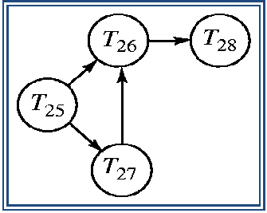

Wait-for graph without a cycle
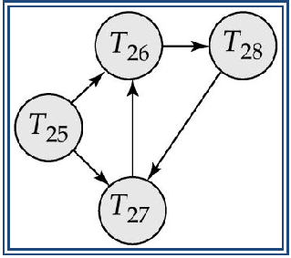

Wait-for graph with a cycle

Deadlock Recovery

When deadlock is detected :

  - Selection of transaction some transaction will have to rolled back (made a victim) to break deadlock. Select that transaction as victim that will incur minimum cost.

  - Rollback -- determine how far to roll back transaction

  - Total rollback: Abort the transaction and then restart it.

  - Partial rollback: More effective to roll back transaction only as far as necessary to break deadlock.

- Starvation happens if same transaction is always chosen as victim. Include the number of rollbacks in the cost factor to avoid starvation

______________________________________________________________________________

Intent Locking

Intent locks are placed on higher level database objects when a user of process locks on the data pages or rows. An intent lock stays in place for the life of the lower-level locks. For example, consider a table created with row-level locking. When a process locks the row, an intent lock is taken on the table. Intent locks are used primarily to ensure that one process can not tale locks on the table, or pages in the table, that would conflict with the locking of another process. For example, if a user was holding an exclusive row lock and another user wished to take out an exclusive table lock on the table containing row, the intent lock held on the table by the first user would ensure that its row lock would not be overlooked by the lock manager.

Recovery (or) Database Recovery Techniques

Recovery System

Failure Classification

Storage Structure

Recovery and Atomicity

Log-Based Recovery

Shadow Paging

Recovery System

Recovery Systems is an integral part of a database system.It stores the database to the consistent state that existed before the failure. The recovery system should provide high availability; that is, it must minimize the time for which the database is not usable after a crash.
Failure Classification

Transaction failure :

- Logical errors: transaction cannot complete due to some internal error condition

  - System errors: the database system must terminate an active transaction due to an error condition (e.g., deadlock)

System crash: a power failure or other hardware or software failure causes the system to crash.

  - Fail-stop assumption: non-volatile storage contents are assumed to not be corrupted by system crash

Database systems have numerous integrity checks to prevent corruption of disk data

Disk failure: a head crash or similar disk failure destroys all or part of disk storage

  - Destruction is assumed to be detectable: disk drives use checksums to detect failures

- log-based recovery, and

- shadow-paging

Log-Based Recovery

A log is kept on stable storage.

  - The log is a sequence of log records, and maintains a record of update activities on the database.

There are several types of log record such as –

Update log record:It describe a single database write.It has following fields-

- Transaction identifier is the unique identifier of the transaction that performed the write operation.

- Data-item identifier is the unique identifier of the data item written. Typically, it is the location on disk of the data item.

- Old value is the value of the data item prior to the write.

- New value is the value that the data item will have after the write.

Other special log records exist to record significant events during transaction

processing,

such as the start of a transaction and the commit or abort of a transaction.

We denote the various types of log records as:

- <Ti start>. Transaction Ti has started.

- <Ti, Xj, V1, V2>. Transaction Ti has performed a write on data item Xj . Xj had value V1 before the write, and will have value V2 after the write.
- <Ti commit>. Transaction Ti has committed.

- <Ti abort>. Transaction Ti has aborted.

Whenever a transaction performs a write, a log record for that write be created. Once a log record exists, we can output the modification to the database if that is desirable. Also, we have the ability to undo a modification that has already been output to the database. We undo it by using the old-value field in log records.

We assume for now that log records are written directly to stable storage (that is, they are not buffered)

Two approaches using logs

- Deferred database modification

- Immediate database modification

Deferred Database Modification

The deferred database modification scheme records all modifications to the log, but defers all the writes to after partial commit.

Assume that transactions execute serially

Transaction starts by writing <T_{i} start> record to log.

A write(X) operation results in a log record <T_{i}, X, V> being written, where V is the new value for X

o Note: old value is not needed for this scheme

The write is not performed on X at this time, but is deferred. When T_{i} partially commits, <T_{i} commit> is written to the log

Finally, the log records are read and used to actually execute the previously deferred writes.

During recovery after a crash, a transaction needs to be redone if and only if both <T_{i} start> and<T_{i} commit> are there in the log.

Redoing a transaction T_{i} ( redoT_{i}) sets the value of all data items updated by the transaction to the new values.

Crashes can occur while

- the transaction is executing the original updates, or

- while recovery action is being taken

Example: Transactions T₀ and T₁ (T₀ executes before T₁):
T₀: read (A) | T₁ : read (C)
A:-A-50 | C:- | C- 100
Write (A) | write (C)
read (B)

B:- B+50

write (B)

Portion of the database log corresponding to T0 and T1.
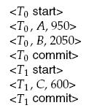

State of the log and database corresponding to T0 and T1.
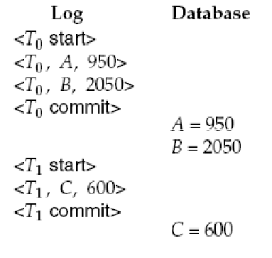

Below we show the log as it appears at three instances of time.

If log on stable storage at time of crash is as in case:

  - No redo actions need to be taken

  - redo(T₀) must be performed since <T₀ commit> is present

  - redo(T₀) must be performed followed by redo(T₁) since

    - <T₀ commit> and <T_{i} commit> are present
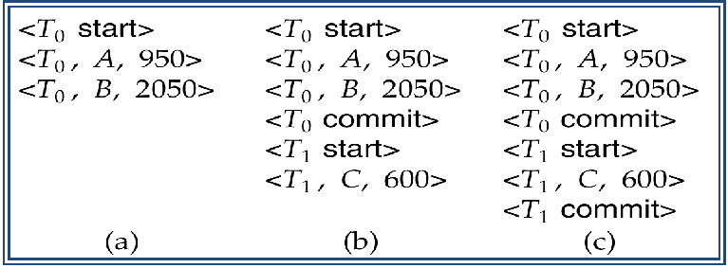

Immediate Database Modification

The immediate database modification scheme allows database updates of an uncommitted transaction to be made as the writes are issued

o since undoing may be needed, update logs must have both old value and new value

Update log record must be written before database item is written

  - We assume that the log record is output directly to stable storage

  - Can be extended to postpone log record output, so long as prior to execution of an output(B) operation for a data block B, all log records corresponding to items B must be flushed to stable storage

Output of updated blocks can take place at any time before or after transaction commit Order in which blocks are output can be different from the order in which they are

written.

Immediate Database Modification Example

Portion of the system log corresponding to T0 and T1.

State of system log and database corresponding to T0 and T1.
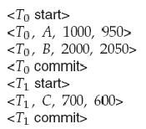
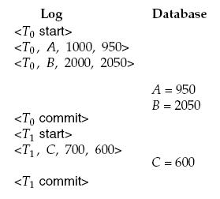

Recovery procedure has two operations instead of one:

  - undo(T_{i}) restores the value of all data items updated by T_{i} to their old values, going backwards from the last log record for T_{i}

  - redo(T_{i}) sets the value of all data items updated by T_{i} to the new values, going forward from the first log record for T_{i}

Both operations must be idempotent

  - That is, even if the operation is executed multiple times the effect is the same as if it is executed once

Needed since operations may get re-executed during recovery When recovering after failure:

o Transaction T_{i} needs to be undone if the log contains the record <T_{i} start>, but does not contain the record <T_{i} commit>.

  - Transaction T_{i} needs to be redone if the log contains both the record <T_{i} start> and the record <T_{i} commit>.

Undo operations are performed first, then redo operations.

Below we show the log as it appears at three instances of time.

Recovery actions in each case above are:

  - undo (T₀): B is restored to 2000 and A to 1000.

  - undo (T₁) and redo (T₀): C is restored to 700, and then A and B are
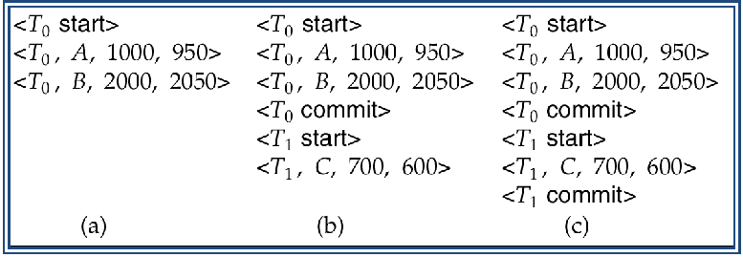

- Set to 950 and 2050 respectively.

  - redo (T₀) and redo (T₁): A and B are set to 950 and 2050

- Respectively. Then C is set to 600

Checkpoints

Problems in recovery procedure as discussed earlier : o Searching the entire log is time-consuming o Output their updates to the database.
Streamline recovery procedure by periodically performing checkpointing

  - Output all log records currently residing in main memory onto stable storage.

  - Output all modified buffer blocks to the disk.

  - Write a log record < checkpoint> onto stable storage.

During recovery we need to consider only the most recent transaction T_{i} that started before the checkpoint, and transactions that started after T_{i}.

  - Scan backwards from end of log to find the most recent <checkpoint> record

  - Continue scanning backwards till a record <T_{i} start> is found.

  - Need only consider the part of log following above start record. Earlier part of log can be ignored during recovery, and can be erased whenever desired.
  - For all transactions (starting from T_{i} or later) with no <T_{i} commit>, execute

undo(T_{i}). (Done only in case of immediate modification.)

o Scanning forward in the log, for all transactions starting from T_{i} or later with a <T_{i} commit>, execute redo(T_{i}).

Example of Checkpoints

- T₁ can be ignored (updates already output to disk due to checkpoint)

- T₂ and T₃ redone.

- T₄ undone
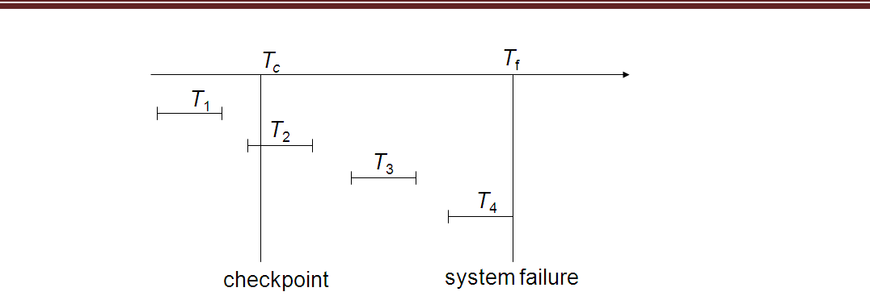

Shadow Paging

Shadow paging is an alternative to log-based recovery; this scheme is useful if transactions execute serially

Idea: maintain two page tables during the lifetime of a transaction –the current page table, and the shadow page table

Store the shadow page table in nonvolatile storage, such that state of the database prior to transaction execution may be recovered.

o Shadow page table is never modified during execution

To start with, both the page tables are identical. Only current page table is used for data item accesses during execution of the transaction.

Whenever any page is about to be written for the first time

- A copy of this page is made onto an unused page.

- The current page table is then made to point to the copy

- The update is performed on the copy

Sample Page Table

Example of Shadow Paging
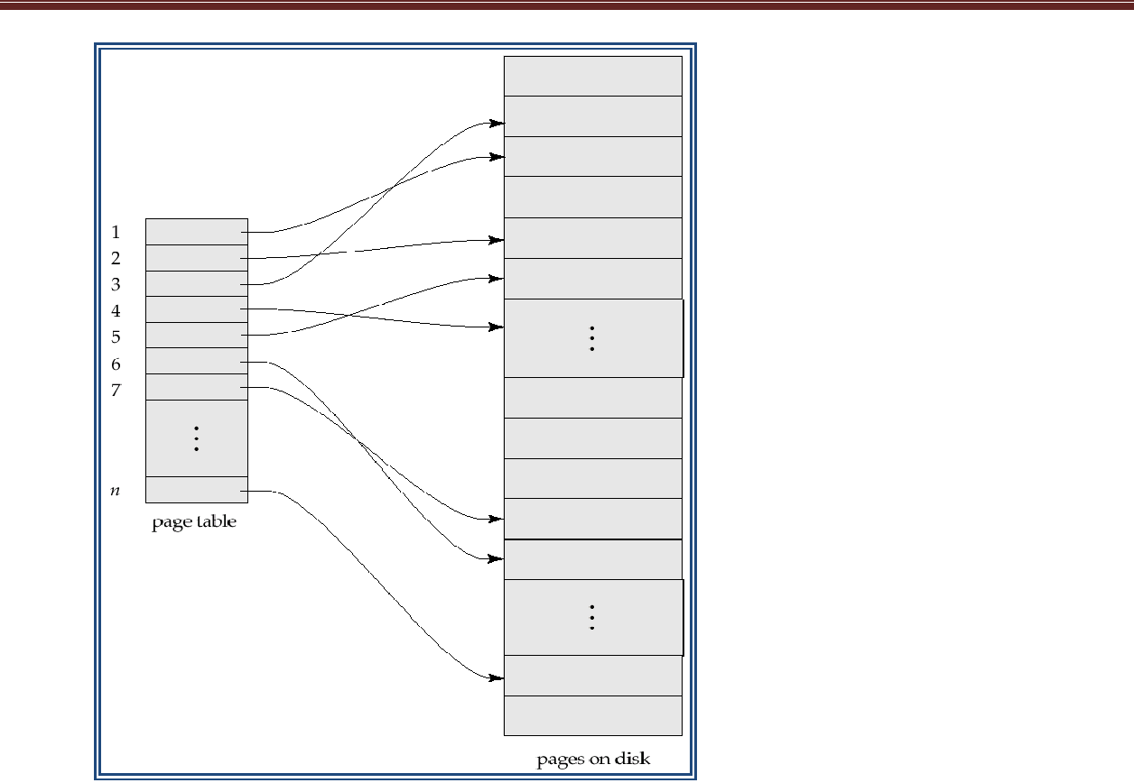

Shadow and current page tables after write to page 4

To commit a transaction :
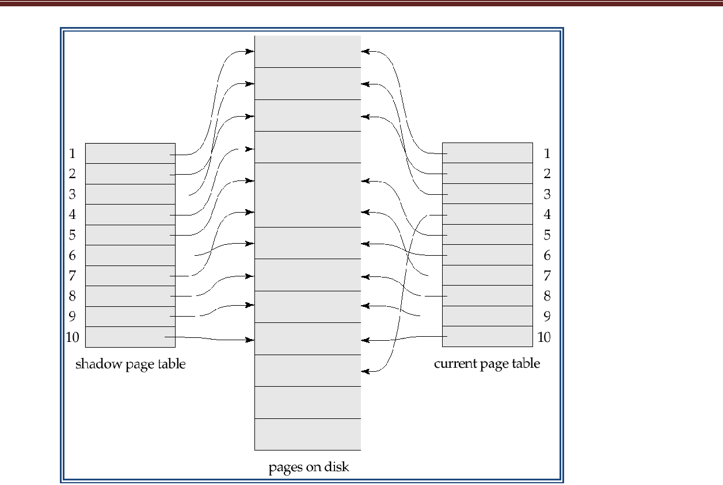

  - Flush all modified pages in main memory to disk

  - Output current page table to disk

  - Make the current page table the new shadow page table, as follows:

  - Keep a pointer to the shadow page table at a fixed (known) location on disk.

  - To make the current page table the new shadow page table, simply update the pointer to point to current page table on disk

Once pointer to shadow page table has been written, transaction is committed.

No recovery is needed after a crash — new transactions can start right away, using the shadow page table.

Pages not pointed to from current/shadow page table should be freed (garbage collected).

Advantages of shadow-paging over log-based schemes

- no overhead of writing log records

- recovery is trivial

Disadvantages:

- Copying the entire page table is very expensive

Can be reduced by using a page table structured like a B⁺-tree

    - No need to copy entire tree, only need to copy paths in the tree that lead to updated leaf nodes

- Commit overhead is high even with above extension

Need to flush every updated page, and page table

- Data gets fragmented (related pages get separated on disk)

- After every transaction completion, the database pages containing old versions of modified data need to be garbage collected

- Hard to extend algorithm to allow transactions to run concurrently Easier to extend log based schemes

______________________________________________________________________________

________________

